第七章：统一计算设备构架

摘要

A Graphics Processing Unit (GPU) is an integral piece of hardware in many electronic devices. It is used to expose graphical interfaces to the user and can be found in almost every workstation or mobile device. Starting from the mid-nineties of the last century, the increasing popularity of 3D-accelerated games (such as the Quake and Unreal series) caused a rapid growth of computational capabilities of modern GPUs allowing for the rendering of more and more complex scenes. In the late nineties, man- ufacturers extended the GPU’s core functionality, the efﬁcient rendering of 3D scenes, to additionally support the processing of geometric operations, notably the pioneering NVIDIA GeForce 256 [5] and its dedicated Transform and Lighting (T&L) unit. This trend continued in the new millennium with the introduction of pixel and vertex shader languages which allowed for the manipulation of the prior to this hard-wired rendering pipeline. Consequently, computer scientists used the increasing computa- tional power of GPUs to implement more general algorithms by expressing them in the aforementioned shader languages. This was the birth of the so-called *general-purpose computing on GPUs (GPGPU)*. A major drawback of GPGPU programming was its lack of abstraction: the processed data had to be encoded in textures and manipulated with the instruction set of the shader language which substantially limited the design of complex programs.1

图形处理器（GPU）作为一个一个整体部件，是很多电子设备中不可或缺的一部分。 在常见的工作站和移动设备中，GPU常被用来作为图像用户接口展现在用户面前。从上个世纪90年代中期开始，随着3d加速游戏的日益流行(如《雷神之锤》和虚幻系列)，带来了现代GPU计算能力的迅速增长，GPU渲染支持越来越复杂的场景。九十年代末，制造商扩展了GPU的核心功能，从3D场景的高效渲染，到几何运算的处理，特别是开创性的NVIDIA GeForce 256 产品[5]，它采用了专门的转换和照明(T&L)单元。 随着Pixel 和 Vertex Shader语言的引入，这种趋势在新千年继续保持，允许在这个硬连线的渲染管道之前对其进行操作。因此，计算机科学家借助GPUs不断增加的计算能力，通过前面提到的shader语言完成更多通用算法的实现。这就是所谓的GPU通用计算的诞生GPGPU编程的一个主要缺点是缺乏抽象性：待处理的数据必须用纹理来编码并用shader语音提供的指令集来操作。这极大地限制了复杂程序的设计。

In summer 2007, NVIDIA released the *Compute Uniﬁed Device Architecture (CUDA)* [3], that allows for the convenient programming of complex applications using a C- or FORTRAN-based language. As a result, general algorithms can be expressed in easily readable code and, at the same time, ben- eﬁt from the up to two orders-of-magnitude faster execution time compared to single-threaded CPU implementations. Although there exist uniﬁed approaches for the programming of GPUs from other vendors (e.g., OpenCL [9] and OpenACC [17]), CUDA is nowadays the predominant parallelization framework on GPUs. This chapter will teach you the basics of CUDA-C++ covering the programming model, the efﬁcient use of the underlying memory hierarchy, and mechanisms for the synchronization of massively parallel tasks with many thousands of threads.

2007年夏天，NVIDIA发布了计算统一设备架构（CUDA）[3]，CUDA允许使用基于C或 FORTRAN编程语言完成复杂应用程序的编程。 因此，可以用简单可读的代码完成通用算法的开发，此外，与单线程的CPU实现相比，CUDA程序可以获得多达两个数量级执行时间的提升。虽然也存在其他供应商提供的gpu编程统一的方法（例如OpenCL [9]和OpenACC [17]）），但CUDA是目前gpu编程主要的并行处理框架。本章将为你介绍CUDA-C++的基本知识，包括编程模型、分层存储层次结构的高效使用，以及成千上万线程大规模并行任务的同步机制。

**Keywords**

CUDA, Massively parallel computing, GPU, Kernel, Thread block, Device synchronization, Warp, Thrust, Compute-to-global-memory-access, Tesla, Streaming multiprocessor, SIMD, Principal compo- nent analysis, Loop unrolling, Coalesced memory access, Eigenvalue decomposition, Shared memory

关键词

CUDA, 大规模并行计算，GPU，内核，线程块，设备同步，Warp，Thrust。计算机到全局存储访问，Tesla，流式多处理器，SIMD，主成分分析。循环展开、合并内存访问、特征值分解、共享内存

GPGPU历史的详尽概述可参见[13]。  
 **CONTENTS**

**7.1 Introduction to CUDA (Hello World)................................................................................** 226

**7.2 Hardware Architecture of CUDA-Enabled GPUs ..................................................................** 228

Interconnection Between Host and Device................................................................ 228

Video Memory and Peak Bandwidth ....................................................................... 229

Organization of Computational Resources ................................................................ 229

Mapping Thread Blocks Onto SMs ....................................................................... 230

Mapping Threads Into Warps .............................................................................. 233

**7.3 Memory Access Patterns (Eigenfaces) ............................................................................** 234

Computation of the Mean Celebrity Face.................................................................. 234

Computing the Centered Data Matrix ...................................................................... 241

Computation of the Covariance Matrix..................................................................... 244

Computation of Eigenfaces.................................................................................. 252

**7.4 Memory Hierarchy (Dynamic Time Warping) .....................................................................** 256 Introduction ................................................................................................... 256

A Linear Memory Algorithm for Sequential DTW......................................................... 261

A Naive CUDA Port of Linear Memory DTW............................................................... 267

Wavefront Relaxation in Shared Memory .................................................................. 271

Concurrent Scheduling and Bank Conﬂicts ............................................................... 277

Texture Memory and Constant Memory .................................................................... 278

**7.5 Optimization Guidelines..............................................................................................** 281

**7.6 Additional Exercises.................................................................................................. 282**

**References...................................................................................................................** 284

**目录**

**7.1** CUDA介绍(Hello World)……………………………………………………226

**7.2**支持CUDA的GPU硬件架构…………………………………………228  
主机与设备之间的互连……………………………………………………228  
显存和峰值宽度…………………………………………………………229  
计算资源的组织………………………………………………………………229  
映射线程块到SMS……………………………………………………230  
映射线程到Warps…………………………………………………………233

**7.3**访存模式(Eigenfaces)……………………………………………………234  
对普通明星脸的计算…………………………………………………………234  
计算居中的数据矩阵…………………………………………………………241  
协方差矩阵的计算………………………………………………………………244  
特征面的计算……………………………………………………………………252

**7.4**内存层次结构(动态时间调整)………………………………………………256  
介绍………………………………………………………………………………256  
序列化DTW的线性存储算法………………………………………………261  
线性存储器dtw的一个初始CUDA端口………………………………267  
共享内存中的波前松弛……………………………………………………271  
并发调度和bank冲突…………………………………………………………277  
纹理和恒定…………………………………………………………………………278

**7.5**优化准则………………………………………………………………………………281

**7.6**课外习题…………………………………………………………………………282

参考文献……………………………………………………………………284

**7.1 INTRODUCTION TO CUDA (HELLO WORLD)**

In this chapter you will learn how to write massively parallel programs on NVIDIA GPUs with the help of the CUDA programming model. Since CUDA is basically an extension to C and C++, we can easily port embarrassingly parallel programs without the overhead of learning a completely new language. Let us start with a simple *Hello World* program that prints a greeting message to the command line. The source code in Listing 7.1 is separated into two parts. It consists of a mainfunction that is executed on the CPU and a kernel method hello_kernel that will be running on the GPU.

**7.1 CUDA介绍(Hello World)**

在本章中，你将学习到如何借助于CUDA编程模型在NVIDIA GPU上编写大规模并行程序。因为CUDA基本上是C和c++的扩展，因此，我们无需学习一门全新的语言就可以很容易地移植复杂的并行程序。让我们从一个简单的Hello world程序开始，这个程序仅仅是在命令行打印一条问候语。列表7.1中的源代码被分成两部分。一部分是在CPU端执行的main函数,一部分是在GPU端执行hello_kernel kernel。

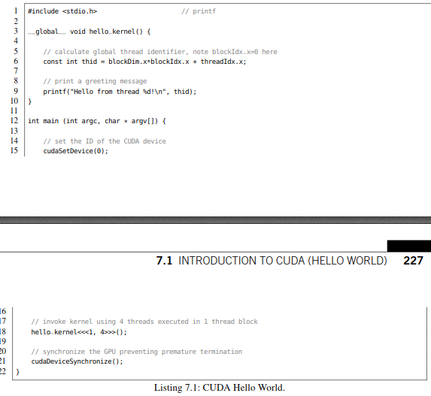

清单7.1：CUDA Hello World

Let us have a look at the mainfunction. The ﬁrst command cudaSetDeviceselects the used CUDA-

capable GPU. Usually, you will only have one GPU attached to your workstation and thus the identiﬁer can be safely set to 0. We will talk about the possibility to simultaneously utilize several GPUs later in this chapter. The second call hello_kernel«<1, 4»>() will invoke one block of four CUDA threads running in parallel on the GPU. Each thread is supposed to print a greeting message. For the moment, we ignore the implementation details of the kernel and proceed with the cudaDeviceSynchronize() call. Kernels on the GPU (device) and code on the CPU (host) are executed asynchronously. The ﬁnal synchronization forces the host to wait until the kernel on the device has ﬁnished its computation. This prevents an immediate termination of the whole program. Otherwise, the host-sided mainfunction will instantly return without printing the desired message when using no explicit or implicit synchronization mechanism.

让我们来看看它的主要功能。第一个命令udaSetDevice会选择可以使用的支持CUDA功能的GPU，通常一个工作站只会安装一个GPU，这样标识符可以被安全地设置为0。我们将在本章后面讨论同时使用多个GPU的可能性。第二个函数调用hello_kernel«<1, 4»>() 将会发起一个包含四个CUDA threads的一个Block。每个线程打印一个问候语。目前，我们忽略了内核的实现细节，继续进行cudaDeviceSynchronize()。因为GPU（设备）上的内核和CPU（主机）上的代码是异步执行的。最后的同步语句迫使主机等待直到设备上的内核完成计算，这可以防止整个程序立刻终止。否则，如果不使用显式或隐式同步机制，主机端main函数将立即返回，从而不会成功打印所期望的消息。

An obvious novelty in the signature of hello_kernel is the __global__ qualiﬁer right in front of the return value void indicating that this method is callable from the host but executed on the device. The CUDA programming language provides further qualiﬁers that can be used to specify the scope of execution and inlining behavior. The most important are the following:

• __global__: callable from host,2 executed on the device,

• __host__: callable from host, executed on the host,

• __device__: callable from device, executed on the device.

hello_kernel中最明显的新奇之处是返回值void前面的全局限定符__global__，该限定符指示此函数可从主机调用，但在设备上执行。CUDA编程语言还提供了一些限定符，可以用来明确函数执行的范围和内联行为，最重要的标识符有以下几种：

. __global__：主机端调用，设备上执行，  
. __host__：主机端调用，主机上执行，  
. __device__：设备端调用，设备上执行。

Note that __host__ is implicitly deﬁned for every host function and thus could be added in front of every traditional function which is executed on the CPU. The qualiﬁers __host__and __device__can be combined in order to force the compiler to generate binary code for both the CPU and GPU. Addi- tionally, the __noinline__ and __forceinline__ qualiﬁers can be used to control inlining behavior. More details can be found in the CUDA programming guide [4].

请注意，__host__它是为每个主机函数隐式定义的，因此可以在CPU上执行的每个传统函数前面添加此限定符。限定符__host__与__device__可以合并，强制编译器产生可以在CPU和GPU执行的二进制代码。另外，__noinline__和__forceinline__可以用于函数内联行为的控制。更多细节可以参考CUDA编程指南【4】。

As mentioned before, we invoke the kernel on the GPU using one CUDA thread block consist- ing of four CUDA threads. Further details on the speciﬁcation of blocks and threads are discussed in the next section. Up to now it is enough to know that we spawn one block with block identiﬁer blockIdx.x=0consisting of blockDim.x=4threads, each of them enumerated with a local thread iden- tiﬁer threadIdx.x ranging from 0 to 3 (inclusive). As a result, the expression in Line 6 evaluates to thid = 0*4 + threadIdx.x = threadIdx.x. Alternatively, we could have generated the same indices when spawning two blocks each executing two threads, or four blocks each executing one thread. As we will see later in Section 7.4, the particular distribution of threads can have a massive impact on the overall performance of our program. Finally, the global thread identiﬁer thidis printed via the printf command. The example code can be compiled with a call to

nvcc hello_world.cu -O2 -o hello_world

and executed like any other binary built with a host compiler obtaining the following output:

Hello from thread 0!

Hello from thread 1!

Hello from thread 2!

Hello from thread 3!

Note that the optimization ﬂag -O2 only affects the host part of the code and does not inﬂuence the performance of device functions. Let us brieﬂy discuss the output in the end. You might wonder why the messages are printed in order in contrast to typical multithreaded applications. This is because

the print statements are always serialized in batches of 32 consecutive threads within a thread block,

a so-called **warp** of threads. If the kernel invocation is modiﬁed to use 512 threads within one block, we will observe shufﬂed batches each consisting of 32 contiguous thread identiﬁers.

如前所述，我们使用由四个CUDA threads组成的一个CUDA thread Block来调用GPU上的内核。关于blocks 和 threads的更多细节将下一节中讨论。到目前为止，我们只需要知道我们生成了一个Block，即blockIdx.x=0，该Block包含4个thread即：blockDim.x=4, 它们都使用本地线程标识符threadIdx.x来枚举，范围从0到3。因此，第6行中的表达式计算结果为=0*4+threadIdx.x=threadIdx.x. 另外，当生成两个block,每个block包含2个thread，或生成4个block,每个block包含1个thread时，我们都可以生成相同的索引。正如我们将在第7.4节看到的，线程的特定分布会对程序的整体性能产生巨大的影响。最后，通过Printf命令打印全局线程标识符thid。示例代码可以通过nvcc hello-world.cu -02 -o hello-world 编译，像其他host编译器构建的二进制一样执行，获得以下输出：

hello from thread 0!

hello from thread 1!

hello from thread 2!

hello from thread 3!

注意，优化标志-02只影响host端的代码部分，不影响device 函数的性能。让我们简单地讨论一下终端的输出。可能疑惑，与传统的多线程应用程序相比，为什么打印的消息是顺序的。这是因为在一个thread Block中，连续的32 个线程为一组来同时执行，也就是所谓的Warp，所以这些打印语句被序列化了。如果内核调用被修改为在一个Block中包含512个thread，我们将会观察到32个连续线程标识符为一组的乱序输出。

**7.2 HARDWARE ARCHITECTURE OF CUDA-ENABLED GPUS**

Admittedly, the Hello World example is not very useful since the printing is serialized and we have no data to process. But before we start crunching numbers, we have to learn about the hardware layout of a typical CUDA-capable GPU and how the CUDA programming model maps onto its individual com- ponents. Although this section is a bit theoretical, we will beneﬁt from this knowledge by exploiting hardware-speciﬁc details that are not part of the CUDA programming language later on. Rephrasing it with the words of Jean-Jacques Rousseau: *Patience is bitter, but its fruit is sweet.*

**7.2 支持CUDA的GPU硬件结构**

无可否认，Hello world示例不是很有用，因为打印是序列化的，而且没有处理数据。但在我们开始计算数字之前，我们必须了解支持CUDA功能的典型GPU的硬件布局，以及CUDA编程模型如何映射到GPU的各个组件。这一节有点理论性，GPU的特定硬件细节不属于CUDA编程语言的一部分，但我们将从这些知识中获益。引用Jean-Jacques Rousseau的话：忍耐是痛苦的，但它的果实是甜蜜的。

**INTERCONNECTION BETWEEN HOST AND DEVICE**

Let us start with the obvious. CUDA-capable GPUs are attached to a server or workstation via dedicatedslots on the mainboard. At the time of writing, the majority of graphics cards are connected via the PCIe v3 bus providing up to 16 GB/s bandwidth (see Fig. 7.1). At ﬁrst sight this sounds reasonably fast but you will soon observe that this is often the main bottleneck of CUDA applications. Addressing this, NVIDIA has introduced NVLink, a novel bus providing up to 80 GB/s peak bandwidth [6], allowing for the efﬁcient communication between the host and the device or between multiple devices attached to the same compute node.

**主机与设备之间的互连**

让我们从显而易见的开始。支持CUDA的GPU通过主板上专用的插槽连接到服务器或工作站。在写作本书时，大多数显卡都是通过PCIe v3总线连接，该总线提供高达16GB/s的带宽（见图7.1）。乍一看，这带宽速度相当快，但很快就会发现该带宽常常是CUDA应用程序的主要瓶颈。针对这一点，NVIDIA推出了NVLink，它是一种可以提供高达80GB/s峰值带宽的新型总线[6]，提供host和device之间或同一个计算节点内多个设备之间的有效通信。

The memory of the host (RAM) and the video memory of the device (VRAM) are physically separated. As a result, we have to allocate memory on both platforms independently and afterwards manage memory transfers between them. It means that data which shall be processed on the GPU has to be explicitly transferred from the host to the device. The computed results residing in the VRAM of the GPU have to be copied back to the host in order to write them to disk. This implies that data allocated on the host cannot be directly accessed from the device and vice versa. The corresponding CUDA commands will be discussed in detail in Section 7.3.

主机（RAM）的内存和设备（VRAM）的视频内存是物理分离的。因此，我们必须在两个平台上独立分配内存，然后管理它们之间的内存传输。这意味着要在GPU上处理的数据必须显式地从主机传输到设备上。必须将驻留在GPU VRAM中的计算结果拷贝回主机，以便将其写入磁盘。也就是说， Device端不能直接访问在主机端分配的数据，反之亦然。相关的CUDA 命令细节将在7.3节讨论.

Note that NVIDIA provides powerful libraries bundled with CUDA, e.g. Thrust [7], which features device vectors that can be manipulated from the host. Nevertheless, you should be aware that these fancy abstraction layers may obscure suboptimal parts of your code. As an example, altering all entries of a Thrust device vector in a host-sided for-loop results in the excessive spamming of tiny memory transfers. A similar though less harsh statement can be made about NVIDIA’s uniﬁed memory layer that treats the address spaces of the RAM and VRAM as one. Consequently, we will pursue the tra- ditional distinction between both memory spaces. This transparent approach will help you to pinpoint performance bottlenecks of your applications without having to guess the internal details of uniﬁed memory addressing.

请注意，NVIDIA提供了与CUDA绑定的功能强大的类库, 例如：Thrust [7], 它支持可以从Host直接操作的设备端 vectors。尽管如此，我们应该注意到这些抽象层可能会使代码变得模糊。例如，在Host端for-loop中更改Thrust设备vector的所有入口条目会产生微小内存传输造成的过量垃圾信息。NVIDIA将RAM和VRAM的地址空间视为一体的统一内存层也可以造成类似的问题。因此，我们将继续研究这两个存储空间之间的传统区别。这种透明的方法将帮助您确定应用程序的性能瓶颈，同时又不必猜测统一内存寻址的内部细节

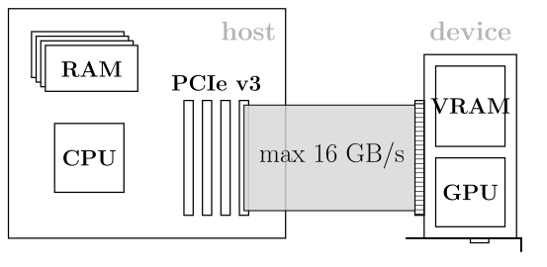

**图7.1**

Schematic overview of the processors (CPU and GPU) and memory components for host and device. Memory transfers are executed over the PCIe v3 bus providing up to 16 GB/s bandwidth. Conceptually, the host and the device can be treated as independent compute platforms which communicate over an interconnection network.

处理器（CPU和GPU）和主机和设备内存组件的示意图概述。通过PCIe v3总线，提供高达16GB/s带宽的内存传输。从概念上讲，主机和设备可以看作是通过互连网络进行通信的独立计算平台。

**VIDEO MEMORY AND PEAK BANDWIDTH**

Conceptually, the graphics card can be treated as an independent compute platform with its own com- pute unit and memory. In contrast to the memory attached to a typical mainboard (at the time of writing, DDR4 DRAM) the video memory of a graphics cards is signiﬁcantly faster. As an example, the Pascal-based Titan X features 12 GB of GDDR5X DRAM modules providing up to 480 GB/s bandwidth compared to the memory bandwidth of current Xeon workstations of less than 100 GB/s. Accelerator cards from the professional Tesla series such as the Tesla P100 or Tesla V100 feature even faster HBM2 stacked memory with up to 720 GB/s or 900 GB/s bandwidth, respectively.

**显存和峰值宽度**

从概念上讲，拥有自己的计算单元和内存的显卡可以被认为一个独立的计算平台。与一般主板上附加的内存（写这本书的时候，DDR4 DRAM）相比，显卡上显存的访问要快很多。例如，基于Pascal的Titan X具有12GB的GDDR 5X DRAM模块，提供高达480 GB/s的带宽，而当前Xeon工作站的内存带宽不足100 GB/s。专业级Tesla系列的加速卡如Tesla P100或Tesla V100，配备更快的HBM2堆叠式存储体，分别可提供高达720GB/s或900GB/s的带宽 。

Despite the fact that we can access the global memory with almost one TB/s, we still have to care about the underlying memory hierarchy. As an example, assume you want to increment single-precision ﬂoating point (FP32) values residing in VRAM (global memory). First, each of the 32-bit values is loaded into a register. Second, the register is incremented by one which accounts for a single ﬂoating point operation (Flop). Finally, the incremented value is written back to global memory. Fig. 7.2 visu- alizes the described scheme. This corresponds to a *compute-to-global-memory-access* (CGMA) ratio of 1 Flop/8 B (four bytes for reading and four bytes for writing after incrementation) resulting in an overall compute performance of 125 GFlop/s for a memory bandwidth of 1 TB/s. This is merely 1% of the 11 TFlop/s FP32 peak performance of a Tesla P100 card. Therefore proper memory access patterns and the efﬁcient use of fast caches will be one of our main concerns.

尽管访问全局内存的带宽可以达到1 TB/s，但我们仍然需要关心底层的内存层次结构。例如，假设要完成驻留在VRAM(全局内存)中的单精度浮点数(FP32)值加1 操作。首先，将每个32位值加载到寄存器中。其次，寄存器作加1操作，即一个浮点运算(FLOP)。最后，递增后的值被写回全局内存。图7.2对运算机制进行了图形化描述。所对应的计算访存比compute-to-global-memory-access为1 Flop/8 B（读取4字节，加1操作后写回4字节）。因此，在内存带宽为1 TB/s的情况下，总的计算性能为125 GFlop/s，这仅仅是Tesla P100加速卡11 TFlop/s FP32峰值性能的1%。因此，适当的内存访问模式和快速缓存的有效使用将是我们主要关注的问题之一。

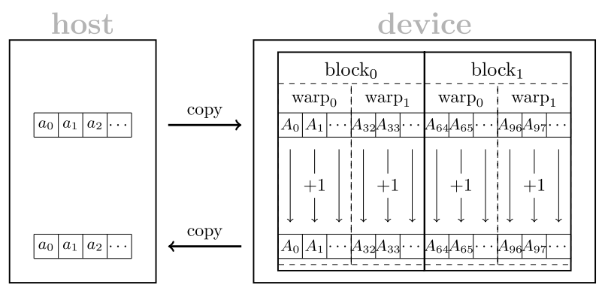

**图7.2**

Memory transfers and control ﬂow of a kernel that increments the entries of an array *a* = *(a*0*,a*1*,...)* stored on the host. First, the host array *a* is copied to the device array *A* of same size. Second, each warp of a thread block simultaneously increments 32 consecutive entries of the array *A*. Third, the incremented values residing in the device array *A* are copied back to the host array *a*.

内存传输和kernel控制流，该kernel完成对存储在host上的数组a=(a0,a1,……)的所有元素进行递增操作。首先，将主机数组a复制到相同大小的设备数组a中。其次，线程block中每个Warp同时对数组a中连续的32个元素进行递增操作。第三，将驻留在设备内存数组A中递增后的值复制回主机数组A

ORGANIZATION OF COMPUTATIONAL RESOURCES

The enormous compute capability of modern GPUs can be explained by the sheer number of processing units which usually exceeds a few thousand cores. In contrast to multi-core CPUs **with a few tens monolithic** processing units featuring complex instruction sets and control ﬂows, GPUs can be treated as a huge array of lightweight processing units with limited instruction set and constrained control ﬂow. The hardware layout of a modern GPU is organized in a hierarchical tree.

**计算资源的组织**

现代GPU巨大的计算能力可以用处理单元的绝对数量来解释，这些处理单元通常超过几千个内核。拥有几十个单片处理单元的多核cpu，通常具有复杂的指令集和控制流程，而GPU可以被看作是一个巨大的轻量级处理单元数组，每个处理单元支持的指令集和控制流都非常有限。现代GPU的硬件布局通常采用层次树的形式来组织。

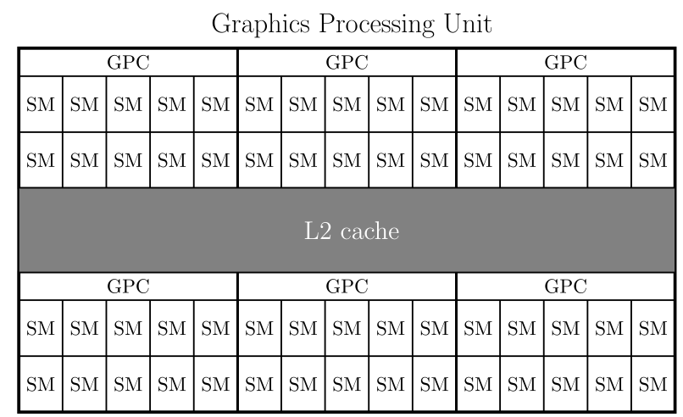

**图7.3**

Schematic layout of the GP102 GPU built in the Tesla P40 card. The GPU is partitioned into six Graphics Processing Clusters (GPCs) each providing ten Streaming Multiprocessors (SMs). Each of the 60 SMs share the same L2 cache and global memory. Consumer GPUs such as the Pascal based GeForce GTX 1080 or Titan X have similar layouts with a smaller number of GPCs or SMs (see Table 7.1).

Tesla P40内置的GP102 GPU示意图。GPU被划分成六个图形处理集群(GPCs)，每个集群提供十个流式多处理器（SMS）。这60个SMs共享相同的L2缓存和全局内存。消费级GPU，如基于Pascal的GeForce GTX 1080或Titan X，具有类似的层次组织但较少的GPCs或SMs（见表7.1）

|  |  |  |  |  |  |
| --- | --- | --- | --- | --- | --- |
| **Table 7.1 Technical speciﬁcation of high-end single GPU video cards across generations. Dual GPUs like the Titan Z, Tesla K80, or Tesla M60 are omitted since they are basically stacked versions of their single GPU counterparts. Tesla cards from the Kepler and Maxwell generation are equipped with slower error- correcting (ECC) RAM. The Pascal-based Tesla P100 and Volta-based Tesla V100 provide signiﬁcantly faster HBM2 stacked memory. Note that the number of cores and VRAM size are slightly increasing over time.**  表7.1跨代高端单GPU显卡技术规范。像Titan Z、Tesla K80或Tesla M60这样的双GPU被省略了，因为它们基本上是它们的单GPU版本的叠加版本。从开普勒和麦克斯韦的特斯拉显卡配备了较慢的纠错(ECC) RAM。基于 Pascal的Tesla P100和基于 Volta 的Tesla V100，配备更快的HBM2堆叠式内存。核心数量和VRAM大小会随着时间的推移而略有增加。 | | | | | |
| **Video card 显卡** | **Generation 代** | **GPCs** | **SMs** | **FP32/GPU** | **VRAM@Bandwidth** |
| Titan (Black) |  |  |  |  |  |
| Tesla K40 |  |  |  |  |  |
| Titan X |  |  |  |  |  |
| Tesla M40 |  |  |  |  |  |
| GTX 1080 |  |  |  |  |  |
| Titan X |  |  |  |  |  |
| Tesla P40 |  |  |  |  |  |
| Tesla P100 |  |  |  |  |  |
| Tesla V100 |  |  |  |  |  |

|  |  |  |  |  |  |
| --- | --- | --- | --- | --- | --- |
| **Table 7.2 Technical speciﬁcation of GPU architectures across four generations. The number of SMs per GPC increases while the amount of cores per SM decreases over time. Thus a core on a Pascal/Volta SM can use more registers than on SMs from previous generations. Further, note the relatively small FP64/FP32 ratio of the Maxwell architecture.**  表7.2跨越四代的GPU架构技术规范。随着时间的推移，每个GPC的SMs数量在增加，而每个SM的内核数量在减少。因此，与上一代相比，Pascal/Volta SM上的core可以使用更多的寄存器。此外，请注意Maxwell体系结构具有相对较小的FP64/FP32比率。 | | | | | |
| **Generation** | **SM/GPC** | **FP32/SM** | **FP64/SM** | **FP64/FP32** | **Registers/SM** |
| Kepler |  |  |  |  |  |
| Maxwell |  |  |  |  |  |
| Pascal |  |  |  |  |  |
| Volta |  |  |  |  |  |

**Mapping Thread Blocks Onto SMs**

The ﬁrst level consists of a small number (see Table 7.1) of Graphics Processing Clusters (GPCs) each of them containing roughly ten (see Table 7.2) Streaming Multiprocessors (SMs) as shown in Fig. 7.3. The GPCs are a rather hardware-speciﬁc detail that have no correspondence in the CUDA programming model. However, the SMs in the second level loosely map onto the aforementioned CUDA thread blocks. One or more thread blocks can be simultaneously executed on a single SM. The speciﬁc number is dependent on the ratio of required and available hardware resources as shown in Section 7.4. Note that the runtime environment does not provide any information about a speciﬁc order of execution, i.e., we can neither inﬂuence nor deduce the planning scheme of the block scheduler. As a result, the parts of our program that are executed on different blocks should be truly data independent.

线程块到SMs的映射

第一层由少量图形处理集群(GPCs)组成(见表7.1)，每个集群包含大约10个(见表7.2)流式多处理器(SMs)，如图7.3所示。GPCs是一个相当具体的硬件细节，在CUDA编程模型中没有与此对应的关系。但是，第二层中的SMs松散地映射到前面提到的CUDA线程块。一个或多个线程块可以同时在一个SM上执行。如图7.4所示，具体数量取决于所需要的和可用硬件资源的比例。请注意，运行时环境不提供关于特定执行顺序的任何信息，即，我们既不能影响也不能推出block调度的规划方案。因此，在不同块上执行的程序是真正数据独立的。

Within the CUDA programming model the block identiﬁers can be deﬁned using 1D, 2D, and 3D grids. This allows for a convenient indexing when accessing data on multidimensional domains. As an example, when processing distinct parts of an image one could assign a block with coordinates (blockIdx.x, blockIdx.y)to each tile. The grid dimension can be deﬁned as an integer for 1D grids or as a dim3struct for the general case. They can be accessed within a kernel via gridDim.x, gridDim.y, and gridDim.z. Our Hello World example from the previous section utilized a 1D grid with either one, two, or four blocks. We demonstrate the invocation of a 3D grid consisting of 3D blocks in Listing 7.2.

在CUDA编程模型中，可以使用1D、2D和3D网格定义块标识符。这使得在访问多维域上的数据时可以方便地建立索引。例如，在处理图像的不同部分时，对每一个tile，可以分配一个包含坐标(blockIdx.x, blockIdx.y)的Block。网格维度可以定义为一维网格的整数或者通常情况的三维结构。它们可以通过gridDim x,gridDim。y,gridDim.z在内核中访问。上一节中的Hello World示例就使用了一个、两个或四个块的1D网格。Listing 7.2展示了由3D Block组成的3D grid的使用。

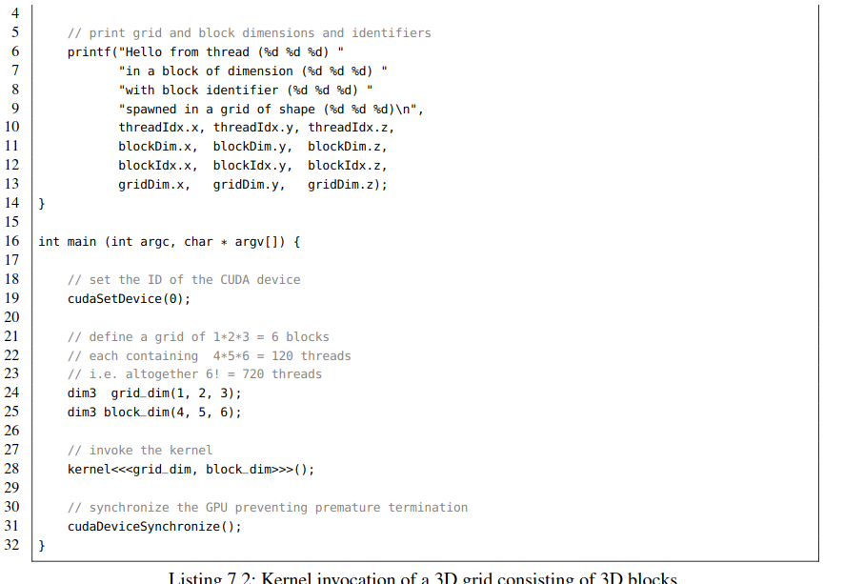

|  |
| --- |
| 1 #include <stdio.h> // printf  2  3 __global__ void kernel() { |

Listing 7.2: Kernel invocation of a 3D grid consisting of 3D blocks.

列表7.2：由3D Block组成的3D Grid的内核调用

Before we proceed with the internal components of an SM we have to make an important remark: different CUDA thread blocks of the same kernel cannot be synchronized during the execution of a kernel since there exists no device-wide barrier up to CUDA version 8 which could be called from within a kernel. Note that CUDA 9 introduces the concept of cooperative groups that provide device- sided multi-grid synchronization calls. However, CUDA 9 is not released at the time of writing this book and thus we stick to the traditional approach: inter-block dependencies have to be realized by stacking several kernels on the host enforcing a barrier between individual kernel invocations. This architectural decision made by NVIDIA has several motivations. First, the hardware layouts of low-end and high-end GPUs mainly differ in the number of provided SMs. Thus an elaborate programming model should scale transparently over an arbitrary number of blocks. Second, synchronization is ex- pensive especially when enforcing a global barrier where all SMs have to wait for the last block to ﬁnish. This observation can be summarized in a statement that *synchronization does not scale*.3 As a consequence, we are forced to refactor or even redesign code that relies excessively on global barriers or mutexes.

在我们继续讨论SM的内部组件之前，我们必须注意: 同一内核的不同CUDA线程块不能在内核执行期间同步, 因为在CUDA版本8之前不存在device范围内，且可在内核中调用的barrier。 注意，CUDA 9引入了提供设备端多网格同步调用的协作组的概念。然而，在写这本书的时候CUDA 9还没有发布，所以我们坚持传统的方法: 块间依赖关系必须通过在主机上叠加几个内核来实现，在各个内核调用之间设置一个屏障。NVIDIA设计这种架构主要有几个原因。第一，低端gpu和高端gpu的硬件布局主要区别在于SMs的数量。因此，一个精心设计的编程模型应该透明地扩展任意数量的Block。其次，同步是有代价的，特别是当强制设置一个全局屏障时，所有的SMs都必须等待最后一个块完成。这一观察结果可以总结为一句: *synchronization does not scale*.3 ( 半自动并行化框架OpenACC遵循同样的原则[14]。) 因此，我们被迫重构甚至重新设计过度依赖全局barrier 或 mutex的代码。

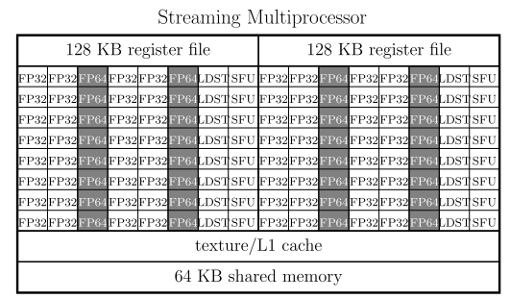

**图7.4**

Schematic layout of a Streaming Multiprocessor (SM) used in the Pascal generation. An SM provides two blocks each consisting of 32 single-precision compute units (FP32), 16 double-precision compute units (FP64), 8 load and store units (LDST), and 8 special function units (SFU). Each of the two blocks can access 32,768 32-bit registers resulting in an overall size of 256 KB for the storage of variables. L1 cache and 64 KB shared memory are shared among all units in the SM.

Pascal一代，流多处理器(SM)布局示意图。SM包含两个Block，每个块由32个单精度计算单元(FP32)，16个双精度计算单元(FP64)，8个加载和存储单元(LDST)和8个特殊功能单元组成。这两个块中的每一个都可以访问32,768个32位寄存器，从而寄存器变量总大小为256 KB，用于存储变量。在SM中的所有单元之间共享L1缓存和64KB共享内存。

**Mapping Threads Into Warps**

Each SM is composed of multiple compute and instruction units as shown in Fig. 7.4. The Pascal generation features 64 single-precision (FP32), 32 double-precision (FP64) compute units, 16 load and store units (LDST), and 16 special function units (SFU) per SM. The number and ratio of FP32 and FP64 units depend on the GPU generation. Therefore, FP64 performance cannot be directly inferred from the number of FP32 units. As an example, the Maxwell generation provided a FP64 to FP32 ratio of merely 1/32 in contrast to the reasonably higher fractions of the Kepler (1/3), Pascal (1/2), and Volta (1/2) generations.

**线程到Warp 的映射**

如图7.4所示，每个SM由多个计算和指令单元组成。Pascal一代的每个SM具有64个单精度计算单元（FP32），32个双精度（FP64）计算单元，16个负载和存储单元（LDST），16个特殊函数单元（SFU）组成。FP32和FP64单元的数量和比例取决于某一代GPU。因此，FP64的性能不能直接从FP32单元的数量来推断。例如，麦克斯韦一代提供的FP64到FP32单元的比值仅为1/32，而开普勒(1/3)、帕斯卡(1/2)和Volta (1/2)这一比值要高得多。

Up to CUDA 8, a warp consisting of 32 contiguous CUDA threads is processed simultaneously on an SM in lock-step manner. Thus all 32 compute units have to perform the same operation at the same time similar to the Single Instruction Multiple Data (SIMD) paradigm. In contrast to traditional SIMD architectures, the compute units may access non-contiguous memory or mask instructions allowing for the branching of control ﬂow. The latter is called **branch divergence** and should be avoided since the hardware executes the branches one by another. This slightly more ﬂexible computation model was coined by NVIDIA as Single Instruction Multiple Thread (SIMT). Strictly speaking one can state that SIMD is a subset of the SIMT model. In this context, a warp can be considered as SIMD vector unit with 32 SIMD lanes. Thus we can easily express SIMD algorithms in terms of the CUDA programming language. Note that CUDA 9 shifts the traditional paradigm of warp-centered programming to cooperative groups which are a generalization of the warp concept. As a consequence, warps in CUDA 9 might not be executed in lock-step anymore having severe implications for implicit synchronization. At the time of writing (Summer 2017), we cannot predict the impact of cooperative groups on future code development. However, be aware of this major paradigm shift since it might become a game changer.

直至CUDA 8，由32个连续CUDA线程组成的Warp在SM上以锁步方式同步进行处理。因此，所有32个计算单元必须在同一时间执行类似于单指令多数据(SIMD)范式的相同操作。与传统SIMD架构相比，计算单元可以完成非连续访存或掩码指令，用于完成控制流的分支。后者称为分支分化，要避免分支分化，因为硬件一个接一个地执行分支。这个稍微灵活一些的计算模型是由NVIDIA创建的，称为单指令多线程(Single - Instruction multi - Thread, SIMT)。严格地说，SIMD是SIMT模型的子集。在这种情况下，Warp可以被认为是包含32个SIMD 通道的SIMD矢量单位。因此，我们可以很容易地用CUDA程序语言来表达SIMD算法。请注意，CUDA 9将传统的以Warp为中心的编程范式转换为合作组的形式，它是对warp概念的推广的。在撰写本文时(2017年夏季)，我们无法预测合作组对未来代码开发的影响。但是，请注意这一重大范式转换，因为它可能会改变游戏规则

The two register ﬁles of a Pascal SM can store up to 65,536 32-bit variables. This rather high number of 1024 registers per compute unit is crucial for an efﬁcient scheduling of lightweight threads. If a warp runs out of work, e.g, when waiting for data, the scheduler can switch to another warp without dumping or loading the corresponding registers. Consequently, the number of maintained threads may easily exceed the amount of available compute units. Rapid switching (warp streaming) can be used to effectively hide the latency of global memory behind computation. Similarly to the scheduling of blocks, we have no control over the execution order of warps. However, you can rely on two properties up to CUDA version 8. First, all threads within a warp are executed simultaneously. Second, all warps and thus all blocks have ﬁnished their computation after termination of the kernel. Only the latter is true for CUDA 9.

每个Pascal SM的两个寄存器文件最多可以存储65,536个32位变量,对于轻量级线程的高效调度来说，每个计算单元1024个寄存器的数量非常高。如果某个warp不再处于执行状态，比如，在等待数据，调度器可以切换到另一个warp，而无需转储或加载相应的寄存器。因此，维护线程的数量很容易超过可用计算单元的数量。快速切换(warp流)可以有效地隐藏计算之后的全局内存访问延迟。与块的调度类似，我们无法控制Warp的执行顺序。但是，在CUDA 8之前，可以依赖两个属性，第一，所有线程都是同时执行的。其次，在kernel终止之后，所有的warp和于此对应的Block都完成了它们的计算，只有后者适用于CUDA 9。

The units of an SM can access up to 64 KB of fast on-chip memory for inter-thread communication and caching. Concluding, a modern CUDA-enabled GPU consists of a few thousand cores (see Table 7.1) which can execute tens of thousands of threads. Hence, parallelism has to be organized on a ﬁne-grained scale compared to coarse-grained parallelization schemes on multi-core architectures. Besides the aspect of massively parallel computation, we have to take care of the additional constraints imposed by the SIMT computation model in order to efﬁciently utilize modern GPUs.

SM的所有计算单元可以访问64 KB的快速片上内存，用于线程间通信和缓存。一个支持CUDA的现代GPU由数千个内核组成（见表7.1）， 可以执行数万个线程，因此，与多核架构上的粗粒度并行化方案相比，并行性必须在细粒度级别上进行组织。除了大规模并行计算因素之外，为了有效地利用现代GPU，我们还必须考虑SIMT计算模型带来的附加约束。

**7.3 MEMORY ACCESS PATTERNS (EIGENFACES)**

After having revisited the hardware architecture of a typical CUDA-capable GPU, we can now start to write some more useful code. Our task is the CUDA implementation of **Principal Component Analysis (PCA)**, a frequently used dimensional reduction technique in the ﬁeld of machine learning. The applications of PCA are manifold and range from lossy audio/video compression in signal processing over the computation of intrinsic coordinate systems of rigid bodies in physics to the determination of latent variables in data mining. Throughout this section we process the *CelebA* dataset [16] consisting of 202,599 aligned celebrity faces (see Fig. 7.5). In particular, we compute numerous quantities such as the mean celebrity face, the centered data matrix, the corresponding covariance matrix, and an eigenvector basis which can be used for lossy image compression.

From a programming point of view you will learn how to transfer data between host and device, the proper addressing of global memory using coalesced access patterns and the manual caching of redundant data in shared memory. After having ﬁnished this section, you will be able to write basic CUDA programs concurrently processing gigabytes of data. Furthermore, we will discuss when a CUDA parallelization of your program is beneﬁcial in terms of runtime but also cases where a multithreaded CPU implementation might be the better choice.

7.3**内存访问模式(**特征脸**)**

在对支持CUDA功能的典型GPU的硬件架构回顾之后，现在我们可以开始编写一些更有用的代码。我们的任务是用CUDA实现主成分分析（PCA），PCA是一种在机器学习领域经常使用的降维技术。其应用广泛，从信号处理中的有损音频/视频压缩，物理学中刚体固有坐标系的计算，到数据挖掘中潜在变量的确定。在这一节中，我们将处理包含202599张明星脸部图片的 CelebA数据集【16】， (见图 7.5)。特别是，通过计算我们得到了许多（量），比如名人图片的均值，中心化的Data Matrix，对应的协方差矩阵，和一种可用于有损图像压缩的特征向量基。

从编程的角度，将学习到如何在主机和设备之间传输数据，如何使用合并访存模式完成全局内存寻址，如何手动缓存共享内存数据。在完成这些以后，就能够编写可以并发处理GB级数据的基本CUDA程序了。此外，考虑运行时和多线程CPU实现可能是更好选择的情况下，我们还将讨论什么时候程序的CUDA并行化才是有益的。

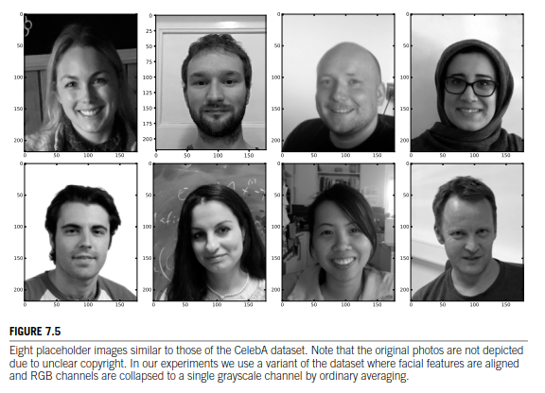

图像7.5八个占位符图像与CelebA数据集的图像类似。 请注意，由于版权不明确，原始照片未被描绘。 在我们的实验中，我们使用数据集的变体，其中面部特征被对齐，并且RGB通道通过普通平均折叠成单个灰度通道。

**COMPUTATION OF THE MEAN CELEBRITY FACE**

The 202,599 images of the CelebA dataset are stored as RGB-valued matrices of shape 178 × 218. For the sake of simplicity we have collapsed the three color channels to grayscale by computing the pixel-wise mean of the red, green, and blue intensities. Furthermore, the images have been down sampled by a factor of roughly four in a preprocessing phase. The resulting images still need more than one gigabyte of memory since *(*45 × 55*)* × sizeof(float)× 202*,*599 *>* 1*.*8 GB. Nevertheless, the algorithms and source code that we discuss perfectly work on the original resolution too (e.g. when utilizing a GPU with 32 GB of VRAM). Moreover, an extension to color images is straightforward by treating the pixels in each color channel independently.

In the following, we interpret each image as a ﬂattened vector *v(i)* ∈ R*n* where the *n* = 45 · 55 = 2475 pixels are indexed in row-major order. Loosely speaking, we forget the shape of the matrix and consecutively map each pixel onto a slot of the vector. Afterwards, the *m* = 202,599 vectors *v(i)* are stored in the rows of a data matrix *D* = *v(*0*),v(*1*),...,v(m*−1*)* ∈ R*m*×*n* such that *Dij* = *vj(i)* denotes the *j*-th dimension (pixel) of the *i*-th vector (image). We subsequently determine the mean image *μ* by computing the normalized pixel-wise sum of intensity values over all images:

包含202599张图像的CelebA数据集， 存储格式为RGB值矩阵，尺寸为178×218。为了简单起见，通过计算红、绿、蓝通道的像素平均值，我们将RGB三通道分解成灰度图。133 811 86383此外，在预处理阶段，图像的下采样率约为4。处理后的结果图像仍然需要超过1G 比特的内存，（ 45 × 55）× sizeof(float)× 202*,*599 *>* 1*.*8 GB。不过，我们讨论的算法和源代码也能很好地处理原始分辨率（比如，使用配有32GB显存的GPU）。此外，直接独立处理每个颜色通道中的像素也是彩色图像的一种扩展。

接下来，我们把每幅图像解释成一个平坦的向量，*v(i)* ∈ R*n* ，*n* = 45 · 55 = 2475，2475个像素以行主序建立索引。大致来说，我们忽略矩阵的形状，并连续地将每个像素映射到向量上。然后，*m* = 202,599 向量，存储在数据矩阵D的行中，*D* = *v(*0*),v(*1*),...,v(m*−1*)* ∈ R*m*×*n，*例如， *Dij* = *vj(i)* 为第i个向量（图像）的第j维（像素）。通过计算所有图像强度值的归一化像素和，最终确定图像均值*μ*

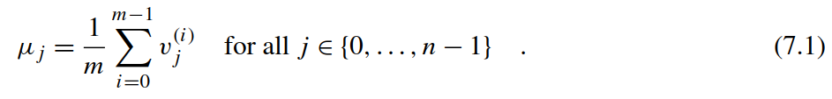

The resulting mean vector *μ* is shown in Fig. 7.6. Note that this one-dimensional representation of higher-dimensional data generalizes to any dataset consisting of *m* ﬁxed length vectors in R*n*. However, the slots of the vectors *v(i)* should be loosely correlated in order to gain meaningful results. Thus you cannot expect this approach to work well on unaligned data without using an approximate alignment of facial features or employing translation-invariant representations. Unaligned data could be tackled with convolutional neural networks [20] or image registration techniques [10].

得到的均值向量μ见图7.6. 这种高维数据的一维表示可以推广到由m个固定长度向量组成的任何数据集，然而，为了得到有意义的结果，向量v(i)的槽应该是松散相关的。因此，如果不使用面部特征的近似对齐或使用平移不变表示，就不能期望这种方法能够很好地处理未对齐数据。可以使用卷积神经网络[20]或图像配准技术[10]来解决未对齐的数据。

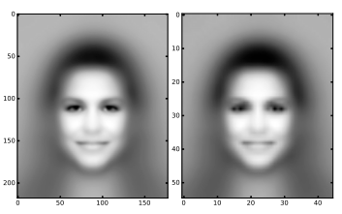

**FIGURE 7.6**

The mean celebrity face of the CelebA dataset in the original resolution (left panel: 178 × 218 pixels) and its downsampled variant (right panel: 45 × 55 pixels).

图7.6 CelebA 数据集中明星脸的均值 （左图：178 × 218像素) 和下采样后（右图：45 × 55 像素）

Let us start coding. Initially, we include some useful headers which are distributed with this book (see Listing 7.3). The hpc_helper.hpp ﬁle contains convenient macros for measuring execution times (TIMERSTART(label) and TIMERSTOP(label)) and for reporting errors (CUERR). Error checking is important since CUDA tends to fail silently after incorrect memory accesses or unsuccessful memory allocations while the host code continues its work. Thus you will observe the frequent use of the CUERR macro in our code. The remaining two headers provide functions for the loading of binary ﬁles and the writing of images in Microsoft bitmap format. Subsequently, we deﬁne a template kernel for the mean computation which can be specialized with custom data types for the indexing (usually uint32_t or uint64_t) and representation of ﬂoating point values (usually float or double). The device pointers Data and Mean are used to address the data matrix and mean vector. The integers num_entries and num_features correspond to the number of images (*m*) and number of features/dimensions (*n*).

让我们开始编码，我们提供了一些与本书一起分发的有用头文件（见列表7.3），文件hpc_helper.hpp包含用于方便测量执行时间 (TIMERSTART(label) 和TIMERSTOP(label)) 和报告错误的宏。错误检查很重要，因为在主机代码继续工作时，在不正确的内存访问或内存分配不成功后，CUDA往往会无声地退出执行而主机端代码还会继续执行。因此，将在我们的代码中观察到UERR宏的频繁使用。其余两个头文件分别是提供加载二进制和以微软位图格式写回图像，随后，我们为均值计算定义了一个模板内核，它可以专门用于索引的自定义数据类型(通常是uint32_t或uint64_t)和浮点值的表示(通常是float或double)。设备指针Data和Mean分别指向数据矩阵和均值向量。整数num_entries和num_features对应于图像的数量（m）和特征/维度的数量（n）。

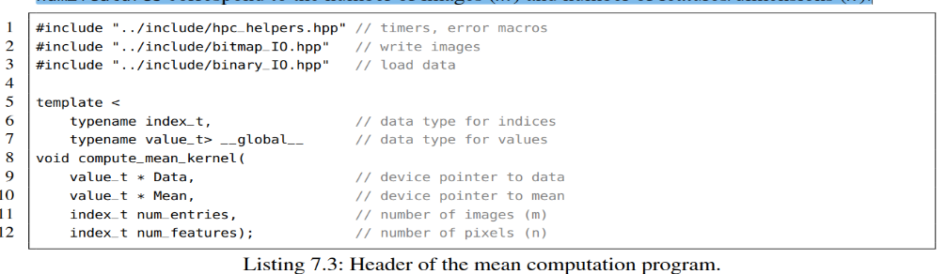

Listing 7.3: Header of the mean computation program.

列表 7.3: 计算均值头文件.

Let us proceed with the main function in Listing 7.4. From Lines 15 to 19, we select the CUDA device and subsequently deﬁne three constants specifying the number of images (imgs) and their correspond- ing shape (rows and cols). Next, we allocate the memory for the data matrix and the mean vector on both the CPU and the GPU using the dedicated commands cudaMallocHost and cudaMalloc, respectively. Both functions take as ﬁrst argument the address of a pointer storing the memory location after allocation. Consequently, the argument is a pointer of a pointer in order to allow cudaMallocHost and cudaMalloc to alter the address from nullptr to the corresponding value. The second argument is the number of accessible bytes from that position. The return value denotes whether the allocation was successful and will be handled by the CUERR macro. While host-sided memory could also be allocated with alternative commands, e.g., by a call to malloc or new, we are limited to cudaMalloc when explicitly reserving memory on a speciﬁc device. Note that throughout this chapter we use capitalized variable names for device-sided pointers and lower case letters for the host. Another popular convention, though not used in this book, appends _h (host) and _d (device) sufﬁxes to variable names to visually distinguish between address spaces.

让我们继续讨论列表7.4main函数，从第15行到第19行，我们选择CUDA设备，然后定义三个常量，指定图像的数量（imgs）及其相应的形状(rows and cols).接着，我们使用专用命令cudaMallocHost 和 cudaMalloc 分别为CPU和GPU分配数据矩阵和均值向量的内存。两个函数都将第一个参数作为分配后存储内存位置的指针的地址。因此，参数是指针的指针，以便允许cudaMallocHost和cudaMalloc将地址从nullptr更改为相应的值。第二个参数是从该位置开始要访问的字节数。 返回值表示分配是否成功并将由CUERR宏处理。虽然主机端内存也可以使用替代命令进行分配，例如，通过调用malloc或new 。但当在特定设备上预留内存时，我们仅限于cudaMalloc。请注意，在本章中，我们使用对设备端指针使用大写的变量名 和对主机端指针使用小写的变量。 虽然没有在本书中使用的另一个约定，但它将_h（主机）和_d（设备）后缀附加到变量名称，以便在视觉上区分地址空间。

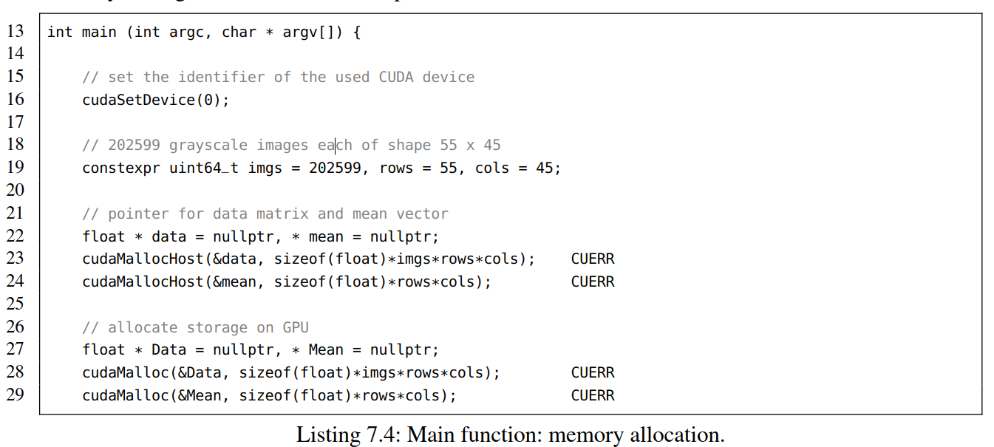

Listing 7.4: Main function: memory allocation.

清单7.4：main函数：内存分配

We proceed with the loading of the matrix *D* from disk to the data array on the host using the load_binary()method from the provided binary_IO.hppheader ﬁle. The TIMERSTARTand TIMERSTOP macros determine the execution time. At this point you would manually ﬁll the array using row-major order addressing when processing your own data.

我们继续使用binary_IO.hppheader文件提供的load_binary（）方法将矩阵D从磁盘加载到主机上的data数组。用TIMERSTART和TIMERSTOP宏来测量执行的时间。 此时，您将在处理自己的数据时使用行主顺序寻址手动填充数组。

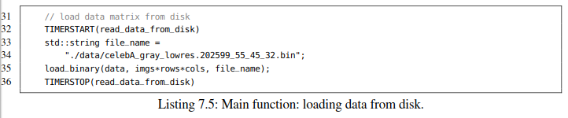

Listing 7.5: Main function: loading data from disk.

清单7.5：主要功能：从磁盘加载数据。

As mentioned before, data that shall be processed on the GPU has to be explicitly transferred from the host to the device. The copying can be achieved with a call to cudaMemcpy as shown in Line 39 of Listing 7.6. The command follows the semantics of the traditional memcpy call, i.e., the ﬁrst argument corresponds to the target address and the second to the source pointer. The third argument denotes the number of transferred bytes and the fourth argument speciﬁes the involved platforms. The rather unhandy constants cudaMemcpyHostToDevice and cudaMemcpyDeviceToHost are used to distinguish between copying from host to device and from device to host. Note that these expressions could be signiﬁcantly shortened by deﬁning custom variables or macros in order to reduce redundant typing of boilerplate. As an example, the hpc_helpers.hppheader ﬁle contains the following two lines:

如前所述，在GPU上处理的数据必须明确地从主机传输到设备。 可以通过调用cudaMemcpy来实现复制，如清单7.6中的第39行所示。 该命令遵循传统memcpy调用的语义，即第一个参数对应于目标地址，第二个参数对应于源指针。 第三个参数表示传输的字节数，第四个参数表示涉及的平台。不可以改变的常量cudaMemcpyHostToDevice 和cudaMemcpyDeviceToHost用于区分从主机到设备的复制以及从设备到主机的复制。 请注意，通过定义自定义变量或宏可以显着缩短这些表达式，以减少样板的冗余类型。 例如，hpc_helpers.hppheader文件包含以下两行：

#define H2D (cudaMemcpyHostToDevice)

#define D2H (cudaMemcpyDeviceToHost)

The call to cudaMemset in Line 41 overwrites the device vector Meanwith zeros. This is a safety mechanism to avoid the following pitfall that we have frequently observed during programming practicals. Assume you have a working CUDA program but neglect return value checking despite the repetitive warnings of your tutor. Moreover, assume you have introduced a bug in the next version which instantly causes your kernel to fail silently. It is highly probable (almost guaranteed) that the subsequent cudaMemcpy of the result vector (in our case Mean) from the device to the host will transfer the old (correct) data from the previous run still residing in global memory. What could be worse than a defective program that passes unit tests until reboot? Concluding, resetting of results and error checking is mandatory.

第41行中对cudaMemset的调用，用零覆盖设备向量Mean。这是一种安全机制，可以避免我们在编程实践中经常发现的以下陷阱。假设您有一个有效的CUDA程序，尽管您的导师重复警告，但还是忽略了返回值检查。 此外，假设在下一个版本中引入了一个错误，该错误会立即导致内核无声地失败。很可能（几乎可以肯定）从设备到主机的结果向量（在我们的例子中是平均值）的后续cudaMemcpy将传输仍然驻留在全局存储器中的先前运行的旧（正确）数据。 还有什么比有缺陷的程序更糟糕的呢？ 总之，重置结果和错误检查是强制性的。

After having copied the matrix *D* to the device we invoke the kernel in Line 46. Referring to Eq. (7.1), parallelization over *j* (the pixel indices) is advisable since each of the *n* = 55 · 45 = 2475 sums can be evaluated independently.4 When utilizing 32 CUDA threads per thread block we have to invoke at least ⌊*n/*32⌋ many blocks. If the remainder *n*% 32 is different from zero, i.e., *n* is not a multiple of the block size, we have to spawn an additional block to process the few remaining pixels. The described scheme can be summarized in a closed expression for safe integer division:

我们在第46行调用内核，将矩阵D复制到设备后。参考公式7.2， 在 j 上并行化（像素的索引）是可取的，因为每个n = 55·45 = 2475求和可以独立计算.4。当每个线程块使用32个CUDA线程时，我们必须调用至少⌊n/32⌋多个block。如果余数n％32不为零, 即，n不是Block大小的倍数, 我们必须生成一个额外的块来处理剩下的几个像素。所描述的方案可以用闭合表达式来概括以进行安全整数除法：



The SDIV macro is deﬁned in the hpc_helper.hpp header ﬁle. After termination of the kernel the result is copied back to the host (see Line 52) using cudaMemcpy.

SDIV宏在hpc_helper.hppheader文件中定义。 内核终止后，使用cudaMemcpy将结果复制回主机（参见第52行）。

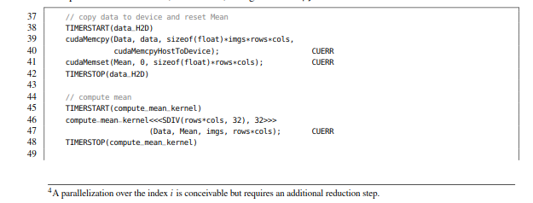

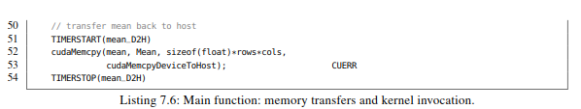

Listing 7.6: Main function: memory transfers and kernel invocation

主函数：内存传输和内核调用

The remaining part of the mainfunction in Listing 7.7 is straightforward. The mean image is written to disk using dump_bitmapfrom the bitmap_IO.hppheader ﬁle. Moreover, allocated memory is explicitly freed using cudaFreeHost for the host and cudaFree for the device in order to prevent memory leaks.

清单7.7中的main函数的其余部分很简单。 使用bitmap_IO.hp头文件中的dump_bitmap将均值图像写入磁盘。 此外，使用cudaFreeHost和cudaFree分别为主机和设备显式释放已分配的内存，以防止内存泄漏。

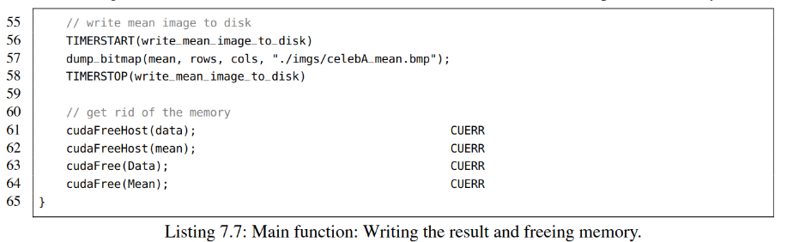

Listing 7.7: Main function: Writing the result and freeing memory.

清单7.7: Main函数：写回结果和释放内存。

Finally, we discuss the compute_mean_kernel implementation in Listing 7.8. First, the global thread identiﬁer is calculated in Line 76 analogically to the Hello World kernel from the introductory section. Second, the range of the thread identiﬁer is checked in Line 79 to avoid potential memory access violations when num_features is not a multiple of blockDim.x. Third, each thread sums up a column of the Data matrix in a dedicated register accum. Optionally, you can tweak this in Line 86 by giving the compiler a hint to unroll the for-loop in batches of size 32. Finally, we normalize the calculated sum and write it to the Mean array.

最后，我们讨论代码清单7.8中的compute_mean_kernel实现。首先，类似于介绍部分中的Hello World内核，76行用来计算全局线程标识符。其次，第79行检查线程标识符的范围，以避免num_features不是blockDim.x的倍数时发生潜在的内存访问冲突。第三，每个线程在专用寄存器accum中累加数据矩阵的列。或者可以选择在第86行中对此进行调整，方法是给编译器提供一个指导语句，以批量32的大小进行for循环展开。最后，我们将计算的和规范化，并将其写入平均数组。

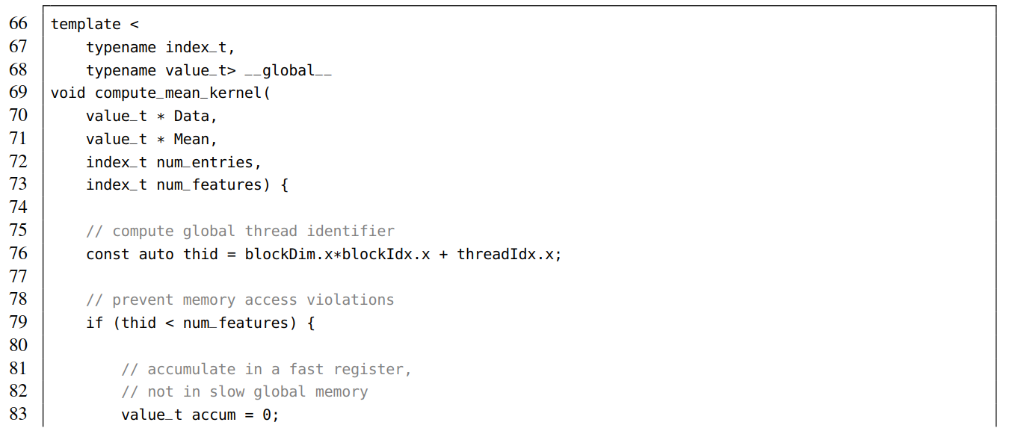

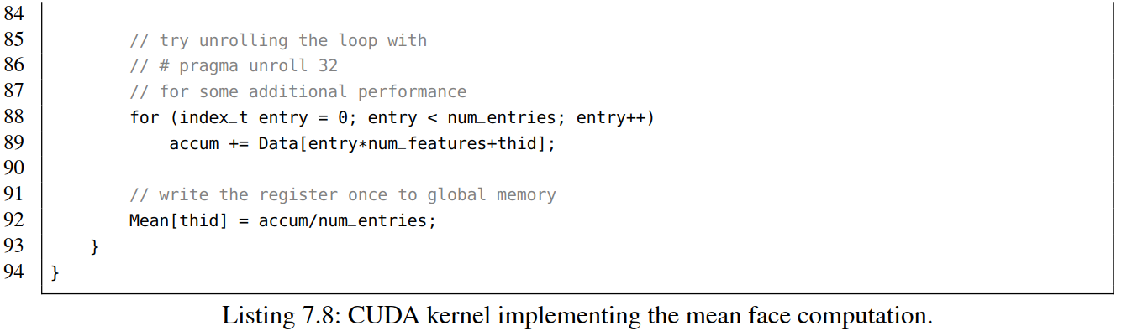

Listing 7.8: CUDA kernel implementing the mean face computation.

清单7.8:CUDA内核实现了平均人脸计算。

The code can be compiled with the following command:可使用以下命令来编译代码

nvcc -O2 -std=c++11 -arch=sm_61 -o mean_computation

We need to set the -std=c++11ﬂag which activates support for the C++11 standard since our code uses the auto keyword. Moreover, -arch=sm_61 speciﬁes the compute capability of the Pascal generation. Please refer to the CUDA programming guide [4] for an extensive overview of conﬁgurable compute capabilities. When executing the program on a Pascal-based Titan X we observe the following output of execution times:

因为我们的代码使用了auto关键字，需要设置-std=c++11标志，它激活了对c++11标准的支持。-arch=sm_61明确指定Pascal一代的计算能力，有关可配置计算能力的广泛概述，请参阅CUDA编程指南[4]。在基于Pascal的Titan X上执行程序时，我们观察到以下执行时间的输出：

TIMING: 13294.3 ms (read_data_from_disk)

TIMING: 170.136 ms (data_H2D)

TIMING: 8.82074 ms (compute_mean_kernel)

TIMING: 0.03174 ms (mean_D2H)

TIMING: 155.921 ms (write_mean_image_to_disk)

It takes roughly 13 seconds to read 1.86 GB of image data from spinning disk (≈ 150 MB/s). The memory transfer from host to device over the PCIe bus is accomplished in roughly 170 ms (≈ 11 GB/s). During the execution of the CUDA kernel we access each pixel of the dataset exactly once and apply one addition. Thus the 9 ms correspond to an effective global memory bandwidth of approximately 208 GB/s and a compute performance of about 52 GFlop/s. The time for transferring the average image (≈ 9.5 KB) back to the host is negligible.

从旋转磁盘(≈ 150 MB/s)读取1.86GB的图像数据大约需要13秒. 通过PCIe总线从主机到设备的内存传输大约在170 ms（≈11 GB/s）内完成。在CUDA内核的执行过程中，访问数据集的每个像素一次，并应用一个加法。大约208 GB/s的全局访存带宽和约52 GFlop/s的计算性能耗时9ms。将均值图像（≈9.5 kb）传回主机的时间可以忽略不计。

Despite the impressive performance of the kernel we utilize merely half of the 480 GB/s theoretical peak bandwidth of the global memory and only 0.5% of the 11 TFlop/s peak performance. Moreover, the amount of *n* = 2475 spawned threads is signiﬁcantly smaller than the number of 3584 available cores (see Table 7.1). A better approach would spawn tens of thousands of threads. The situation gets even worse if we include the reasonably slower memory transfers over PCIe or the time needed for reading the data from disk. As a result, the described algorithm considered as standalone application is not well suited for the GPU since the 52 GFlop/s compute performance can easily be beaten by state-of-the-art multi-core CPUs. Nevertheless, the kernel can be used as subroutine in high-level algorithms which stack several CUDA kernels. Concluding, raw compute performance is meaningless when having too few data to process.

尽管内核的性能令人还挺可观。但我们仅使用了全局访存带宽理论峰值480GB/s的一半，仅使用了峰值性能11 TFlop/s的0.5%。此外，n=2475生成线程的数量明显小于3584可用内核的数量(见表7.1)。更好的方法将产生数万个线程。如果我们包含 PCIe相当慢的内存传输或从磁盘读取数据所需的时间，情况会变得更糟。因此，将所述算法作为独立应用程序不太适合GPU，因为当前最先进的多核CPU很容易击败52 Gflop/s的计算性能。然而，内核可以用作高层算法中的子程序，这些高层算法可以堆叠几个CUDA内核。最后，如果需要处理的数据太少时，原始计算性能也就毫无意义

Finally, let us make an important statement about synchronization. You may have noticed the missing cudaDeviceSynchronize() command after calling the kernel in Line 46. The following memory transfer using cudaMemcpy implicitly synchronizes the device rendering an explicit synchronization redundant. However, asynchronous memory transfers and kernel launches are possible and will be discussed in Section 8.2. This implicit synchronization behavior is also enforced when allocating/freeing memory using cudaMalloc(Host)/cudaFree(Host), setting memory with cudaMemset or a switch bebween the L1/shared memory conﬁgurations using cudaDeviceSetCacheConfig. A complete list can be found in the CUDA programming guide [4].

最后，让我们重点介绍一下同步。在第46行调用内核后，可能已经注意到缺少cudaDeviceSynchronize（）命令。使用cudaMemcpy的内存传输隐式地同步设备，从而避免显式同步冗余。异步内存传输和内核启动是可能的，将在8.2节中讨论。当使用cudaMalloc（Host）/ cudaFree（Host）分配/释放内存，使用cudaMemset对内存赋值或使用cudaDeviceSetCacheConfig来设置L1与共享内存配置之切换是，也会强制执行此隐式同步行为。完整列表可以在CUDA编程指南[4]中找到。

**COMPUTING THE CENTERED DATA MATRIX**

计算中心化的Data Matrix

PCA is usually performed on centered data, i.e., we have to subtract the mean vector *μ* from each of the vectors *v(i)*. The components of the centered vectors *v(i)* are obtained as follows:

PCA经常应用在中心化数据，我们必须从*v(i*)中的每个向量减去均值向量μ。中心化向量vectors *v(i)*的分量可以通过一下获得：

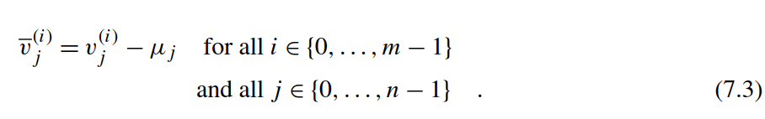

As a result, the columns of the centered data matrix *Dij* = *vj(i)* sum up to zero. Conceptually, there are two levels of parallelism. On the one hand, we could parallelize the mean correction over the pixel indices j analogically to the previous subsection. On the other hand, each image *v(i)* can an also be treated independently. We will see that the ﬁrst approach is about eight times faster than the latter. This can be explained by the different memory access patterns of both approaches. However, before we dive into details let us write some code. The ﬁrst kernel parallelizes the centering over the pixel indices and serializes the loop over the image indices (see Listing 7.9).

结果，居中数据矩阵的列总和为零。从概念上讲，有两个级别的并行性。一方面，前一小节类似，我们可以在像素索引 j上 的并行化均值校正。另一方面，每个图像v(i)也可以独立处理。我们发现第一种方法比后者快八倍。这可以通过两种方法的不同访存模式来解释。但是，在我们深入细节之前，让我们编写一些代码。第一个内核将像素索引上的中心并行化，并将循环序列化为图像索引(see Listing 7.9).

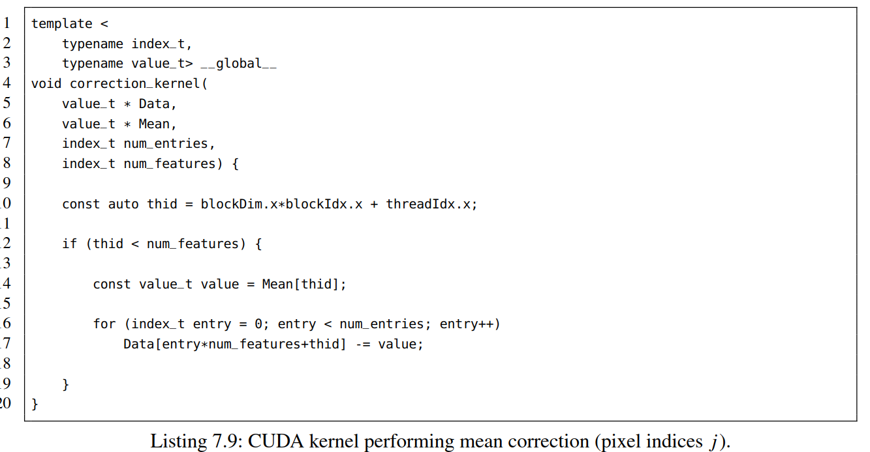

清单7.9:执行均值矫正CUDA kernel

The code is similar to the mean computation kernel. First, the global thread identiﬁer thid is determined in Line 10. Second, we check the range of the thread indices to prevent memory access violations (Line 12). Third, the *j*-th component of the Mean vector is written to the register value in Line 14. Fourth, we subtract the corresponding value from each vector in the loop body. Finally, the kernel is launched with the following call:

代码与平均计算内核类似。首先， 第10行完成全局线程标识符thid计算，第二，我们检查线程索引的范围以防止内存访问冲突（第12行），第三，第14行，Mean向量的第j个分量被写入寄存器value。第四，通过循环体中，每个向量元素减去相应的值。最后，使用以下调用启动内核：

correction_kernel<<<SDIV(rows*cols, 32), 32>>> (Data, Mean, imgs, rows*cols); CUERR

An orthogonal approach spawns one thread for each of the images and serializes the loop over the pixel indices. The corresponding source code is provided in Listing 7.10. Here, we compute again the global thread identiﬁer and subsequently check its range. Finally, the loop is executed over pixel indices.

另外一种通用方法是为每个图像生成一个线程，并串行完成以像素索引的循环。相应的源代码见列表7.10. 在这里，我们再次计算全局线程标识符，然后检查其范围。最后，执行像素索引的循环。

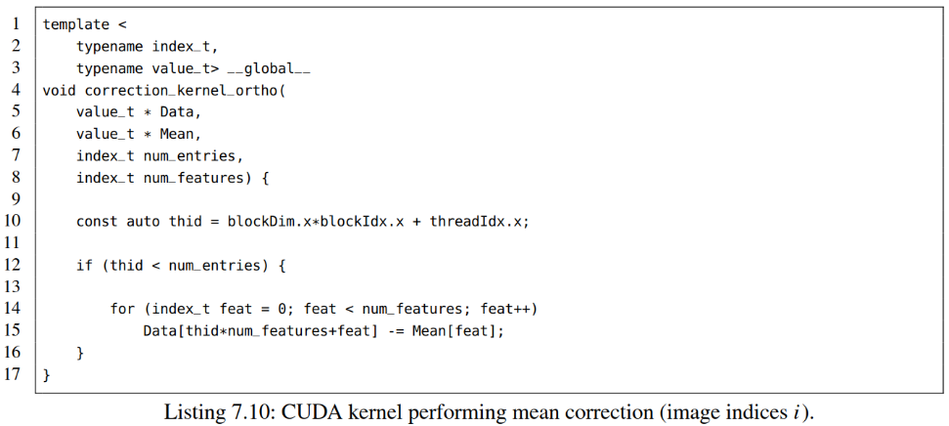

Listing 7.10: CUDA kernel performing mean correction (image indices *i*).

清单7.10：执行均值矫正CUDA kernel（图像索引i）

The corresponding kernel call differs mainly in the number of spawned blocks and threads which now correspond to the number of images.

相应的内核调用主要区别在于根据对应于图像数量所产生的Blocks和线程的数量。

correction_kernel_ortho<<<SDIV(imgs, 32), 32>>> (Data, Mean, imgs, rows*cols); CUERR

When executing both kernels on a Pascal based Titan X we measure roughly 60 ms for the ﬁrst kernel and approximately 500 ms for the orthogonal approach. On ﬁrst sight, this observation seems to be counterintuitive since the number of images exceed the number of pixels by far. Nevertheless, the second kernel cannot beneﬁt from the increased level of parallelism due to its suboptimal memory access pattern. Let us have a look at the for-loop body of the orthogonal approach:

在基于Pascal的Titan X上执行两个内核时，第一个内核执行大约60 ms，正交方法内核大约500 ms。乍一看，结果似乎出人意料，因为图像的数量远远超过了像素的数量。然而，由于并不最优的访存模式，第二个kernel不能从提高的并行度中获益。让我们看一下正交方法的for循环体：

for (index_t feat = 0; feat < num_features; feat++)

Data[thid*num_features+feat] = some_value;

The entries of Data are not accessed consecutively although the variable feat enumerates the inner loop and thus seems to address contiguous memory. Recall that 32 threads of a warp are executed simultaneously. Therefore the index thid is altered faster than the variable feat. As a result, we access 32 entries residing in the same column during each iteration of the loop. This causes excessive invalidation of cache lines. By contrast, the access pattern of the ﬁrst kernel, addresses consecutive memory during each iteration.

虽然 变量feat枚举内循环且看起来访存连续，但是 Data访存并不连续。回想一下，32个warp线程同时执行。因此，索引thid的变化速度比变量feat要快。循环体中的每一次迭代就会访问驻留在同一列中的32个条目，这会导致缓存行的过度无效。相比之下，第一个内核的访问模式,每次迭代都是连续访存。

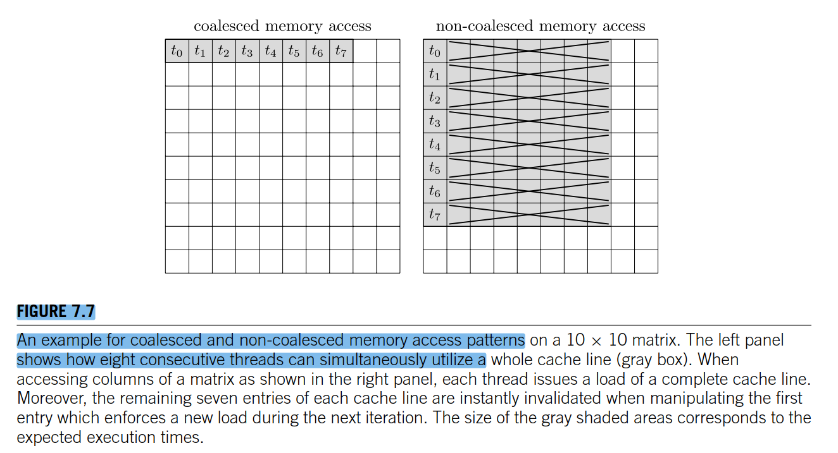

**图7.7**

An example for coalesced and non-coalesced memory access patterns on a 10 × 10 matrix. The left panel shows how eight consecutive threads can simultaneously utilize a whole cache line (gray box). When accessing columns of a matrix as shown in the right panel, each thread issues a load of a complete cache line. Moreover, the remaining seven entries of each cache line are instantly invalidated when manipulating the ﬁrst entry which enforces a new load during the next iteration. The size of the gray shaded areas corresponds to the expected execution times.

10×10矩阵上的合并访存和非合并访存模式示例。左侧面板显示了八个连续线程如何同时使用整个缓存行（灰色框）。如右面板所示，当访问矩阵的列时，每个线程发射一个完整缓存行的负载。此外，当操作在下一次迭代期间强制执行新加载的第一个条目时，每个高速缓存行的剩余七个条目立即无效。灰色阴影区域的大小对应于预期的执行时间。

for (index_t entry = 0; entry < num_entries; entry++)

Data[entry*num_features+thid] = some_value;

Let us revisit what we have seen. Whenever consecutive threads access contiguous memory, more precisely when a sequence of threads *(tk,tk*+1*,...,tk*+31*)* simultaneously reads or writes contiguous memory positions *(pl,pl*+1*,...,pl*+31*)* for ﬁxed values of *k* and *l*, we call this pattern **coalesced** and otherwise **non-coalesced** (see Fig. 7.7). Coalesced access patterns are highly advisable in order to saturate the bandwidth to global memory. Non-coalesced reads or writes are often as slow as random accesses and should be avoided at any cost. Several techniques can be applied to effectively prevent random access, e.g. the reordering of indices, transposition of input data (which is an exercise), or the execution of highly irregular access patterns on faster memory types. The latter will be demonstrated in Section 7.4. Finally, let us make a concluding remark related to coalesced addressing in multidi- mensional blocks. Usually, the local thread identiﬁer threadIdx.x is altered faster than threadIdx.y and threadIdx.z. Therefore variables that depend on threadIdx.x (in our case thid) should always manipulate the least signiﬁcant bits of the indexing scheme. As an example, the coalesced scheme

Data[threadIdx.y*matrix_width+threadIdx.x] = some_value;

is typically signiﬁcantly faster than its non-coalesced counterpart

Data[threadIdx.x*matrix_width+threadIdx.y] = some_value;

keep in mind that this subtle distinction may slow down your algorithm by roughly one order-of- magnitude. A similar behavior can be observed on traditional CPUs where row-major addressing, which corresponds to coalesced memory access, reasonably outperforms column-major indexing (see Section 3).

让我们重温一下我们所看到的。每当连续线程访问连续内存时，更准确地说，当一系列线程（tk，tk+1，…，tk+31）同时连续内存位置（pl，pl+1，…，pl+31）读取或写入固定值k和l时，我们称此模式为“合并访存”或“非合并访存” (见 Fig. 7.7)。为了全局存储带宽饱和，建议使用合并的访问模式。非合并读或写通常和随机访问一样慢，应该尽量避免。有几种技术可以有效地防止随机访问，例如，索引的重新排序、输入数据的换位（这是一个练习）或在更快的内存类型上执行高度不规则的访问模式。后者将在第7.4节中演示。最后，让我们做一个关于多维block中合并寻址的总结。通常，本地线程标识符threadidx.x的更改速度比threadidx.y和threadidx.z快。因此，依赖于threadidx.x的变量（在我们的例子中是thid）应该总是操作索引方案中最小的显著位。例如，合并方案

Data[threadIdx.y*matrix_width+threadIdx.x] = some_value;

通常比非合并访存方案快很多

Data[threadIdx.x*matrix_width+threadIdx.y] = some_value;

请记住，这种微妙的区别可能会使您的算法减慢大约一个数量级。 在传统的CPU上可以观察到类似的行为，其中行主序寻址（对应于合并的存储器访问）理所当然地优于列主要索引（参见第3节）。

**COMPUTATION OF THE COVARIANCE MATRIX**

计算协方差矩阵

PCA determines a new intrinsic coordinate system for the centered vectors *v(i)* by performing a diagonalization of their covariance matrix

通过执行其协方差矩阵的对角化，计算对中心化向量v(i)的新的固定坐标系。

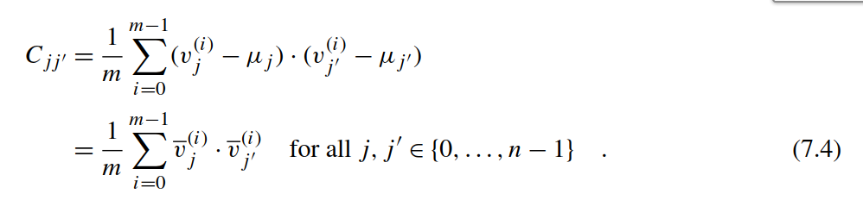

An entry *Cjj*′ describes how two pixels *j* and *j*′ are correlated since it reassembles the scalar product of the corresponding intensity vectors along the image axis.

条目Cjj'描述了两个像素j和j'是如何相关的，沿着图像轴，因为它重新组装了相关强度向量的标量积。

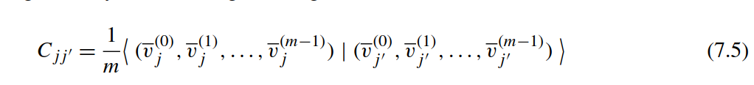

Here, <·|·> denotes the standard scalar product in Euclidean space. As an example, if *j* denotes the position of the left eye and *j*′ the position of the right eye, we expect *Cjj*′ to be a reasonably high value. In the general case, we determine all pairwise correlations of the *n* features represented in the vector space R*n*. The covariance matrix *C* exhibits a number of desirable mathematical properties:

符号<.|.>表示为欧氏空间中的标准标量积。例如，如果j表示左眼的位置而j'表示右眼的位置，我们希望Cjj'得到合理值。在通常情况下，我们确定向量空间R*n*.中表示的n个特征的两两相关性。协方差矩阵C会展现许多合理的数学特性。

• (**Symmetry**) An entry *Cjj*′ is invariant under the swapping of the indices *j* and *j*′ since multiplication of two real numbers is commutative.

• (**Normality**) *C* is a normal matrix since *CT* · *C* = *C* · *CT* . Thus *C* can be diagonalized using an eigenvalue decomposition.

• (**Positive Spectrum**) The scalar product in Eq. (7.5) is a positive-deﬁnite bilinear form. Consequently, *C* exhibits exclusively non-negative eigenvalues.

* (对称性)由于两个实数的乘法是可交换的，交换索引j和*j*′ ，*Cjj*′是不变的。
* (正态) 因为*CT* · *C* = *C* · *CT*因为C是正态规阵。因此，可以使用特征值分解来对角化C.
* (正谱)，公式（7.5）中的标量乘积是一种正有限双线性形式，因此，C具有唯一的非负特征值。

The real-valued eigenvectors {*u(*0*),u(*1*),...,u(n*−1*)*} of *C* are mutually orthogonal and span an *n*-dimensional vector space over R. You might wonder why we are interested in this particular basis, as we could have stuck to the canonical basis or any other set of linearly independent vectors. Assume we want to describe the images from the high-dimensional vector space R*n* with just one coordinate. Mathematically speaking, we are interested in the optimal basis vector *b* ∈ R*n* \ {0} which on average captures most of the information stored in the centered data matrix *D*. Let *v(i)*|*b*ˆ be the projection of the centered vector *v(i)* onto the normed basis vector in terms of the scalar product. Then we need to determine the minimizer *u* that provides the optimal least square approximation of all vectors *v(i)*:

在R的n维向量空间， C的实数-特征向量{u（0），u（1），...，u（n-1）}相互正交。你可能想知道为什么我们对这个特殊的基础感兴趣，因为我们可以坚持规范基础或任何其他线性独立向量集。假设我们想要仅适用高维矢量空间Rn的一个坐标来描述图像图像。从数学上讲，我们感兴趣的是最优基矢量*b* ∈ R*n* \ {0}，它一般捕获存储在居中数据矩阵D中的大部分信息。设*v(i)*|*b*ˆ 通过标量积表示的，中心化向量v（i）到标准基向量*v(i)*|*b*ˆ 的投影。然后我们需要明确最小值u，它提供所有向量*v(i)*的最佳最小二乘近似：

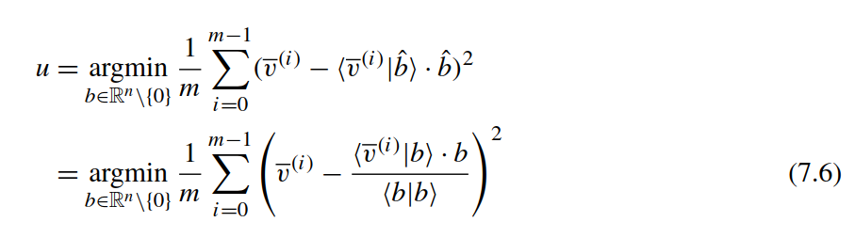

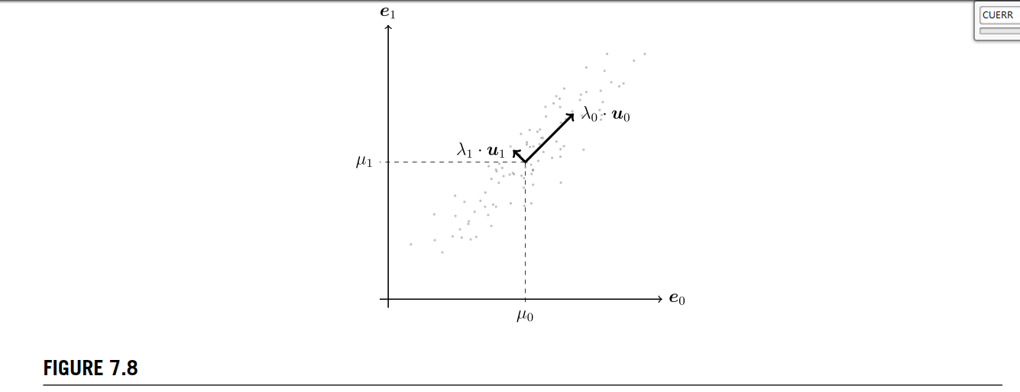

Exemplary eigenvalue decomposition of the covariance matrix computed from 100 points in R2. The point cloud is sampled from a multivariate normal Gaussian which has been stretched by a factor of 4 along the x-axis, rotated by 45 degrees, and subsequently shifted by *μ* = *(μ*0*,μ*1*)*. Thus the two eigenvectors *u*0 = *(*1*/*√2*,*1*/*√2*)* and *u*1 = *(*−1*/*√2*,*1*/*√2*)* describe the columns of the rotation matrix. The eigenvalues *λ*0 = 4 and *λ*1 = 1 are equivalent to the standard deviations in the rotated intrinsic coordinate system.

从R2 100个点计算的协方差矩阵的示例性特征值分解, 点云从多元法线高斯中采样，该高斯普通高斯沿x轴被拉伸4倍，旋转45度，随后移位*μ* = *(μ*0*,μ*1*)*。因此，两个特征向量*u*0 = *(*1*/*√2*,*1*/*√2*)* and *u*1 = *(*−1*/*√2*,*1*/*√2*)*描述了旋转矩阵的列。特征值*λ*0 = 4 and *λ*1 = 1等于旋转的内部坐标系中的标准差。

Let us expand the square in the last equation and substitute the scalar products by explicit sums over *j* and *j*′. We obtain a constant term which can be neglected during optimization and a second term depending on the covariance matrix *C*. Note that the second (mixing) term and the third term from the binomial expansion coincide up to multiplicative factors.

让我们对最后一个等式中的平方进行扩展，并用j和j'上的显式和来代替标量积。我们得到一个常数项，这个常数项可以在优化过程中忽略，第二项可以根据协方差矩阵C得到。注意，来自二项式扩展的第二（混合）项和第三项与乘法因子一致。

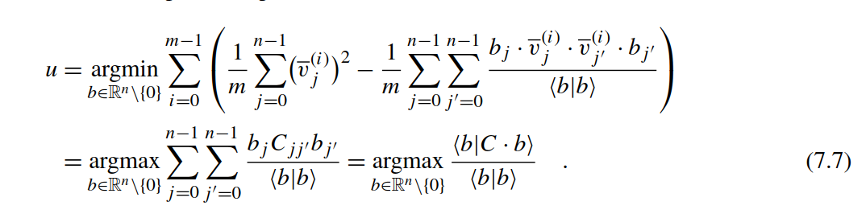

The last fraction is called *Rayleigh quotient* in the literature. We can maximize this expression for a diagonalizable matrix *C* by simply choosing the eigenvector of *C* with highest eigenvalue. This can be easily validated by setting *C* · *b* = *λ* · *b*. Analogically, one can show that the optimal basis for the approximation of our data with 0 *< k* ≤ *n* vectors is given by the subset of *k* eigenvectors with the greatest eigenvalues. An extensive proof can be found in [8]. Fig. 7.8 visualizes the described procedure.

最后一个部分在文献中称为*Rayleigh* 熵。通过简单地选择具有最高特征值的C的特征向量, 我们可以将这个表达式最大化为可对角化的矩阵C. 通过设置 *C* · *b* = *λ* · *b*.可以轻松获得验证。以此类推，可以证明，具有K（0 <k≤n）个向量最优基的数据近似值由具有最大特征值的k个特征向量的子集给出。详细证明见参考文献【8】。  图7.8显示了所描述的程序。

In the following, we will compute a suitable basis for the (lossy) approximation of celebrity faces, so-called eigenfaces. The eigenvalue decomposition will be accomplished using the cusolverDnSgesvd method from the cuSOLVER library which is bundled with CUDA. Hence, the implementation of the covariance matrix computation is left to us. We assume that the mean adjusted images are stored in the centered data matrix *Dij* and that we have already allocated memory for the covariance matrix *Cjj*′ on the device. A naive implementation of the covariance kernel would look as follows:

在下文中，我们将计算名人面部（有损）近似的合适基，即所谓的特征脸。特征值分解将使用与CUDA捆绑在一起的cuSOLVER库中的cusolverDnSgesvd方法完成。因此，协方差矩阵计算的实现留给我们。我们假设平均调整后的图像存储在居中数据矩阵Dij中，并且我们已经为协方差矩阵*Cjj*′在设备上分配了内存。 协方差内核的原始实现如下：

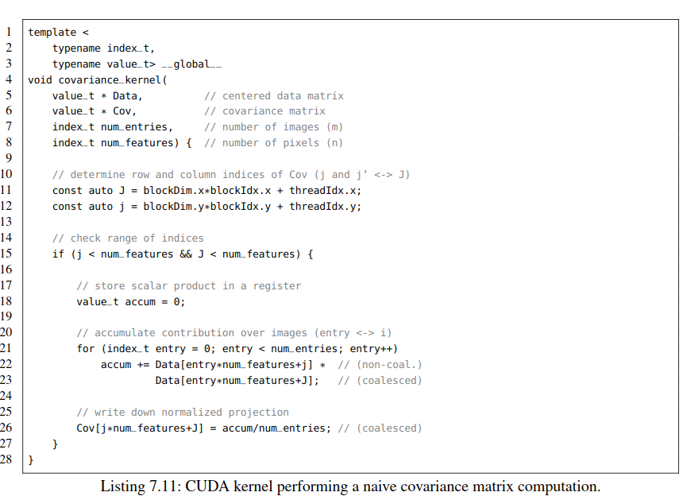

Listing 7.11: CUDA kernel performing a naive covariance matrix computation.

清单7.11 协方差矩阵计算CUDA kernel

The source code is similar to the mean computation kernel where we have summed up entries of the data matrix along the image axis. In this case, the accumulation is performed for all *n*2 products of pixel values. The kernel launch is straightforward:

源代码与均值计算内核类似，其中我们沿图像轴对数据矩阵的条目。在这种情况下，对所有*n*2个像素值的乘积执行累加。

// feel free to experiment with different block sizes 随意尝试不同的块大小  
dim3 blocks(SDIV(rows*cols, 8), SDIV(rows*cols, 8));   
 dim3 threads(8, 8); // 64 threads (2 warps) per block 每个block64线程（2个warp）  
 covariance_kernel<<<blocks, threads>>>(Data, Cov, imgs, rows*cols); CUERR

The kernel takes roughly 36 seconds to compute the whole covariance matrix for *m* = 202*,*599 images each consisting of *n* = 2475 pixels. The execution time can be cut in half if we exploit the symmetry of *C*. Here, we compute only entries below the diagonal.

整个协方差矩阵计算内核大约耗时36秒，其中m = 202,599个图像，每个图像由n = 2475个像素组成。 如果我们利用C的对称性，只计算对角线以下的元素。执行时间可以缩减一半。

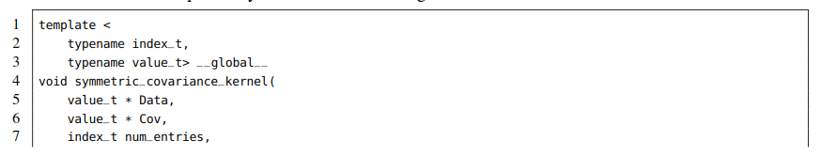

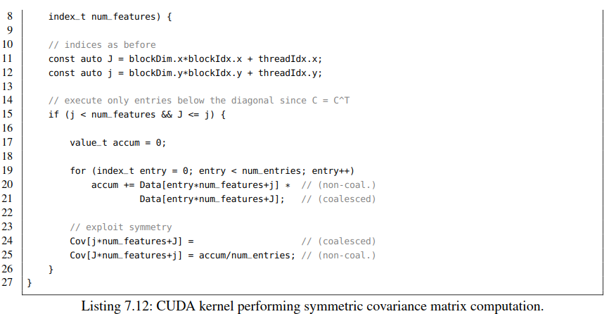

清单7.12 对称协方差矩阵计算CUDA 内核

Both the naive and symmetric kernel can be further accelerated by a factor of at least ten if we remove redundant accesses to global memory. Assume you want to compute the ﬁrst row of the covariance matrix

如果我们减少全局访存的冗余则，初始和对称内核都可以进一步加速至少十倍。假设要计算协方差矩阵的第一行

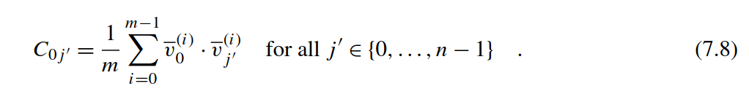

The naive kernel loads all *m* entries of *v*0*(i)* for each choice of *j*′ from global memory. This results in *m* · *n* global memory accesses. The symmetric approach reduces this by a factor of two but still exhibits an *O(m* · *n)* dependency. This can be avoided if we store the *m* entries belonging to pixel zero in a separate cache that can be accessed signiﬁcantly faster than global memory. When neglecting the time for accessing this type of memory we can reduce the loads of all values belonging to pixel zero (left factor) to *O(m)* operations during the computation of a single row.

每次选择*j*′ ， 原始内核从全局内存加载*v*0*(i)*的m个条目。这需要m·n次全局内存访问。对称方法的访存次数将其减少了两倍，但复杂度仍然是O *O(m* · *n)*。如果我们将属于像素零的m个条目存储在可以比全局存储器快得多的单独高速缓存中，则可以避免这种情况。在计算单行期间，如果忽略访问这种类型存储器的时间，我们可以减少属于零像素的所有值的负载（左因子）到O（m）。

Conceptually, we aim for an implementation which loads the whole *m* × *n* matrix *Dij* only once from global memory and subsequently performs the *n*2 · *m* many additions needed for the computation of *C*. As a result, we can reasonably increase the computing-to-global-memory-access (CGMA) ratio. This approach could be realized on a hypothetical GPU with roughly 2 GB of fast on-chip memory. Unfortunately, this requirement sounds rather utopian due to the sheer number of needed transistors and the associated cost of such a device. In comparison, a Pascal-based Titan X provides 64 KB of *shared memory* for each of the 56 SMs (see Table 7.1 and Fig. 7.4) resulting in an overall size of roughly 3.5 MB for the whole device. Shared memory has to be explicitly utilized by the programmer and can be accessed by all threads within the same block. It is usually used to store redundant data or to perform highly irregular memory access patterns which would be inefﬁcient when executed on global memory. Note that in the literature some authors tend to refer to shared memory as *scratchpad* due to the described usage as tiny storage for organizational purposes. In the following, we will utilize shared memory to explicitly cache small tiles of the data matrix in order to drastically reduce the execution time of the covariance kernel. Although an SM may physically provide a greater amount of shared memory, e.g., 64 KB for the Pascal generation, we can utilize 48 KB at most within a single thread block. As an example, if we specify a kernel to launch with 32 KB of shared memory on a Pascal GPU then the block scheduler can map two thread blocks onto a single SM.

从概念上讲，我们的目标只从全局存储器加载整个m×n矩阵*Dij*一次，然后执行计算C所需的*n*2 · *m*多次加法。因此，我们可以合理地提高计算访存（CGMA）的比率。假设GPU具有大约2gb的快速片上内存，那么这种方法就可以实现。不幸的是，由于所需晶体管的数量太大且这种设备的成本较高，这一需求这一要求听起来相当不切实际。相比之下，基于Pascal的Titan X， 56个SM中的每一个都提供64 KB的共享内存*shared memory*（参见表7.1和图7.4），那么整个设备总体shared memory 大约为3.5 MB。共享内存必须由程序员明确使用，并且可以由同一Block的所有线程访问。它通常用于存储冗余数据或执行高度不规则的存储器访问模式，这些模式在全局存储器上执行时效率低下。请注意，在文献中，一些作者倾向于将共享内存称为暂存器{ *scratchpad* }，因为所描述的用途是用于组织目的的微小存储。在下文中，我们将利用共享内存来显式缓存数据矩阵的小块，以便大幅减少协方差内核的执行时间。尽管一个SM可以提供更大量的物理共享存储器，例如，Pascal 一代配有64KB，但是我们可以在一个线程块内最多使用48KB。 例如，如果我们在Pascal GPU上启动的内核指定要使用32 KB共享内存，则Block调度器会将两个线程Block映射到单个SM上。

Assume we want to compute all entries *Cjj*′ residing in a quadratic tile of shape *w* × *w*. The contributions during the summation over the *m* images depend only on the pixel indices *j* and *j*′ that are within the range of that tile. Consequently, we would have to store *w* columns of the data matrix each of length *m* for both the indices *j* and *j*′. Unfortunately, this does not ﬁt in 48 KB of shared memory since the length of a column *m* = 202*,*599 is extraordinarily large. However, we can exploit the associativity of addition by subsequently summing up *w* images in a neighborhood of *w* pixels. Let *c* be the index enumerating *C* = *SDIV (m,w)* = *m*+*ww*−1 many chunks of image indices then we can rewrite the computation as

假设我们想要计算形状为w×w的方块中的所有条目*Cjj*′ 。  m个图像的总和仅取决于该图块范围内的像素索引。因此，对于索引j和j'，我们必须存储长度为m的数据矩阵的w列，但由于列的长度m = 202,599非常大，放不下48 KB的共享内存中。但是，我们可以利用加法的相关性， 通过随后在w像素的邻域中的w图像求和。设c是枚举C许多图像索引块的索引*SDIV (m,w)* = *m*+*ww*−1，然后我们可以将计算重写为：

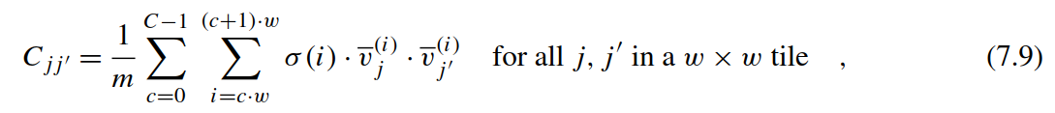

where *σ(i)* equals one if *i < m* and zero otherwise. Note that the auxiliary term *σ(i)* is only needed if *m* is not a multiple of *w*. For each contribution (iteration) of the outer sum (loop) we store all values stemming from *w* images within a neighborhood of *w* pixels around *j* and *j*′ in two separate arrays in scratchpad memory. In the inner sum (loop) we can now load the factors for all index combinations of *j* and *j*′ within a tile from fast memory. Each of the *SDIV (n,w)* × *SDIV (n,w)* many tiles of the *n* × *n* covariance matrix *C* will be processed by a single thread block spawned in a 2D grid. The indices *j* and *j*′ within a tile correspond to local thread identiﬁers threadIdx.x and threadIdx.y. Furthermore, we can again exploit the symmetry of *C* by considering only these tiles that contain no index combination *(j,j*′*)* below the diagonal. Fig. 7.9 illustrates the described approach.

这里，如果if *i < m，* 则*σ(i)* =1， 否则*σ(i)* =0. 注意，如果m不是w的倍数时，辅助项*σ(i)*才需要。对于外部sum（loop）的贡献份额（iteration）， 我们将来自w图像，在j和j'周围的w像素的值存储内暂存区的两个单独数组中。n×n协方差矩阵C的每个SDIV（n，w）×SDIV（n，w）个分块将由在2D网格中生成的单个线程块处理。每个tile中的索引j和j'对应于本地线程标识符threadIdx.x和threadIdx.y。此外，我们可以利用C的对称性，只考虑那些对角线以下不包含索引组合(j,j ')的块。图7.9说明了所描述的方法。

Let us start coding. First, we deﬁne some auxiliary variables for the convenient indexing of the tiles. The window *w* corresponds to the chunk_size parameter in the template. A thread block will consist of chunk_size×chunk_sizemany threads organized in a 2D grid. Furthermore, we immediately abort thread blocks which compute tiles above the diagonal in Line 25. This could be optimized by spawning only blocks below the diagonal. However, the resulting index calculation is non-trivial and would unreasonably complicate this example.

让我们开始编码。 首先，我们定义了一些辅助变量，以便对分块进行索引。窗口w对应于模板中的chunk_size参数。线程块以2D将由在2D网格中组织的chunk_size×chunk_size 线程组成。此外，如果线程块计算三角线以上的部分，线程块会中止。 这可以通过只生成对角线以下的块来优化。然而，最终的索引计算并不简单，而且会使这个示例变得异常复杂。

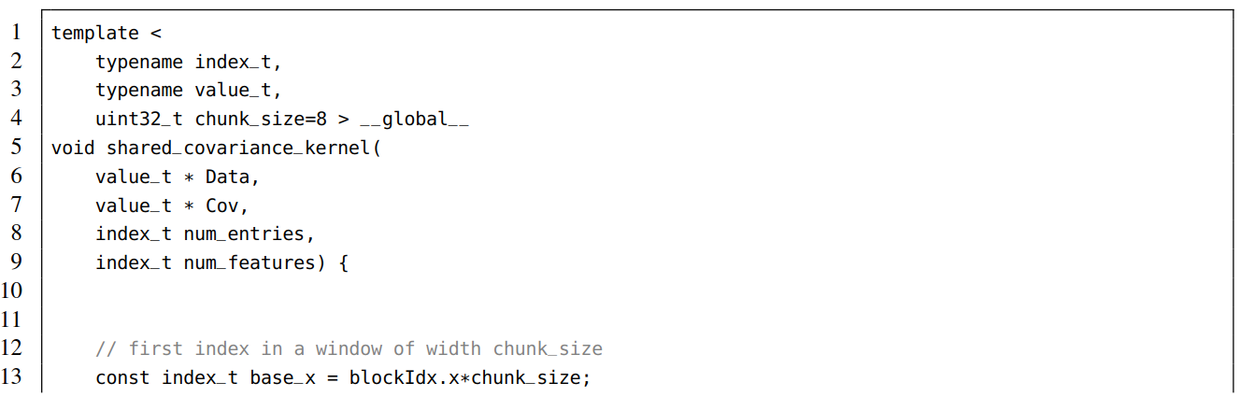

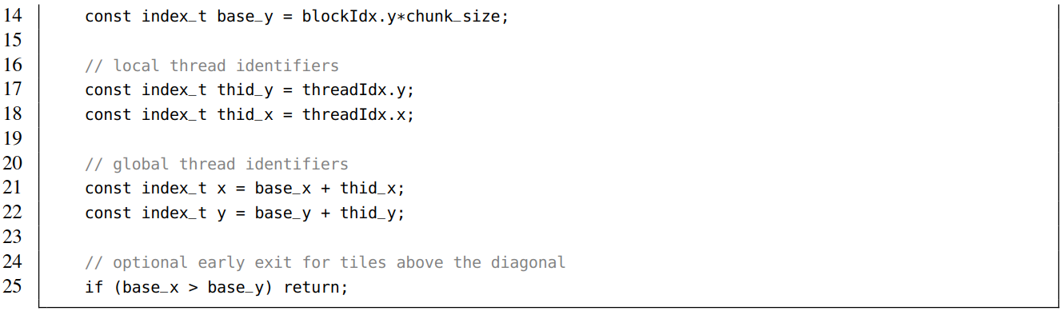

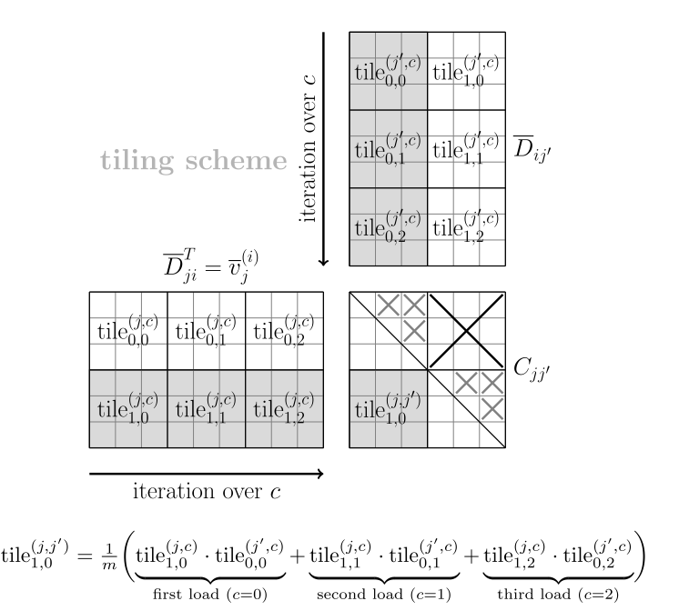

**FIGURE7.9**

Tiling scheme for the efﬁcient computation of a covariance matrix *C* of shape *n* × *n* = 6 × 6 from a centered data matrix *D* of shape *m* × *n* = 9 × 6. Both *C* and *D* are subdivided into tiles of shape *w* × *w* = 3 × 3. The contributions within a tile of *C* are consecutively summed up in *m/w* = 3 iterations. During each iteration the tiles have to be loaded into shared memory before we can process the matrix product of the corresponding tiles. The matrix product is performed by *w* × *w* many threads within a thread block which can simultaneously access the values stored in shared memory. As a result, we can decrease the accesses to global memory by a factor of *w*. Tiles which are located above the diagonal can be neglected due to the symmetry of *C*. Moreover, the contributions of tiles on the diagonal only have to be evaluated partially.

从形状M×N=9×6的中心数据矩阵D中有效计算形状N×N=6×6的协方差矩阵C的分块方案。C和D都被细分为形状为W×W=3×3的分块。C分块的份额以m/w=3次迭代的形式连续累加，在每次迭代对想要分块进行矩阵乘积之前，分块必须被加载到共享内存中。矩阵乘积由一个线程块内的w×w多个线程执行，这些线程块可以同时访问存储在共享内存中的值。因此，我们可以将对全局内存的访问减少w倍。由于C的对称性，对角线下方的分块可以不进行计算。另外，对角线之上的元素只需部分评估。

Second, we allocate shared memory for the two tiles using the __shared__ qualiﬁer in Lines 27 and 28. The semantic is similar to the deﬁnition of static arrays in multiple dimensions. The dimensions have to be speciﬁed with constant integers, so you cannot use variables deﬁned inside the kernel or its signature. Thus we have to pass chunk_size as template parameter which is known at compile time. Alternatively, one can deﬁne the size of shared memory during the invocation of a kernel which will be discussed in detail in Section 7.4. Further, we compute the number of chunks to be processed and deﬁne a register which will accumulate the contributions during summation along the image axes.

其次，我们使用第27行和第28行中的__shared__限定符为两个tile分配共享内存。此语法类似于多维中静态数组的定义。维度必须用常整数指定，而不能使用在内核或其签名中定义的变量。因此，我们必须将chunk_size作为模板参数传递，这在编译时是已知的。或者，可以在调用内核期间定义共享内存的大小，这将在第7.4节中详细讨论。 此外，我们计算要处理的块的数量，并定义一个寄存器，该寄存器将将沿着图像轴在求和过程中积累。

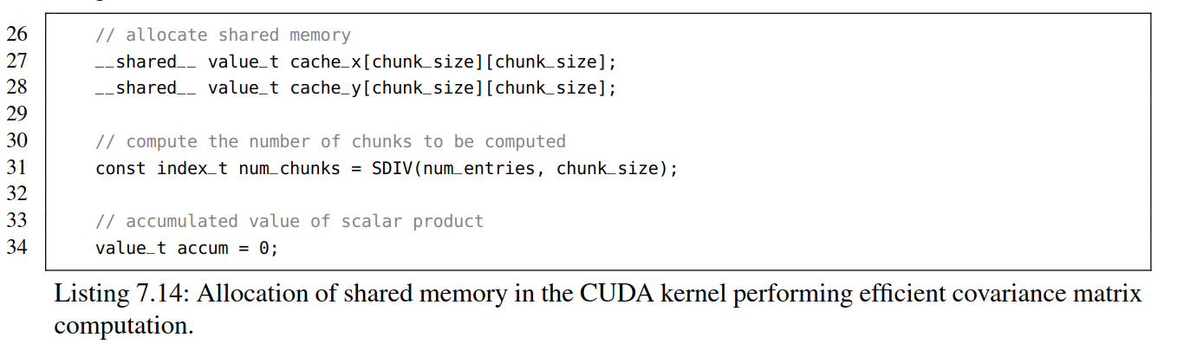

Listing 7.14: Allocation of shared memory in the CUDA kernel performing efﬁcient covariance matrix computation.

清单7.14： 在CUDA内核中分配共享内存，执行有效的协方差矩阵计算。

Before we can start to sum up the contributions we have to load the corresponding portions from the centered data matrix *D* to shared memory. In each chunk of images we enumerate the rows (index *i*) of the data matrix with the local thread identiﬁer thid_y = threadIdx.y. This local index has to be adjusted by an offset chunk*chunk_size as shown in Line 39 to determine the global row identiﬁer row. The column indices (*j* and *j*′) are represented by thid_x = threadIdx.x shifted by the offsets base_x and base_y in order to select the correct tile (see Lines 40 and 41). Subsequently, we check if the global identiﬁers are within a valid range (see Lines 44–46). The auxiliary variables valid_row, valid_col_x and valid_col_y are used for masking in a later step in case the number of images *m* or the number of pixels *n* is not a multiple of the window size.

其次，在开始累加份额之前，我们必须将中心化矩阵D中的相应的部分加载到共享内存。在每个图像块中，我们使用本地线程标识符thid_y = threadIdx.y.枚举数据矩阵的行（索引i）。必须通过偏移chunk*chunk_size调整此本地索引，如第39行所示，以确定全局行标识符row。列索引（j和j'）由thid_x = threadIdx.x表示，通过移动偏移量base_x和base_y以选择正确的Tile.(见40和41行)。随后，我们检查全局标识符是否在有效范围内（见44-46行）。在图像数量m或像素数量n不是窗口尺寸的倍数的情况下。辅助变量valid_row, valid_col_x 和 valid_col_y用来做后续步骤的标记。

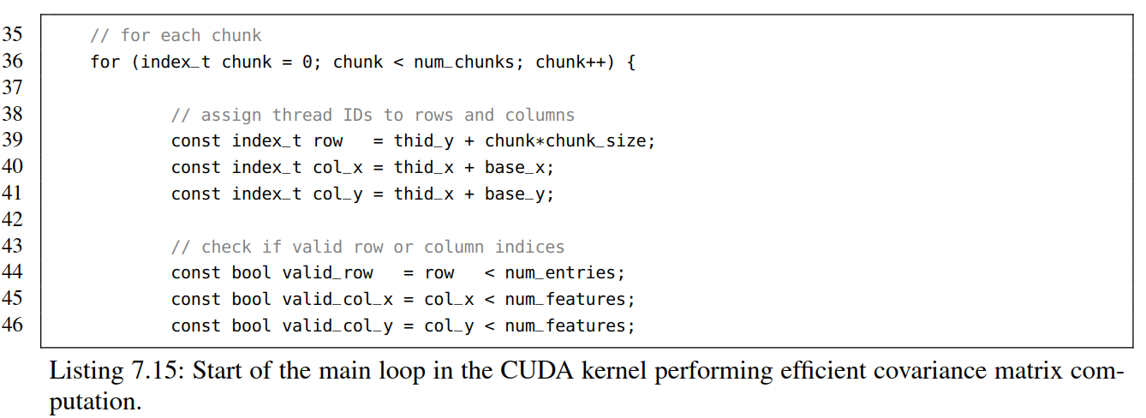

Listing 7.15: Start of the main loop in the CUDA kernel performing efﬁcient covariance matrix computation.

列表7.15：在CUDA内核中启动主循环，执行有效的协方差矩阵计算

After having deﬁned the necessary variables for indexing we can now load the tiles from global memory to fast shared memory. This is accomplished with a simple assignment as show in Lines 53–55. The aforementioned auxiliary variables are used to prevent malicious memory accesses. Entries that exceed the range of *m* and *n* are ﬁlled with zeros which does not inﬂuence the ﬁnal result. Note that we use local thread identiﬁers on the left-hand side where we access shared memory in contrast to the right-hand side where we read global memory using global identiﬁers. Afterwards, we have to ensure that all threads in a block have ﬁnished loading with a call to __syncthreads() in Line 60. In our case we have spawned a 2D block of shape 8 × 8, i.e., both warps (2 × 32 threads) are potentially executed in parallel and thus have to be explicitly synchronized. This is crucial to prevent that one warp proceeds its execution while the other is still loading data. Thread blocks consisting of only one warp are always synchronized rendering a call to __syncthreads() redundant. Note that this barrier only affects the threads within a thread block. Device-wide barriers across all threads of the GPU have to be enforced by terminating the whole kernel or using atomic based synchronization schemes (see Section 8.1).

在为索引定义必要的变量之后，我们现在可以将tiles切片从全局内存加载到快速共享内存。可以通过第53-55行显示的简单分配完成。上述辅助变量用于防止恶意存储器访问。 超出m和n范围的条目填充零，这不会影响最终结果。请注意，我们使用左侧的本地线程标识符来访问共享内存，而右侧则使用全局标识符读取全局内存。之后，我们必须确保线程块中的所有线程都已完成加载，并在第60行调用__syncthreads() _ 。在我们的例子中，我们生成了一个形状为8×8的2D块，即两个warp（2×32个线程）可能会并行执行，因此必须明确同步。这对于防止一个warp继续执行而另一个warp仍在加载数据至关重要。只由一个经线组成的线程块总是同步的，这会导致对……syncthreads()的调用冗余。请注意，此barrier仅影响一个线程块中的线程。跨GPU所有线程的设备级屏障必须通过终止整个内核或使用基于原子的同步方案来实现（见8.1节）。

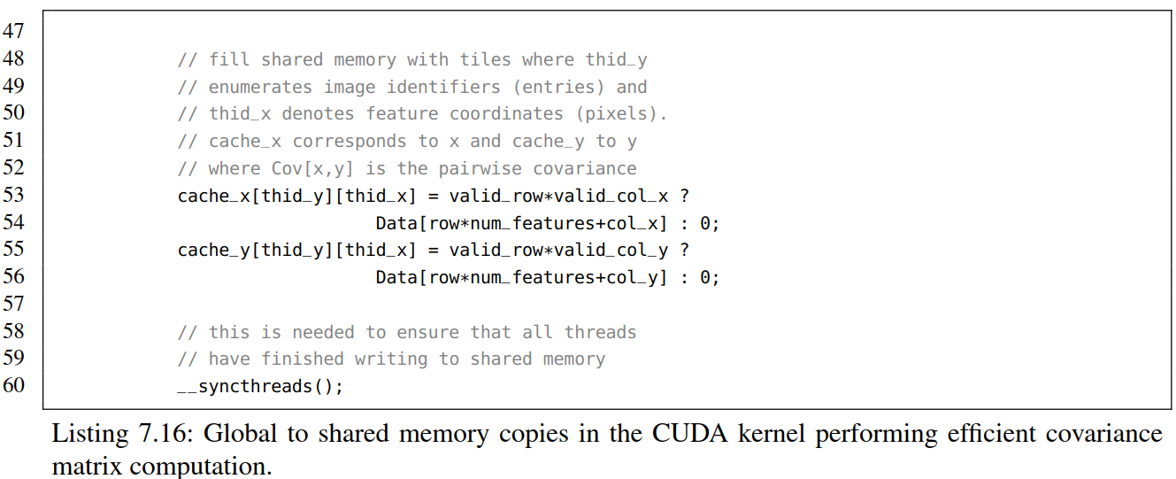

Listing 7.16: Global to shared memory copies in the CUDA kernel performing efﬁcient covariance matrix computation.

清单7.16： 有效执行协方差矩阵计算内核中全局内存到局部内存拷贝

At this point we have stored both tiles in shared memory. The partial scalar products are now computed using a simple loop over the pixel dimension (see Line 66). Again, we can exploit symmetry and abandon entries above the diagonal in Lines 63 and 75. This affects only tiles on the diagonal of the covariance matrix (see gray crosses in Fig. 7.9). The second call to in Line 71 enforces a block-wide barrier to prevent premature execution of the next iteration. Finally, the normalized result is written to the covariance matrix in Line 76 for both entries below and their symmetric counterpart above the diagonal.

此时，我们已经将两个tile存储在共享内存中。部分标量乘积现在使用像素维度上的简单循环来计算(参见第66行)。同样，我们可以利用对称性，放弃第63行和第75行对角线以上的元素计算。这只影响协方差矩阵对角线上的块（见图7.9中的灰色的十字线）。71行对第二次调用__syncthreads( ) 强制一个block范围内的屏障，，以防止下一个迭代的过早执行。最后，对于对角线下的元素和对角线上的对称元素，将归一化结果写入第76行中的协方差矩阵。

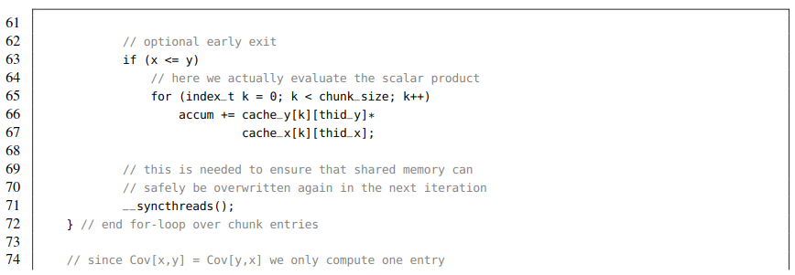

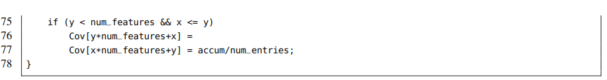

Listing 7.17: Main computation in the CUDA kernel performing efﬁcient covariance matrix computation.

清单7.17： CUDA核执行有效的协方差矩阵的主要计算。

The described kernel computes the whole covariance matrix in only 980 ms on a Pascal-based Titan X in comparison to 18 s for the symmetrized naive kernel which exclusively operates on global memory. This impressive speedup of roughly 18 is caused by the caching of redundant entries in shared memory. In theory, we can reuse *w* columns of the data matrix after having read them once from global memory. Consequently, the speedup should monotonically grow if we increase the window parameter. However, the amount of used shared memory per block also inﬂuences the execution time. Section 7.4 discusses this topic in detail.

描述的内核在基于pascal的Titan X上仅用980毫秒就计算出整个协方差矩阵，而对称的原生内核用了18秒计算整个协方差矩阵的计算。在共享内存中缓存冗余条目会带来大约18的明显加速。理论上，从全局内存中读取数据矩阵的w列之后，可以重用它们。因此，如果我们增加窗口参数，速度应该会单调增长。然而，每个Block使用的共享内存数量也会影响执行时间。第7.4节会详细介绍这个主题。

**COMPUTATION OF EIGENFACES**

计算特征脸

After having determined the covariance matrix we can compute the set of eigenvectorsand the spectrum of eigenvalues {*λ*0*,...,λn*−1}. This is accomplished with the cusolverDnSgesvd routine for singular value decomposition (SVD) provided by the cuSOLVER library which is bundled with CUDA. Note that SVD and eigenvalue decomposition can be used interchangeably in the case of positive deﬁnite and symmetric matrices. SVD factorizes a general *m* × *n* matrix *D* into a product of three matrices

在确定协方差矩阵后，我们可以计算特征向量集合{*u(*0*),...,u(n*−1*)*} 和特征值谱{*λ*0*,...,λn*−1}.征这是通过cuSOLVER库提供的用于奇异值分解(SVD)的cusolverDnSgesvd 程序实现的，该库与CUDA绑定在一起。注意，在正定矩阵和对称矩阵的情况下，SVD和特征值分解可以互换使用。SVD将一般的m×n矩阵D分解成三个矩阵的乘积*U* ∈ R*m*×*m*, *Σ* ∈ R*m*×*n* and *V T* ∈ R*n*×*n*:



Where both U and *V T* are orthogonal linear maps, i.e., U ·*U T* = I*m*×*m* and *V T* ·*V* = I*n*×*n*. The matrix of singular values Σ is zero everywhere except on the diagonal. It is easy to show that eigenvalue decomposition of *C* = *DT* · *D*  can be obtained via SVD:

其中U和*V T*是正交线性映射, 比如U ·*U T* = I*m*×*m* 和*V T* ·*V* = I*n*×*n*. 矩阵的奇异值Σ除了对角线上到处都是零。很容易看出，通过SVD可以得到 *C* = *DT* · *D*的特征值分解:

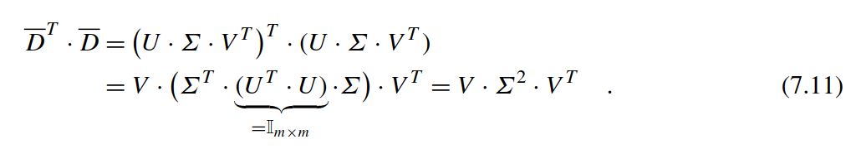

However, instead of computing a costly SVD of the huge centered data matrix D, we apply it directly to the much smaller covariance matrix C. Recall that C is symmetric (C = CT ) and thus we observe that U = V

然而，我们并没有花非常大的代价计算规模较大的中心化数据矩阵D的SVD，而是直接将其应用于小得多的协方差矩阵C。回想一下，C是对称的（C = CT），因此我们观察到U = V，因为



which is the eigenvalue decomposition of the covariance matrix. Note that this is not a rigid mathematical proof but shall sufﬁce for a programming book. We can further exploit the fact that SVD returns the eigenvectors sorted by the magnitude of their eigenvalues which in our case coincide with the singular values stored in *Σ*. Thus the ﬁrst eigenvector captures most of the variance stored in the centered data matrix *D* and so forth. Fig. 7.10 depicts the ﬁrst 16 eigenvectors of the CelebA dataset.

即协方差矩阵的特征值分解。注意，这不是一个严格的数学证明，但是对于一本编程书来说就足够了。我们可以进一步利用SVD返回特征向量的事实，这些特征向量按其特征值的大小排序，在本例中，特征值与存储在*Σ*其中的奇异值一致。因此，第一个特征向量捕获了存储在中心数据矩阵D中的大部分方差，以此类推。图7.10描绘了CelebA数据集的前16个特征向量。

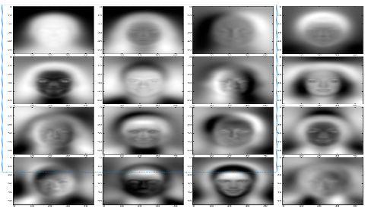

**FIGURE 7.7**

The top-16 eigenvectors *(u(*0*),...,u(*15*))* each of shape 55 × 45 computed from the covariance matrix *C* of the centered images *v(i)* stored in the CelebA dataset. The images are sorted by the magnitude of their corresponding eigenvalue in descending order (row-major indexing). The eigenvectors are ideally suited for the lossy compression of celebrity photos due to their strong similarity with human faces. Moreover, one can observe that the ﬁrst eigenfaces encode low frequency structures of a typical face while those with higher indices reassemble facial features in the high frequency domain. Note that eigenvectors can be scaled with any non-zero scalar while preserving their mathematical properties. Thus we occasionally observe negative images.

由存储在CelebA数据集中的中心图像v(i) 的协方差矩阵C计算出形状为55×45的前16个特征向量(u(0)，…，u(15))。图像按其对应特征值的大小按降序排列(行主序)。由于名人照片与人脸具有很强的相似性，特征向量非常适合于名人照片的有损压缩。此外，可以看出，第一特征面编码的是典型人脸的低频结构，而索引较高的特征在高频域重新组合面部特征。注意，特征向量可以用任何非零标量来进行缩放，同时保持它们的数学性质。因此，我们偶尔会观察负像。

For the sake of simplicity, we have hidden the call to cusolverDnSgesvd in a device function deﬁned in the svd.hpp header which is distributed with this book.

为了简单起见，我们隐藏了对cusolverDnSgesvdin的调用，它是e svd.hpp头文件中定义的一个设备函数。随本书一起发布

**svd_device(Cov, U, S, V, height, width);**

The matrices Cov, U, and V of shape *n*×*n* have to be provided as device pointers. Moreover, the diagonal matrix of singular values S is represented as device array of length *n*. Afterwards, the *n* eigenvectors each of length *n* are stored in the rows of the matrix U. Finally, we transfer U to the host matrix eigs and subsequently write the top-16 candidates to disk.

形状n×n的矩阵Cov、U和V必须作为设备指针提供。此外，奇异值S的对角矩阵用长度为n的设备端数组表示。然后，将每个长度为n的n个本征向量存储在矩阵U的行中。最后，我们将U转移到主机矩阵eigs，然后将前16位候选者写入磁盘。

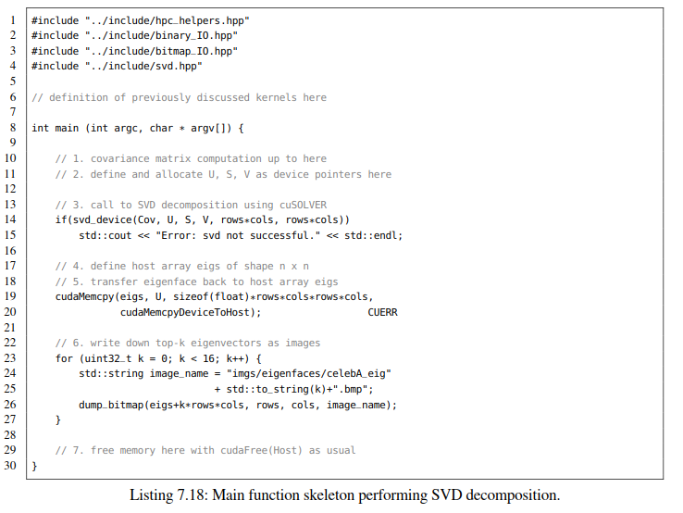

Listing 7.18: Main function skeleton performing SVD decomposition.

清单7.18：执行SVD分解的主要函数骨架

Having come to the end, let us brieﬂy discuss a useful application of eigenfaces. Assume we want to approximate an image of a face *v* ∈ R*n* with merely *k << n* values instead of storing all *n* pixels. This can be achieved by projecting **the mean adjusted face *v* = *v* − *μ* onto the top-*k* eigenvectors.** The new feature representation of the image *v* consists of *k* features *(f*0*,...,fk*−1*)*:

最后，让我们简要讨论一个特征面的应用。假设我们想要用k << n个值来近似人脸v∈R*n*的图像，而不是存储所有n个像素。这可以通过将均值调整后的脸v = v – μ映射到top-k特征向量上。图像v的新特征由k个特征(f0，…，fk - 1)来表示：



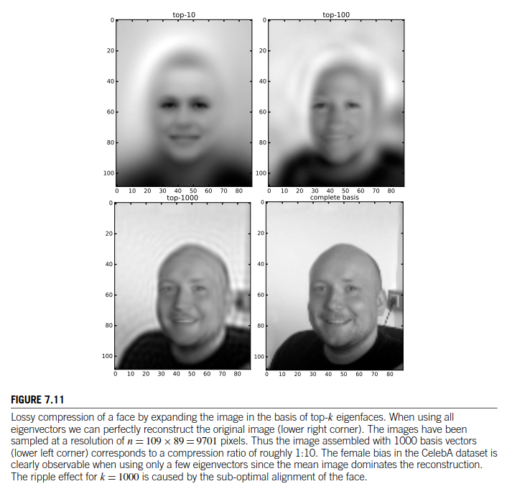

Lossy compression of a face by expanding the image in the basis of top-k eigenfaces. When using all eigenvectors we can perfectly reconstruct the original image (lower right corner). The images have been sampled at a resolution of n = 109 × 89 = 9701 pixels. Thus the image assembled with 1000 basis vectors (lower left corner) corresponds to a compression ratio of roughly 1:10. The female bias in the CelebA dataset is clearly observable when using only a few eigenvectors since the mean image dominates the reconstruction. The ripple effect for k = 1000 is caused by the sub-optimal alignment of the face.

图7.11 ：在top-k特征面的基础上，对图像进行有损压缩。执行SVD分解的主要函数骨架. 当使用所有的特征向量时，我们可以完美地重建原始图像(右下角)。图像的分辨率为n = 109×89 = 9701像素。因此，由1000个基向量组合而成的图像(左下角)的压缩比约为1:10。当仅使用少量特征向量时，CelebA数据集中的女性偏倚是可以明显观察到的，因为重构中以平均图像为主。k = 1000时的纹波效应是由曲面的次优对准引起的。

Where< ·|·> denotes the standard scalar product in Euclidean space. The reconstruction of the original image *v* is straightforward – we simply expand the mean adjusted image *v* in the basis of eigenvectors:

< ·|·> 表示欧几里德空间中的标准标量积. 原始图像v的重构很简单--我们简单地对基于特征向量的图像V调整后的均值进行扩展:

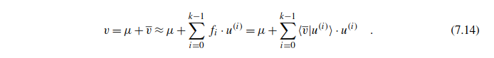

Note that in the case *k* = *n* we can reconstruct *v* perfectly since we have expanded it in a complete basis of *n* linearly independent vectors *(u(*0*),...,u(n*−1*))* . For *k < n* we obtain a lossy approximation of the original image (see Fig. 7.11).

注意，在k = n的情况下，我们可以完美地重构v，因为我们把它展开成了n个线性无关向量*(u(*0*),...,u(n*−1*))*组成的完全基。对于k < n，我们得到原始图像的有损近似（见图7.11）

**7.4 MEMORY HIERARCHY (DYNAMIC TIME WARPING)**

内存层次结构(动态时间warping)

In the previous section, you have learned how to properly exploit memory access patterns and shared memory to signiﬁcantly speed up the performance of CUDA kernels. This section elucidates the beneﬁts and tradeoffs of shared memory in more detail. Furthermore, we will employ other types of memory, namely texture memory and constant memory, to further reduce the execution times of CUDA applications.

在上一节中，您已经学习了如何正确利用内存访问模式和共享内存，从而显着提高CUDA内核的性能。 本节更详细地阐述了共享内存的优势和权衡。此外，我们将使用其他类型的内存，即纹理内存和常量内存，以进一步减少CUDA应用程序的执行时间。

Throughout this section we will implement an algorithm for the elastic comparison of time-resolved sequences stemming from the ﬁeld of time series data mining the so-called Dynamic Time Warping (DTW) similarity measure. Before we start coding, let us deﬁne the term time series and discuss the DTW algorithm.

在本节中，我们将实现时间序列数据挖掘领域的时间分辨序列的弹性比较算法——即动态时间翘曲(DTW)相似性度量。在开始编码之前，让我们先定义时间序列这个术语并讨论DTW算法。

INTRODUCTION

介绍

This subsection is mainly used to provide a brief introduction into the elastic matching of time series and to ﬁxate some important notations. If you are already familiar with the topic feel free to skip it.

本小节主要用于简要介绍时间序列的弹性匹配，和注意一些重要的符号。 如果已经对此非常熟悉，请自行绕过。

**Deﬁnition 1** (Uniform time series)**.** Let R be the set of real numbers and further *T* =a ﬁnite sequence of *n* real-valued, uniformly spaced, and ordered time stamps, i.e.,

定义1（统一的时间序列）。设R是实数的集合，T= *(t*0*,t*1*,...,tj ,..., tn*−1*)*为 n个实值的有限序列，均匀间隔，有序的时间戳，比如：



then a mapping of the time stamps onto real values tj → Stj is called real-valued and uniform time series over the real domain.

然后，将时间戳映射到实数值tj→Stj， 即在实数域上称为实值和统一时间序列。

The particular values of the time stamps are often neglected. Slightly abusing notation, the mapping of *n* time stamps *tj* → *Stj* can be rewritten as plain vector by enumerating the measured values with indices ranging from 0 to *n* − 1:

时间戳的特定值常常被忽略。略为滥用符号，n个时间戳tj→Stj的映射可以用索引从0到n - 1的实测值枚举，将其改写为平面向量:



This definition can be naturally extended to higher-dimensional values Sj ∈ Rd or non-uniformly spaced or continuous time domains. However, for the sake of simplicity, we limit ourselves to this simple scenario.

该定义可以自然地扩展到更高维值Sj∈Rd或非均匀间隔或连续时域。 但是，为了简单起见，我们仅限于这种简单的场景。

Time series are ubiquitous. They can be found in almost any ﬁeld of research, e.g., natural science, ﬁnance or medical applications. This includes the measurement of physical quantities over time such as voltage, pressure, and speed, exchange rates or stock prices as well as electrocardiograms. Fig. 7.12 shows two further daily life examples. Moreover, pseudo time series exclusively exhibiting discrete values can be found in many other domains, e.g., DNA or protein sequences and strings in natural language processing. The discussed concepts and techniques are also applicable to those domains with only minor modiﬁcation of the source code. Actually, the to be discussed wavefront relaxation scheme of DTW was ﬁrst applied during parallelization of a sequence alignment algorithm in bioinformatics.

时间序列无处不在。它们几乎可以在任何研究领域中找到，例如自然科学，金融或医学应用。包括测量随时间变化的物理量，如电压，压力和速度，汇率或股票价格以及心电图. 图7.12显示了日常生活的两个例子。此外，专门展示离散值的伪时间序列可以在许多其他域中找到，例如，DNA或蛋白质序列和自然语言处理中的字符串。仅对源代码进行少量修改，就可以使用在所讨论的概念和技术。 实际上，将讨论的DTW波前松弛方案首次应用于生物信息学中序列比对算法的并行化。

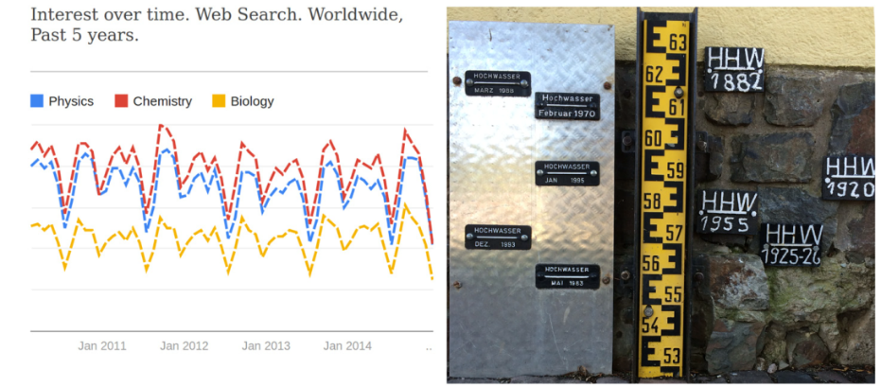

**FIGURE 7.12**

Two examples for the occurrence of time series in daily life. The left panel depicts the search interest for the three scientiﬁc ﬁelds “physics,” “chemistry,” and “biology” as stated by Google Trends. Similar graphs can be obtained for “math” and “computer science.” Obviously, the three graphs are strongly correlated and could be used as an indicator function for lecture periods at universities. The right panel illustrates historic signs for the registration of high tides of the river Rhine in Bingen (Germany). Each sign corresponds to one entry in a time series of water levels.

日常生活中与时间序列有关的两个例子，左面板描述了谷歌Trends对“物理”、“化学”和“生物学”三个科学领域的搜索兴趣。当然 “数学”和“计算机科学”也可以获得此类图表。显然，这三幅图具有很强的相关性可以作为大学课堂教学的指标函数。 右图为宾根(德国)莱茵河涨潮的历史标志每个符号对应于水位时间序列中的一个条目。

Assume you have stored *m* time series *S(i)* of ﬁxed length *n* in a *m*×*n* data matrix *Dij* = *Sj(i)* where *i* denotes the identiﬁer of a particular time series *S(i)* and *j* enumerates its *n* time stamps. Further, you have measured another time series *Q* of length *n* and subsequently want to determine the most similar entry *S(i)* from your data matrix by querying *Q* against your stored data. A canonical notion of similarity dist*(Q,S(i))* between *Q* and a data base entry *S(i)* could be established by computing the *Lp* norm of their difference vector:

假设您将m个固定长度为n的时间序列S(i)存储在m×n的数据矩阵*Dij* = *Sj(i)*  中，其中i表示特定时间序列S(i)的标识符，j枚举其n个时间戳。此外，还测量了另一个长度为n的时间序列Q，接着可以通过查询存储数据的Q来确定数据矩阵中最相似的条目*S(i)* S(i)。通过计算Q与数据库项S(i)之间的差分向量Lp范数，可以建立Q与数据库项S(i)之间相似距离(Q,S(i))的正则概念:

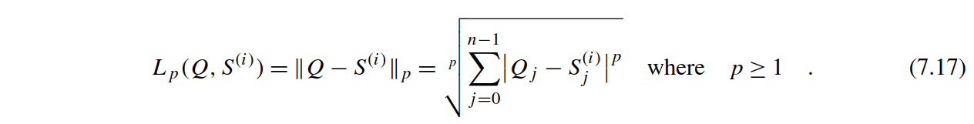

Common values for the external parameter are *p* = 2 for so-called *Euclidean Distance* or *p* = 1 for *Manhattan Distance* which is typically more robust against noise and outliers. Note that we can safely omit the expensive computation of the root due to its monotony property.

外部参数的一般值p = 2，表示所谓的欧式距离, p = 1表示曼哈顿距离，后者通常对噪声和异常值具有更强的鲁棒性。注意，由于其单调性，我们可以安全地忽略根的计算开销。

Despite the frequent use of *Lp* based distance measures in time series data mining, the lock-step computation of differenceslimits their applicability to (approximately) aligned data. More precisely, every index *j* of the query *Q* has to be mapped onto exactly the same index of the subject sequence *S(i)*. This implies, that we have to know the correspondence of time stamps beforehand. Unfortunately, that is not necessarily the case when processing signals from motion sensors or audio recordings since humans tend to perform motions at varying speeds or pronounce syllables of spoken words differently. DTW determines the unknown correspondence of indices by locally shrinking and stretching the time axis.

尽管在时间序列数据挖掘中经常使用基于Lp的距离度量，但差分*Q* − *S(i)* 的锁步计算限制了它们对(近似)对齐数据的适用性。更精确地说，查询Q的每个索引j都必须映射目标序列*S(i)*完全相同的索引上。这意味着，我们必须事先知道时间戳的对应关系。不幸的是，当处理来自运动传感器或音频记录的信号时，情况未必如此，因为人类往往以不同的速度进行运动，或者以不同的发音说出单词的音节。DTW通过局部收缩和拉伸时间轴来确定指标之间的未知对应关系。

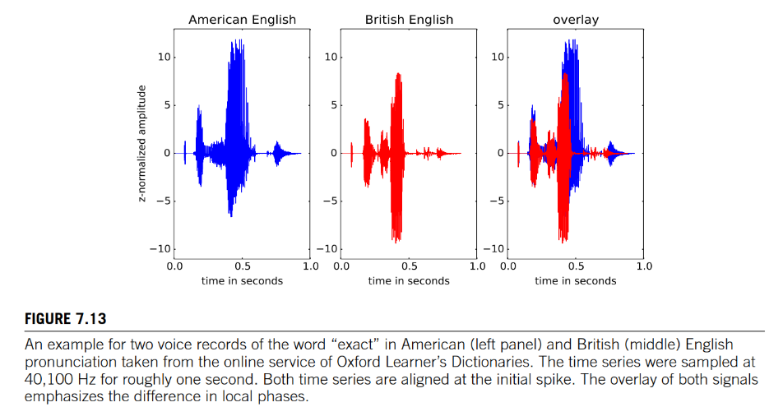

**FIGURE 7.13**

An example for two voice records of the word “exact” in American (left panel) and British (middle) English pronunciation taken from the online service of Oxford Learner’s Dictionaries. The time series were sampled at 40,100 Hz for roughly one second. Both time series are aligned at the initial spike. The overlay of both signals emphasizes the difference in local phases.

例如，从牛津学习词典的在线服务中提取了美国(左)和英国(中)单词“exactly”的两个语音记录。时间序列在40100Hz 采样大约一秒钟。两个时间序列在初始峰值处对齐。两种信号的叠加强调了局部相位的差异。

As an example, consider two voice recordings of the word “exact.” The online service of Oxford Learner’s Dictionaries [18] speciﬁes the same pronunciation for both American and British English. However, the provided recordings differ slightly in the length of syllables. The American speaker spends more time on the “a” than his British counterpart. Fig. 7.13 visualizes both voice records and a direct comparison of both time series. Obviously, both recordings have similar shape but occasionally tend to be out of phase. Thus a rigid one-to-one mapping of indices is apparently not advisable. The simplest approach to ﬁx the phase shifts would be the local adjustment of the time-axis in such a manner that both speakers spend the same time on each syllable. In 1994, Berndt and Clifford introduced such a time-warping mechanism to the data mining community [1] which was developed before by Sakoe and Chiba in 1978 [19] in the ﬁeld of speech recognition. Fig. 7.14 illustrates the idea of local shrinking and stretching of the time-axis for the two given voice recordings.

例如，考虑两个“准确”一词的发音。牛津学习者词典Oxford Learner's Dictionaries [18]的在线服务为美国和英国英语提供相同的发的音。然而，所提供的录音在音节长度上略有不同。美国人比英国人花更多的时间在“a”上。图7.13显示了两个语音记录和两个时间序列的直接比较。很明显，这两种录音的形状相似，但有时会出现反相。因此，索引的严格一对一映射显然是不可取的。固定相位偏移最简单的方法是对时间轴进行局部调整，使两个说话者在每个音节上花费相同的时间。1994年，Berndt和Clifford将这种时间扭曲机制引入到之前Sakoe和Chiba在1978年[19]在语音识别领域开发的数据挖掘社区[1]中。图7.14给出了两个给定语音记录的时间轴的局部收缩和拉伸的思想。

In the following, we develop a formal description for the dynamic deformation of the time-axis. However, we do not want to allow arbitrary mappings between the index sets of the query *Q* and the subject *S(i)* and therefore impose the following restriction. Consider the Cartesian product of index domains *J* = *(*0*,...,j,...,n* − 1*)* and *J*′ = *(*0*,...,j*′*,...,n* − 1*)* of all possible combinations of time stamps stemming from the query and subject sequence

接下来，我们对时间轴的动态变形进行了形式化描述。但是，我们不希望允许查询Q的索引集与主题S之间的任意映射，因此我们施加了以下限制。考虑索引域J *J* = *(*0*,...,j,...,n* − 1*)*和J *J*′ = *(*0*,...,j*′*,...,n* − 1*)*的笛卡尔积，这些索引域包含来自查询和主题序列的所有可能的时间戳组合



hen we are interested in a path that begins at the node *(j* = 0*,j*′ = 0*)* and ends at *(j* = *n* − 1*,j*′ = *n* − 1*)*. This implies that the ﬁrst/last entries of both time series are matched onto each other resulting in a global alignment of time series. During the further matching of indices, we impose that beginning from *(*0*,*0*)* we have to increment either the indices *j*, or *j*′, or both by one until we ﬁnally reach *(n* − 1*,n* − 1*)*. Loosely speaking, we locally decide either to forward the time of the query, the subject, or both. Hence, each index in the query and the subject is at least matched once. Moreover, this monotonic mapping of indices prohibits loops resulting in a directed acyclic graph (DAG) with nodes *V* = {*(j,j*′*)*} and directed edges from the set where

当我们对从结点开始*(j* = 0*,j*′ = 0*)*到结点结束t *(j* = *n* − 1*,j*′ = *n* − 1*)*的路径感兴趣时。这意味着两个时间序列的第一个/最后一个条目相互匹配，从而导致时间序列的全局对齐。在进一步匹配指标的过程中，我们要求从(0,0)开始，我们必须将指标j或j '或两者都加1，直到最终达到(n - 1,n - 1)。简而言之，我们在本地决定转发查询时间，主题或两者都转发。 因此，查询中的每个索引和主题至少匹配一次。此外，这种索引的单调映射禁止循环，从而产生具有节点V *V* = {*(j,j*′*)*}和来自该集合*E* ⊆ *V* × *V*的有向边的有向非循环图(DAG)



A warping path γ is a sequence of nodes (0,0),...,(n − 1,n − 1) from the set of all paths Γ which are compatible with the described edge scheme. Let us summarize that with a deﬁnition:

γ变形路径是一个序列的节点集 (0,0),...,(n − 1,n − 1)的所有路径Γ兼容边缘描述方案。让我们用定义来总结一下:

**Deﬁnition 2.** Let *J* := dom *Q* and *J*′ := dom *S(i)* be the index sets of the time series *Q* and *S(i)*, then the sequence of tuples *γ* := *(jl,jl*′*)* ∈ *J* × *J*′ *l* is a monotone, continuous, and bounded warping path if and only if

定义 2. *J* := dom *Q，J*′ := dom *S(i)为时间序列Q和S(i)*的索引集，元组的序列*γ* := *(jl,jl*′*)* ∈ *J* × *J*′ *l* 是单调的、连续的、有界的翘曲路径吗当且仅当

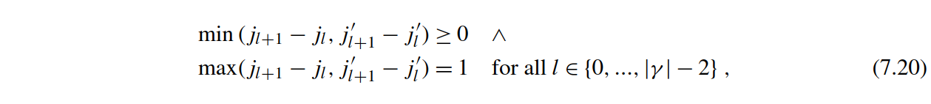

where *(j*0*,j*0′*)* = *(*0*,*0*)* and *(j*|*γ*|−1*,j*|′*γ*|−1*)* = *(*|*Q*| − 1*,*|*S(i)*| − 1*)*.

**这里*(j*0*,j*0′*)* = *(*0*,*0*)*， *(j*|*γ*|−1*,j*|′*γ*|−1*)* = *(*|*Q*| − 1*,*|*S(i)*| − 1*)*.**

Finally, we deﬁne a weighting function that assigns the squared distance between the corresponding values belonging to the incoming (right) node of each edge

最后，我们定义了一个加权函数，它分配属于每条边的传入(右)节点的对应值之间的平方距离。



Usually, the weighting function is designed to express similarity. In our case a weight is zero if the difference of combined time series entries vanishes. By contrast, alignment algorithms from the ﬁeld of Bioinformatics such as Needleman–Wunsch (NW) or Smith–Waterman (SW) assign positive/high values for matches and negative/small values for mismatches or insertion and deletions. Thus DTW aims to minimize while NW and SW maximize weights. Concluding, the objective of DTW is to ﬁnd the optimal warping path *γ*ˆ out of all valid paths *Γ* that minimizes the accumulated weights along the matched nodes.

通常，权重函数是用来表示相似性的。在本例中，如果组合时间序列项的差消失，则权重为零。相比之下，来自生物信息学领域的对齐算法（如Needleman–Wunsch（NW）或Smith-Waterman（SW））如果匹配，则赋值为正或较高值，如果不匹配，或者插入和删除，则赋值为负或较小的值。 因此，DTW旨在最小化，而NW和SW的目标旨在权重最大化。总之，DTW的目标是从所有有效路径Γ中找出最佳warping path *γ*ˆ，其沿着匹配节点使累积权重最小化。

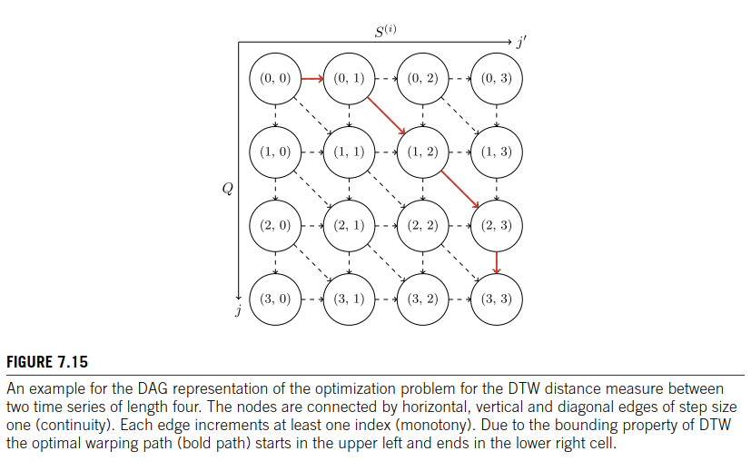

**FIGURE 7.15**

An example for the DAG representation of the optimization problem for the DTW distance measure between two time series of length four. The nodes are connected by horizontal, vertical and diagonal edges of step size one (continuity). Each edge increments at least one index (monotony). Due to the bounding property of DTW the optimal warping path (bold path) starts in the upper left and ends in the lower right cell

给出了长度为4的两个时间序列间DTW距离测量优化问题的DAG表示。节点由步长为1的水平、垂直和对角边连接(连续)。每条边至少增加一个索引(单调)。由于DTW的边界特性，最优的整经路径(粗体路径)从左上角开始，到右下角结束

**Deﬁnition 3** (DTW)**.** Let *Γ* be the set of all monotone, continuous, and bounded warping paths. The optimal warping path *γ*ˆ and its associated measure *d*ˆ with respect to a given weighting function *w* : *J* × *J*′ → R0+ are deﬁned as:

定义3（DTW）。*Γ*为是所有单调、连续和有界的弯曲路径的集合。相对于给定加权函数*w* : *J* × *J*′ → R0+ 的最佳warping路径γ及其相关度量d被定义为：

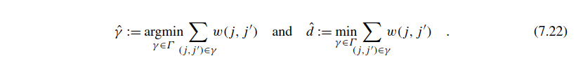

Fig. 7.15 depicts a sketch of the described graph representation. This optimization problem is equivalent to the calculation of a shortest path within the aforementioned DAG. Each cell *(j,j*′*)* is represented by a node and has maximal three incoming edges with associated weights *w(j,j*′*)*. The **Single-Source Shortest Path** problem on DAGs can be solved in linear time *O(*|*V* | + |*E*|*)* by the relaxation of nodes in topological order [2]. Fortunately, we do not need to compute a topological sorting beforehand since it is implicitly given by enumerating the cells in lexicographic order. We can consecutively relax the cells in row-major order without violating node dependencies (see Fig. 7.15). In practice the computation is achieved by **dynamic programming** using a matrix of size |*Q*| + 1 × |*S(i)*| + 1 = *(n* + 1*)* × *(n* + 1*)*.

The corresponding relaxation scheme can be written recursively

图7.15描绘了所述图表示的草图。这个优化问题等价于上述DAG中最短路径的计算, 每个单元(j,j′)由一个节点表示，并具有最大的三条输入边，其权值为 *w(j,j*′*)*. DAG上的单源最短路径问题可以通过松弛拓扑顺序中的节点[2]，在线性时间*O(*|*V* | + |*E*|)中求解。幸运的是，我们不需要事先计算拓扑排序，因为它是通过按字典顺序枚举单元格来隐式给出的。我们可以在不违反节点依赖性的情况下以行主顺序连续放松单元格（见图. 7.15） 在实际应用中，计算是通过使用一个矩阵大小的动态规划来实现的e |*Q*| + 1 × |*S(i)*| + 1 = *(n* + 1*)* × *(n* + 1*)*.

相应的松弛方案可以递归地写出来：

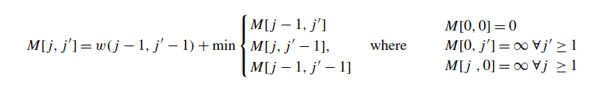

As a result, the ﬁnal DTW measure *M* |*Q*|*,*|*S(i)*| = *M*[*n,n*] can be computed in *O* |*Q*| · |*S(i)*| =*O* *n*2 time.5 The optimal warping path *γ*ˆ is determined by back-tracing the predecessor information stored in a separate matrix. The *Lp*-norm is a special case where *γ* consists only of nodes on the main diagonal. Hence, the Euclidean-ﬂavored DTW meas fulﬁlls the inequality DTW *Q,S(i)* ≤ ED *Q,S(i)* for all time series *Q,S(i)* of the same length.

因此，最终的DTW测量M = M可以在O |Q|·|S(i)| =O n2时间内计算出来 。最优warping路径γˆ是由通过回溯存储在单独matri中的前置信息决定的。*Lp*-norm是一种特殊情况，这里γ只包含主对角线上的节点。因此，对于长度相同的所有时间序列*Q,S(i)*，欧式DTW测量方法满足不等式DTW *Q,S(i)* ≤ ED *Q,S(i)* 。

**A LINEAR MEMORY ALGORITHM FOR SEQUENTIAL DTW**

序列化DTW的线性存储算法

Having revisited the theoretical fundamentals we can start to write a ﬁrst sequential program that compares a query *Q* with *m* time series *S(i)* stored in a data matrix *D*. In our experiments we will process *m* = 220 = 1*,*048*,*576 time series each of length *n* = 128 from the popular Cylinder–Bell–Funnel (CBF) dataset. CBF is a synthetically created set of time series consisting of three characteristic classes. The generating functions for the classes are given as follows [12]:

重温了理论基础之后，我们可以开始编写第一个顺序程序，将查询Q与存储在数据矩阵D中的m个时间序列S(i)进行比较。在实验中，我们将从流行的Cylinder-Bell-Funnel（CBF）数据集中来处理每个长度为n = 128的m个时间序列。在我们的实验中，我们将从流行的圆柱形钟形漏斗(CBF)数据集中处理*m* = 220 = 1*,*048*,*576 个长度为n = 128的时间序列。其中，CBF是由三个特征类组成的综合创建的时间序列集。这些类的生成函数如下所示[12]:

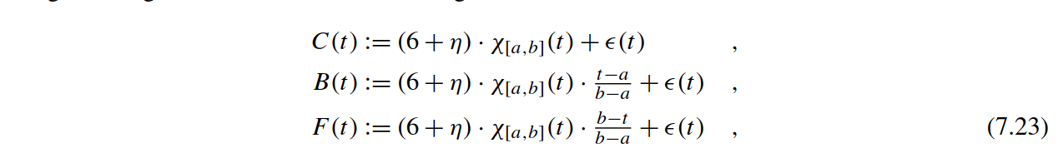

where *t* ∈ {0*,...,*127}, *χ*[*a,b*] the indicator function on [*a,b*], *η* as well as *ǫ(t)* drawn from a standard normal distribution *N(μ* = 0*,σ* = 1*)*, *a* an integer uniformly drawn from the interval [16*,*32], and *b* − *a* an integer uniformly drawn from [32*,*96]. As a result, CBF exhibits a reasonable variability in the amplitudes (*η*) and time-dependent noise on the measurement-axis (*ǫ(t)*) as well as variable length and position of the shape’s support on the time-axis (*χ*[*a,b*]). Fig. 7.16 depicts a family of time series for each of the three classes. For the sake of simplicity, we provide a generate_cbf method deﬁned in the cbf_generator.hpp header ﬁle which allows for the convenient sampling of time series from the CBF dataset.

其中t∈{0，…127},*χ*[*a,b*] 为在[a, b]上的 指标函数,η以及*ǫ(t)* 来自一个标准正态分布*N(μ* = 0*,σ* = 1*)。*a 为从区间[16,32] 统一绘制的整数。b – a为来自[32,96]的统一绘制的整数。因此，CBF在测量轴（ǫ（t））上显示出幅度（η）和时间相关噪声的合理变化，以及时间轴上形状支撑的可变长度和位置(*χ*[*a,b*])。图7.16描绘了三个类别中每个类别的一系列时间序列。为了简单起见，我们在cbf_generator.hpp头文件中提供了一个generate_cbf方法，它可以从CBF数据集中方便地采样时间序列。

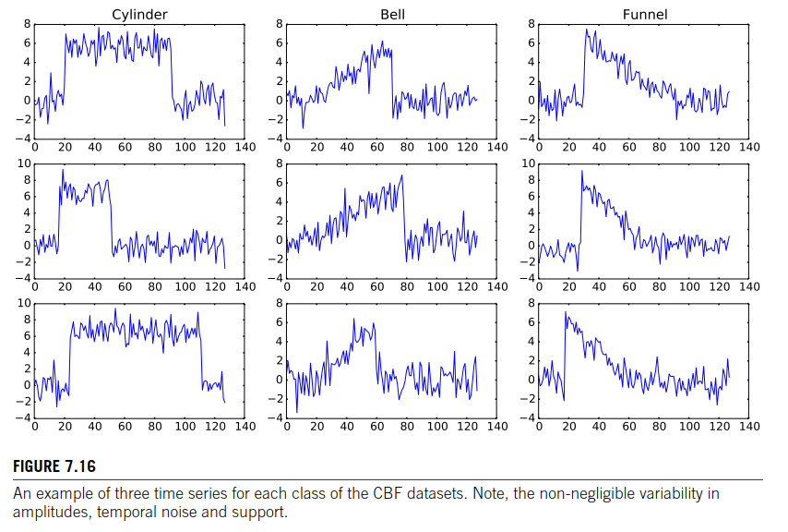

**FIGURE 7.16**

An example of three time series for each class of the CBF datasets. Note, the non-negligible variability in amplitudes, temporal noise and support.

每个CBF数据集类的三个时间序列的示例。注意，在振幅，时间噪声和支持不可忽略的差异性。

Now we implement a sequential version of DTW for arbitrary numerical data types that support addition, subtraction, and the minimum operation (see Listing 7.19). The query and subject are passed as pointers of type value_t and their length is encoded by the argument num_features of type index_t. In Line 11 we allocate the aforementioned penalty matrix *M* of shape *(n* + 1*)* × *(n* + 1*)*. The initialization is accomplished in Lines 14–16 by setting every entry of the ﬁrst row and ﬁrst column to inﬁnity, except the upper left corner *M*[0*,*0] which is set to zero. This mimics the missing incoming edges at the border of the graph. The two for-loops traverse the nodes *(j,j*′*)* = *(*row*,*col*)* of the DAG in lexicographic order. The registers diag, abve and left store the accumulated cost of the diagonal cell *(j* − 1*,j*′ − 1*)*, above cell *(j* − 1*,j*′*)* and left cell *(j,j*′ − 1*)* of *M*. Afterwards, their minimum is added to the weight *w(j* − 1*,j*′ − 1*)* = residue * residue of the corresponding node and sub- sequently stored in *M*[*j,j*′] (see Line 33). Recall that this greedy relaxation scheme produces the globally optimal solution on weighted DAGs since it respects the topological sorting [2]. Finally, the lower right corner of the penalty matrix *M*[*n,n*] coincides with the measure of the shortest and thus optimal warping path *γ*ˆ.

现在，我们实现了支持任意数值数据类型的DTW顺序版本，该版本支持加法，减法和最小操作(见清单 7.19).。query 和 subject分别为value_t类型的指针，query 和 subject的长度由index_t类型num_features带入。在第11行中，我们分配前面提到的形状为(n + 1) × (n + 1)的惩罚矩阵M。 第14-16行中完成初始化，除了左上角M[0,0]被设为0外，将第一行和第一列的每个条目设置为无穷大。 这模拟了图的边缘上缺失的传入边。两个for循环按字典顺序遍历DAG的节点*(j,j*′*)* = *(*row*,*col*)*。寄存器diag、abve和left存储对角线单元*(j* − 1*,j*′ − 1*)*的累计成本，M上面的单元和右边的单元。然后，将它们的最小值添加到相应节点的权值*w(j* − 1*,j*′ − 1*)* = residue * residue中，并按子顺序存储在*M*[*j,j*′] (见33)。回想一下，这种贪婪的放松方案可以在加权DAG上产生全局最优解，因为它采用的是拓扑排序。最后，惩罚矩阵 *M*[*n,n*]的右下角与最短且因此获得最佳的warping 路径*γ*ˆ.一致。

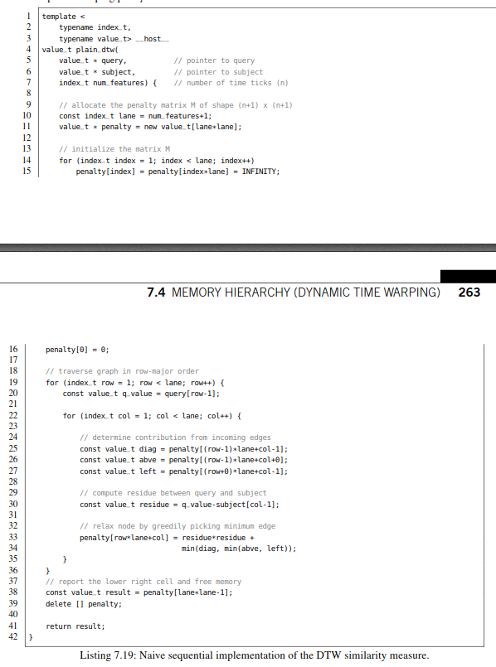

清单7.19：Naive sequential implementation of the DTW similarity measure.DTW

相似性度量的简单顺序实现。

The plain DTW function can now be called in parallel using OpenMP or any other threading library. Note that the DTW call remains sequential.

可以使用OpenMP或任何其他线程库并行调用DTW函数。 请注意，DTW任然是顺序的。

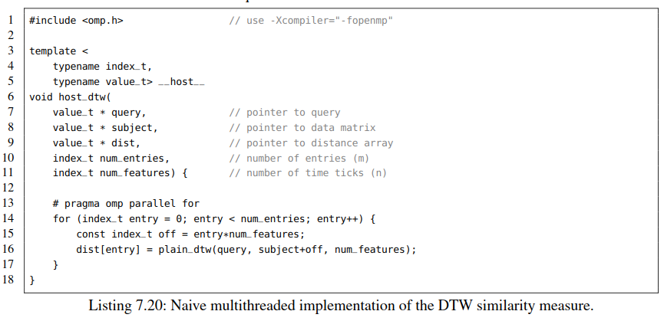

清单7.20：DTW相似性度量的简单多线程实现。

The major drawback of this implementation is the quadratic memory consumption of the cost matrix *M*. Assume we want to concurrently query a float-valued times series of length *n* = 128 against *m* = 220 time series then we have to allocate sizeof(float)·*(n*+1*)*2 ·*m* ≈ 65 GB of memory. Fortunately, we can modify the quadratic memory algorithm to only use linear memory occupying sizeof(float)· 2 · *(n* + 1*)* · *m* ≈ 1 GB which easily ﬁts into the RAM of a GPU. This can be achieved as follows. The relaxation of a cell *M*[*i,j*] only depends on two cells (diagonal and above) from the previous row and on one cell (left) in the same row. Thus it is sufﬁcient to store merely two rows each of length *n* + 1 and subsequently interleave them using a cyclic indexing scheme.

该实现的主要缺点是成本矩阵M的二次内存消耗。假设我们想并发地从*m* = 220时间序列中查询长度为n = 128的浮点值得时间序列，那么我们需要分配sizeof(float)·(n+1)2·m≈65 GB内存。幸运的是，我们可以修改二次内存算法，使其仅使用线性内存即占用size (float)·2·(n + 1)·m≈1gb，很容易就可以装入GPU的RAM中。这可以做到如下。一个M[i,j]的单元格relaxation松弛只依赖于前一行中的两个单元格(对角线和之上的)和同一行中的一个单元格(左边的)。因此，只存储长度为n + 1的两行就足够了，然后使用循环索引方案将它们交错放置。

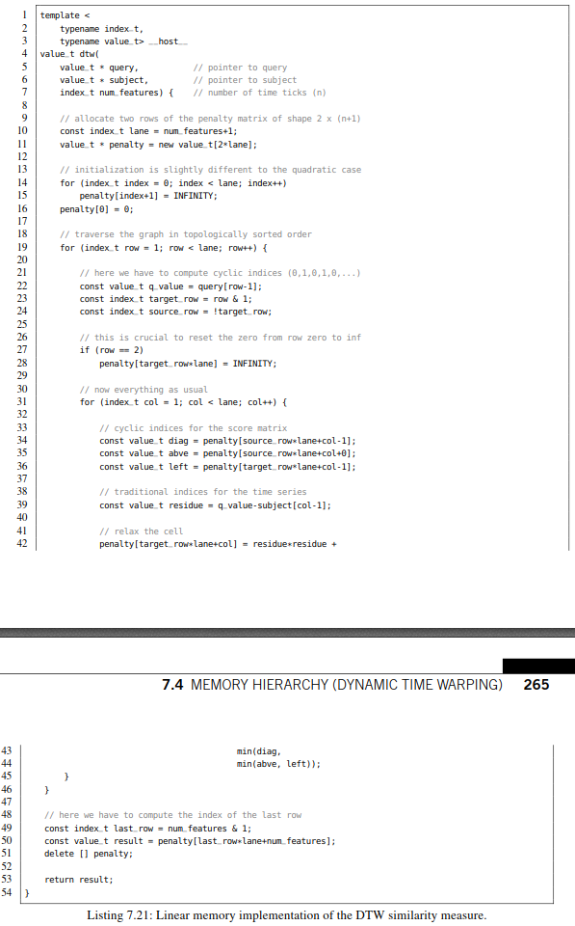

清单7.21： DTW相似性度量的线性内存实现

At this point, we can call the host_dtw method in the main function. The corresponding code snippet is shown in Listing 7.22. First, we allocate host-sided memory for the storage of the time series **data** and the distance vector **dist** in Lines 20–23. Second, we generate *m* = 220 database entries each of length *n* = 128 in Line 32 using the generate_cbf method deﬁned in the header ﬁle cbf_generator.hpp. For the sake of simplicity, we have chosen *Q* = *S(*0*)* in this example. Hence, we pass the data pointer as ﬁrst argument which is reserved for the query and, as expected, again as second argument which corresponds to the database. The array labelsstores the class labels being either 0 (Cylinder), 1 (Bell), or 2 (Funnel). They are used later for a simple consistency check. Third, we compute all DTW distances using a call to host_dtw in Line 32. Finally, we print some distance scores and clean up the memory.

此时，我们可以在main函数中调用host_dtw方法。相应的代码片段如清单7.22所示。首先，第20-23行分配主机端内存来存储时间序列**data**和距离向量 **dist**。其次，在第32行，使用头文件cbf_generator.hpp中定义的generate_cbf方法生成*m* = 220个长度为n = 128的数据库条目。为简单起见，我们在此示例中选择*Q* = *S(*0*)* 。因此，我们将data指针作为第一个参数传递，该参数是为查询保留的，并且如预期的那样，再次作为对应于数据库的第二个参数。数组 labels存储的类标签要么为0 (Cylinder), 要么为1 (Bell), 要么为 2 (Funnel). 稍后将使用它们进行简单的一致性检查。32行通过对host_dtw的调用来完成所有的DTW距离的计算。最后，我们打印出距离分数并清理内存

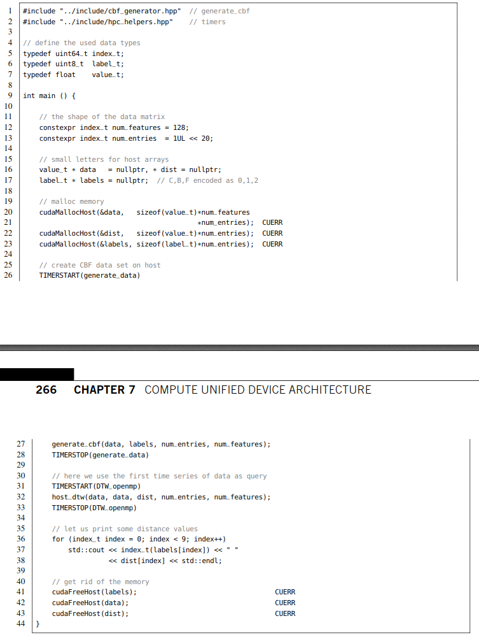

Listing 7.22: Host implementation of one-versus-all DTW computation.

**清单7.22： one-versus-all DTW计算的主机端实现**

When executing this program on a dual socket Intel Xeon E5-2683 v4 (2.1 GHz) CPU we need roughly 92 seconds to sequentially compute the 220 DTW scores using only the master thread. The multithreaded variant which harnesses all 2 × 16 physical cores scales almost linearly resulting in proximately 2.9 seconds execution time. The program’s output shows the ﬁrst nine computed distance scores (right column) with their corresponding class labels (left column). As expected, the distance between the query *Q* = *S(*0*)* and the ﬁrst database entry *S(*0*)* vanishes. Moreover, we observe that DTW distance to other Cylinder instances (0) is signiﬁcantly smaller than to Bell (1) and Funnel entries.

**当在Intel Xeon E5-2683 v4 (2.1 GHz)双核CPU上执行这个程序时，仅使用主线程，我们需要大约92秒才能顺序计算** 220 **DTW 分数。使用所有2×16物理内核的多线程版本几乎可以达到线性扩展，其执行时间接近2.9秒。程序的输出显示了前九个计算的距离分数(右列)及其对应的类标签(左列)。正如预期，查询***Q* = *S(*0*)***和第一个数据库条目***S(*0*)***之间的距离消失。此外，我们还发现，DTW到其他圆柱体实例**(0)**的距离明显小于到钟形**Bell (1)**和漏斗形入口的距离。**

**TIMING: 901.758 ms (generate_data)**

**TIMING: 2894.01 ms (DTW_openmp)**

**0 0**

**1 175.457**

**2 319.968**

**0 6.02721**

**1 158.446**

**2 281.643**

**0 18.9647**

**1 157.522**

**2 179.027**

A common performance metric for dynamic programming-based alignment algorithms is the number of cell updates per second (CUPS). In our case, we have relaxed 1282 cells in each of the 220 score matrices which results in 190 MCUPS for the sequential version using a single core and 6 GCUPS for the multithreaded variant harnessing all cores of two Xeon CPUs. In the following, we will develop a CUDA parallelization that performs at 34 GCUPS on a single Pascal-based Titan X GPU.

基于动态编程的对齐算法的一个常见性能指标是每秒的单元格更新数(CUPS)。在我们的例子中，我们在220个得分矩阵的每一个中放松了1282个单元，这种情况下，使用单个核心的顺序版本性能为190 MCUPS，而使用两个Xeon CPU的所有核心的多线程版本的性能为6 GCUPS。 在下文中，我们将开发一个CUDA并行化版本，在基于Pascal的单个Titan X GPU可以达到34 GCUPS。

**A NAIVE CUDA PORT OF LINEAR MEMORY DTW (P270 20190326)**

线性存储DTW CUDA移植

Assume we have already copied the host-sided database data from the host to an appropriate device array Data and further allocated memory for the device-sided distance vector Dist. An obvious paral- lelization strategy would be the computation of one DTW score per CUDA thread. Consequently, we have to allocate 2 ·*(n*+1*)* cells of the score matrix in each thread when employing the aforementioned linear memory scheme. Conceptually, we already know four kinds of user-modiﬁable memory:

假设我们已经将主机侧数据库data从主机复制到适当的设备数组Data，并进一步为设备端距离向量Dist分配了内存。一个明显的并行化策略是用每个CUDA线程来计算一个DTW分数。因此，当采用上述线性存储器方案时，每个线程必须得分配包含2·（n + 1）个单元的分数矩阵。 从概念上讲，我们已经知道了四种用户可修改的内存：

• **global memory:** We could pass an auxiliary array Cache to the kernel which resides in the global memory of the GPU in order to store the score matrices.

• **local memory:** The same could be achieved by deﬁning static arrays, so-called local memory, inside the kernel body.

• **shared memory:** Alternatively, we could reserve scratchpad memory to beneﬁt from faster access times. Unfortunately, we have to deal with its small size.

• **registers:** The reasonable amount of registers per SM could be used to store the score matrix. However, it is not obvious how to enumerate them in a for-loop.

•全局内存：我们可以将辅助数组Cache传递给内核，该Cache驻留在GPU的全局内存中，以便存储分数矩阵。

•本地内存：通过在kernel内定义静态数组，即所谓的本地内存，可以实现同样的目的。

•共享内存：或者，我们可以预留暂存器内存，以便从更快的访问时间中受益。 不幸的是，我们必须处理它的小尺寸。

•寄存器：给每个SM分配合理数量的寄存器用于存储分数矩阵。 但是，如何在for-loop中枚举它们并不明显。

In this subsection, you will learn how to employ the ﬁrst two strategies. Furthermore, we will demon- strate, that in most cases accesses to local memory coincide with interleaved accesses to global memory, a fact that is surprisingly unknown among CUDA programmers. In detail, we will investigate another example for coalesced and non-coalesced memory access patterns which are now hidden behind primitives of the CUDA programming language.

在本小节中，将学习如何使用之前的两个策略。此外，发现在大多数情况下对本地存储器的访问与对全局存储器的交错访问一致，令人惊讶的是，CUDA程序员对此一无所知。详细地说，我们将研究合并和非合并内存访问模式的另一个例子，这些模式隐藏在CUDA编程语言的原语之中。

Let us start coding. The signature of the kernel in Listing 7.23 is straightforward: we pass the device pointers to the query of length *n*, the subject database of shape *m*×*n*, the distance vectors of length *m*, and the auxiliary memory Cache of shape *m* × 2 · *(n* + 1*)*. Afterwards, we compute the global thread identiﬁer thid which enumerates the time series in the database and determine the index offset base addressing the ﬁrst time tick of each subject sequence. The constant laneis deﬁned for convenience to simplify the indexing scheme.

开始编码，代码清单7.23中的内核签名很简单：设备指针指向长度为n的查询，subject指向形状为m×n的数据库，长度为m的距离向量，形状为m × 2 · (n + 1) 的辅助内存缓存。然后，我们计算全局线程标识符thid，该标识符枚举数据库中的时间序列，并确定寻址每个主题序列的第一个时间标记的索引偏移base。为了简化索引方案定义了常量lane。

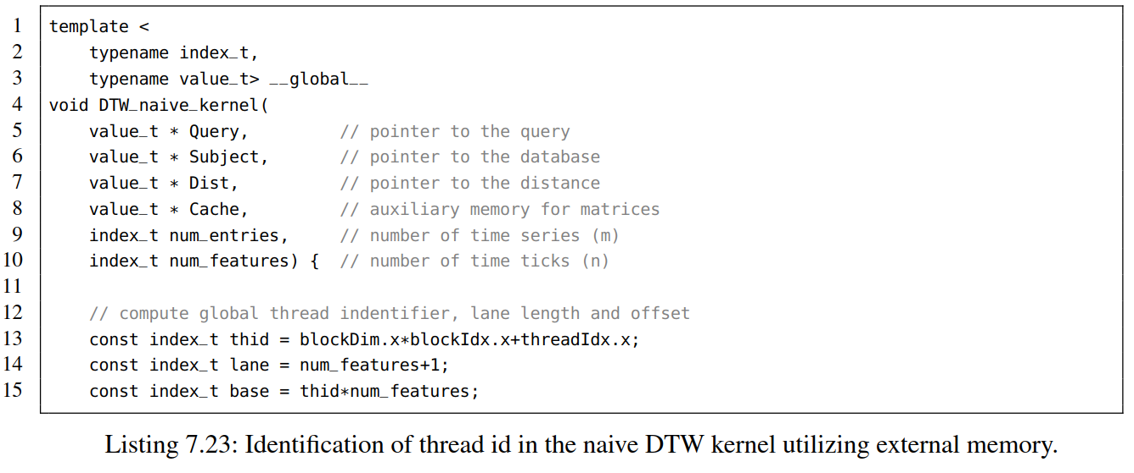

Listing 7.23: Identiﬁcation of thread id in the naive DTW kernel utilizing external memory.

利用外部内存识别原始DTW内核中的线程id。

At this point, we have to check if the thread identiﬁer thid is within the range of allowed indices. The remaining code is almost identical to the host-sided linear memory implementation in Listing 7.21. The only differences are the missing memory deallocation and the distance assignment at the end of the kernel.

此时，我们必须检查线程标识符thid是否在合理的索引范围内。其余代码几乎与清单7.21中的主机端线性内存实现相同。其余代码几乎与代码清单7.21中的主机端线性内存实现完全相同。 唯一的区别是缺少内核末尾的内存释放和距离赋值。

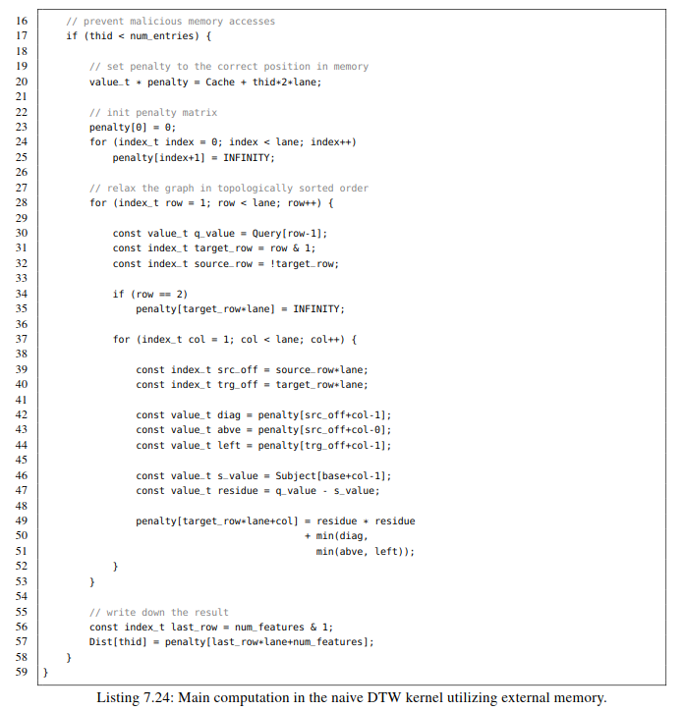

Listing 7.24: Main computation in the naive DTW kernel utilizing external memory.

代码清单7.24：利用外部存储器实现DTW内核的主要计算

The kernel can be called from within the main function as follows:

可以在main函数中调用内核，如下所示:

const uint64_t threads = 32;

DTW_naive_kernel<<<SDIV(num_entries, threads), threads>>>

(Data, Data, Dist, Cache, num_entries, num_features);

The runtime of this kernel is roughly 30 seconds on a Pascal-based Titan X. This is three times faster than the sequential computation from the previous subsection. Nevertheless, it performs ten times worse than the multithreaded variant harnessing all 2 × 16 cores of a dual socket Xeon CPU. Actually, this is caused by a suboptimal memory access pattern.

在基于Pascal的Titan X上，这个内核的运行时间大约是30秒。这比前一小节的顺序计算快三倍。 然而，它比使用双路Xeon CPU中所有2×16核的多线程版本的性能差十倍。 实际上，这是由次优的内存访问模式引起的。

An alternative approach would be the use of static arrays deﬁned inside the kernel, so-called local memory. The signature of the kernel is similar to the previous one with the exception that we do not need to pass the array Cache. Auxiliary memory is now deﬁned inside the kernel on a per thread basis as shown in Line 20 of Listing 7.25. Each CUDA thread can access its own instance of the score matrix penalty. Similarly to the deﬁnition of shared memory inside a kernel, the size of the array must be known at compile time. This can be realized by passing the number of time ticks as an additional template parameter const_num_features(see Line 4).

另一种方法是使用在内核中定义的静态数组，即所谓的本地内存。内核的签名与前一个类似，只是我们不需要传递数组Cache。如清单7.25中的第20行所示，kernel内部的每个线程定义辅助内存。 每个CUDA线程都可以访问自己的**分数矩阵惩罚实例，与**内核中共享内存的定义类似，编译时必须要知道数组的大小。这可以通过传递计时次数作为附加模板参数const_num_features来实现(参见第4行)。

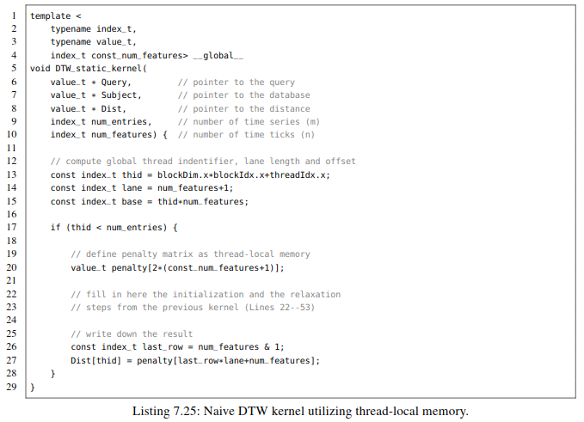

The corresponding kernel call additionally speciﬁes the data types and num_features as compile time constant in single angle brackets:

在对应的内核调用中，用单尖括号明确数据类型和并制定num_features为编译时常量:

const uint64_t threads = 32;

DTW_static_kernel<uint64_t, float, num_features>

<<<SDIV(num_entries, threads), threads>>>

(Data, Data, Dist, num_entries, num_features);

Surprisingly, this kernel terminates after merely 2.7 seconds being on a par with the multithreaded CPU implementation. But how can we explain this massive difference in runtime of more than one order- of-magnitude? To answer this question, we have to understand how CUDA maintains local memory. Some programmers falsely claim that arrays in local memory are always stored in fast registers and thus memory accesses must be signiﬁcantly faster. However, an all-encompassing answer is more com- plicated. CUDA may assign arrays deﬁned inside a kernel to registers if their size is reasonably small but tends to put long arrays (like in our case) in ordinary global memory. The only way to validate an assignment to registers is a careful inspection of PTX ISA instructions – the CUDA equivalent of assembly code. However, an exhaustive introduction to PTX ISA is way beyond the scope of this book and thus we assume for simplicity that local memory resides in global memory. Consequently, the massive difference in execution time is caused by something else.

令人惊讶的是，这个内核仅在与多线程CPU实现相同的2.7秒之后就终止了。但是，我们怎样才能解释超过一个数量级的运行时间的这种巨大差异? 要回答这个问题，我们必须了解CUDA如何维护本地内存。一些程序员错误地声称本地存储器中的数组总是存储在快速寄存器中，因此存储器访问必须明显更快。然而，一个包罗万象的答案更加复杂。CUDA可以将内核中定义的数组且这个相当小，则会分配给寄存器，如果数组比较长（如我们的情况）则放在普通的全局内存中。验证寄存器赋值的唯一方法是仔细检查PTX ISA指令 - 相当于汇编代码的CUDA。但是，对PTX ISA的详尽介绍超出了本书的范围，因此我们假设本地存储器位于全局存储器中。 因此，执行时间的巨大差异是由其他原因引起的。

Local memory when stored in global memory has a different layout than our naive aliasing of auxiliary memory using the array Cache. In the naive case, the two rows of our score matrices are stored in chunks of size *c* := 2·*(n*+1*)*. Consider the case where we simultaneously access the upper left entry of the score matrix penalty[0] during initialization. The 32 threads of a warp concurrently write to memory positions which are *c* slots apart. Hence, we cannot beneﬁt from caching when accessing the entries of the score matrices. By contrast, local memory exhibits a distinct layout which interleaves the entries, i.e., all upper left entries penalty[0] are stored in contiguous positions of the memory followed by all entries penalty[1] and so forth. This coalesced access pattern results in signiﬁcantly faster execution times since we can beneﬁt from optimal cache utilization of global memory. Hence, a better term to describe the characteristics of local memory would be *thread-local interleaved global memory*. We can easily validate this by changing the addressing of the auxiliary array Cache. This can be achieved by deﬁning an index transformation iotawhich reorders the memory accesses analogically to local memory (see Line 19 in Listing 7.26).

存储在全局内存中的本地内存的布局与我们使用数组cache对辅助内存进行的初始混叠不同。在最初的版本，得分矩阵的两行存储在大小为c：= 2·（n + 1）的块中。考虑这样一种情况:在初始化期间，我们同时访问分数矩阵惩罚penalty[0]的左上角条目。一个warp的32个线程同时写会间隔为C的内存位置。因此，当访问score矩阵的条目时，我们不能从缓存中获益。相比之下，本地内存呈现出一种独特的布局，将条目相互交错，比如，所有左上方条目penalty[0] 存储在存储器的连续位置，随后是所有条目penalty[1]，依此类推。因为合并访问模式可以从全局内存的最佳缓存利用率中受益，可以显著缩短执行时间。因此，描述本地存储器特性的最好的术语是e *thread-local 与 global memory*交织。我们可以通过更改辅助数组Cache的寻址来轻松验证这一点。这可以通过定义索引转换iota来实现，该索引转换iota类似地将内存访问重新排序到本地内存（参见代码清单7.26中的第19行）。

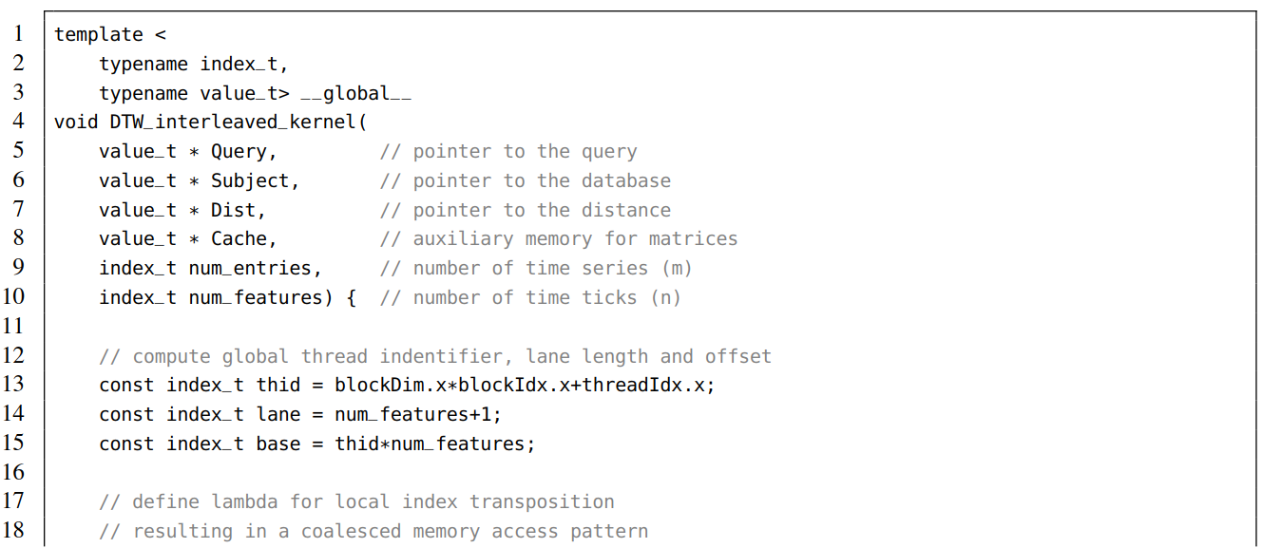

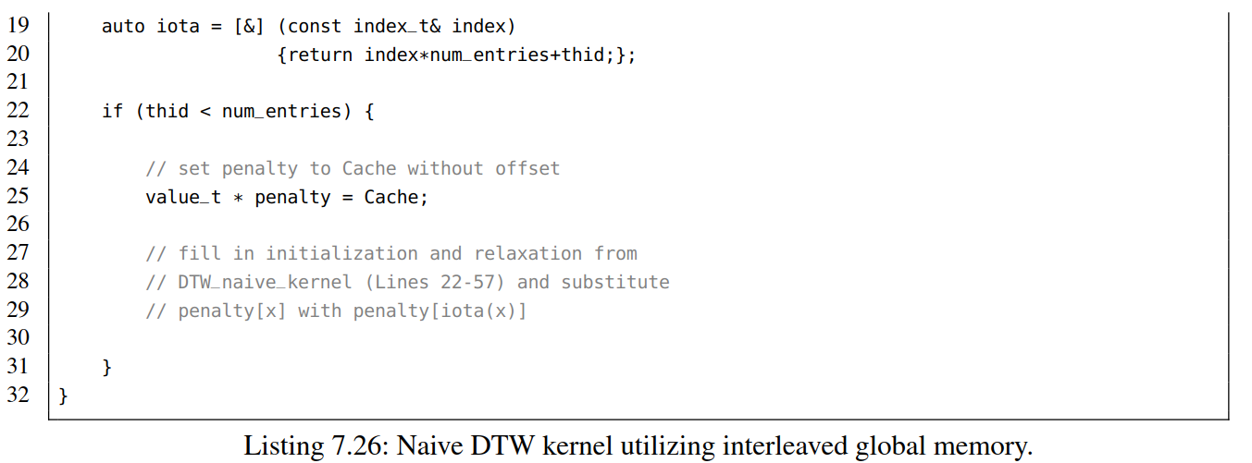

Listing 7.26: Naive DTW kernel utilizing interleaved global memory.

清单7.26:使用交错全局内存的初始DTW内核。

This kernel performs at the same speed as the static kernel which employs local memory. Concluding, our take-home message is that local memory coincides for long arrays with device memory using interleaved addressing. Hence, it has the same high latency and low memory bandwidth as global memory. (See Fig. 7.17.)

这个内核执行的速度与使用本地内存的静态内核相同。最后，得出结论是，对于长数组，本地内存与使用交错寻址的设备内存是一致的。因此，它具有与全局内存相同的高延迟和低内存带宽。

**WAVEFRONT RELAXATION IN SHARED MEMORY**

共享内存中的波前弛豫

Shared memory can be employed to drastically speed up the computation of memory-bound algorithms as we have already seen in Section 7.7. Shared memory is block-local memory in contrast to local memory which is thread-local. Thus we have to slightly modify the indexing scheme since all threads within a CUDA thread block share the same memory. Listing 7.27 shows the implementation of the corresponding kernel. The allocation of the memory in Line 17 differs slightly from our previous approach in Section 7.7. The extern qualiﬁer allows for the speciﬁcation of the array size during kernel launch which reliefs us from the burden to pass a constant integer via a template parameter. Further- more, we adjust the offset of the score matrix penalty using the local thread identiﬁer threadIdx.x instead of the global thread identiﬁer thid (see Line 22).

正如我们在第7.7节中看到的，共享内存可以极大地加快访存密集算法的计算速度。共享内存是块本地内存，而本地内存则是线程本地内存。因此，我们必须稍微修改索引方案，因为CUDA线程块中的所有线程共享相同的内存。清单7.27显示了相应内核的实现。第17行内存的分配与第7.7节介绍的方法略有不同。 限定符extern允许在内核期间指定数组大小，启动它可以减轻我们通过模板参数传递常量整数的负担。此外，我们使用本地线程标识符threadIdx.x而不是全局线程标识符thid来调整评分矩阵penalty的偏移量

The corresponding kernel call speciﬁes the size of the reserved shared memory in bytes with a third parameter in triple angle brackets:

相应的内核调用以三角括号中的第三个参数指定保留的共享内存的大小（以字节为单位）：

uint64_t threads = 32;

uint64_t sh_mem = 2*(num_features+1)*threads*sizeof(float);

DTW_shared_kernel<uint64_t, float>

<<<SDIV(num_entries, threads), threads, sh_mem>>>

(Data, Data, Dist, num_entries, num_features);

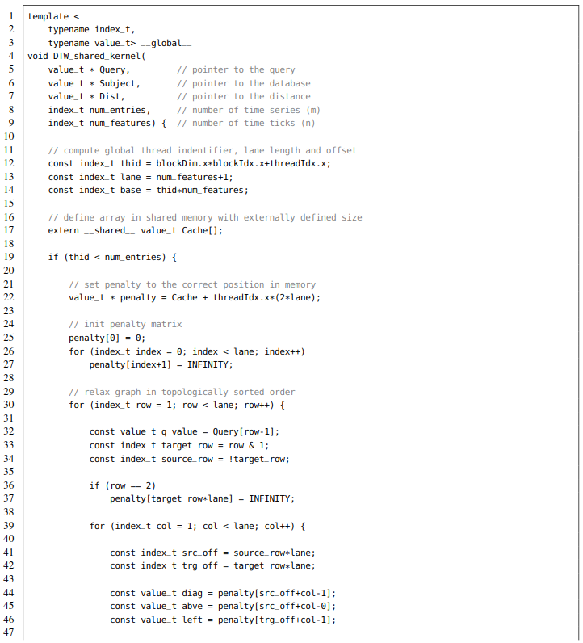

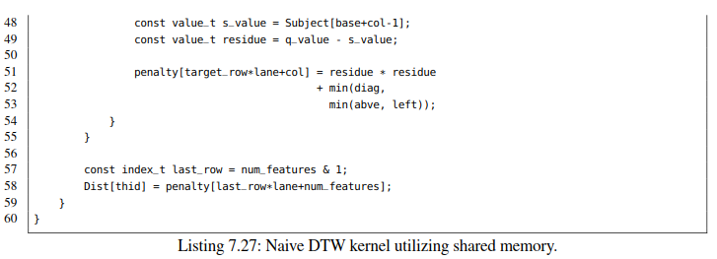

This kernel terminates after approximately 630 ms when executed on a Pascal-based Titan X resulting in a speedup of roughly four over the local memory implementation. Unfortunately, the use of shared memory imposes a major limitation. We cannot use this approach when processing signiﬁcantly longer time series. The size of sh_mem is 2 · *(n* + 1*)* · blockDim.x· sizeof(float)= 2 · *(*128 + 1*)* · 32 · 4 ≈ 32*.*25 KB in our example, i.e., it ﬁts within the 48 KB limitation of allowed shared memory per block, however, for *n* = 192 we exceed this value.

基于pascal的Titan X上执行该内核大约耗时630 ms，比本地内存实现的版本提高了约4倍。不幸的是，共享内存的使用带来了很大的限制。当处理明显较长的时间序列时，我们不能使用这种方法。在我们的例子中，sh_mem的大小为 为 2 · *(n* + 1*)* · blockDim.x· sizeof(float)= 2 · *(*128 + 1*)* · 32 · 4 ≈ 32*.*25 KB，它在每个块所允许占用共享内存48 KB限制范围内。但是，对于n = 192，我们超过了这个值。

To overcome this limitation, a distinct parallelization technique can be employed – the so-called wavefront relaxation scheme. The naive approach either using global, local, or hared memory employs a coarse-grained parallelization scheme processing one DTW score per thread. By contrast, wavefront relaxation is based on a ﬁne-grained parallelization strategy where one CUDA thread block computes one DTW score. As a consequence, we have signiﬁcantly more shared memory left per block allowing for the computation of longer time series. Moreover, we can utilize more than one warp within a thread block. A disadvantage is that we can neither control nor deduce the execution order of threads within a block in order to respect cell dependencies in the graph structure. Wavefront relaxation reorders the cell updates in such a manner that all threads simultaneously work on independent entries of the score matrix.

A close look at Fig. 7.15 reveals that we can concurrently relax all nodes which are located in the same minor diagonal (lower left to upper right) of the penalty matrix without breaking dependencies. The 2 ·*n*+1 minor diagonals can be updated one by another since an entry only depends on three entries stored in the two previous diagonal lanes. Fig. 7.18 visualizes the described access scheme. Unfortunately, the memory and compute footprint of wavefront relaxation is slightly higher than the traditional approach. e have to store three lanes of length *(n*+1*)* instead of two and moreover the number of *(*2 · *n* + 1*)* · *(n* + 1*)* = 2 · *n*2 + 3 · *n* + 1 relaxed cells is almost two times higher than the naive scheme which updates only *(n* + 1*)*2 = *n*2 + 2 · *n* + 1 cells. Nevertheless, we will observe that the described strategy is highly competitive to the naive approach.

为了克服这一限制，可以采用一种独特的并行化技术——所谓的波前弛豫方案。使用全局，本地或共享存储器的朴素方法采用粗粒度并行化方案，每个线程处理一个DTW分数。相比之下，波前弛豫是基于细粒度并行化策略，其中每个CUDA线程块计算一个DTW分数。因此，我们在每个块上留下了更多的共享内存，允许计算更长的时间序列。此外，我们可以在一个线程block中使用多个warp。缺点是我们既不能控制也不能推断块内线程的执行顺序，以便遵从图结构中的单元依赖性。波前松弛以这样的方式重新排序单元更新：所有线程同时处理分数矩阵的独立条目。仔细查看图7.15可以发现，我们可以同时relax位于惩罚矩阵相同的小对角线(从左下角到右上角)上的所有节点，而不破坏依赖关系。2·n + 1次对角线可以逐个更新，因为条目仅取决于存储在前两个对角线中的三个条目。图7.18显示了所述的访问机制。不幸的是，波前弛豫的内存和计算占用比传统方法略高。我们必须存储三条长度为（n + 1）的通道，而不是两条，而且(2 · n + 1) · (n + 1) = 2 · n2 + 3 · n + 1松弛单元的数量几乎是naive方案的两倍，naïve方案更新单元的个数为 (n + 1)2 = n2 + 2 · n + 1。然而，我们将注意到，所述的战略与天真的方法相比具有高度的竞争性。

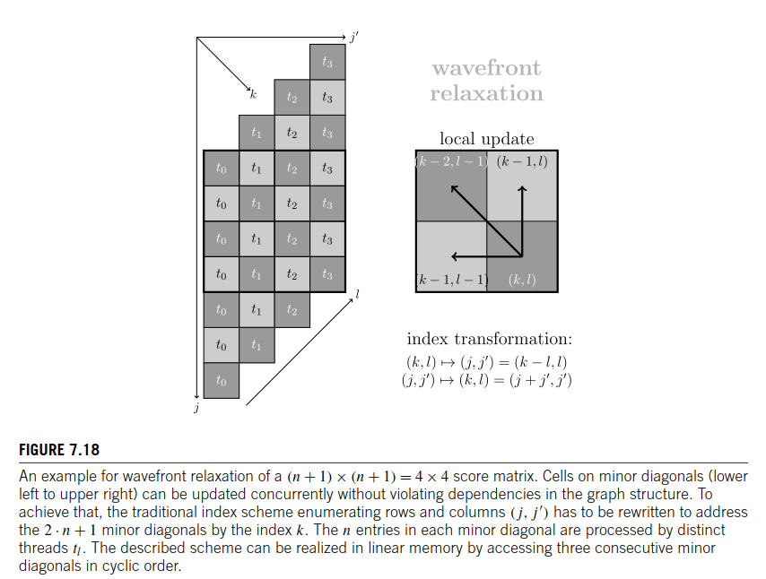

**FIGURE 7.18**

An example for wavefront relaxation of a (n + 1) × (n + 1) = 4 × 4 score matrix. Cells on minor diagonals (lower left to upper right) can be updated concurrently without violating dependencies in the graph structure. To achieve that, the traditional index scheme enumerating rows and columns has to be rewritten to address the 2 · n + 1 minor diagonals by the index k. The n entries in each minor diagonal are processed by distinct threads tl. The described scheme can be realized in linear memory by accessing three consecutive minor diagonals in cyclic order. **（page 277）**

一个大小为(n + 1) × (n + 1) = 4 × 4 的 分数矩阵波前弛豫的一个例子。次对角线上的单元格（左下角到右上角）可以同时更新，而不会破坏图形结构中的依赖关系。要实现这一点，必须重写行和列(j,j′)的传统索引方案，以通过索引k来寻址2 · n + 1个次对角线。每个次要对角线中的n个条目由不同的线程t1处理。所述方案可以在线性存储器中通过循环访问三个连续的小对角线来实现。

Let us start coding. Listing 7.28 shows the kernel signature and the initialization phase of the DTW algorithm. First, we deﬁne the block identiﬁer blidwhich enumerates the subject sequences (one DTW score per block) and the local thread identiﬁer thid which is used to address the cells on a diagonal in Lines 12–13. Second, the constant lane is deﬁned for convenient indexing and the offset base is adjusted to use the block identiﬁer instead of the global thread identiﬁer (see Lines 16–17). Third, we reserve three lanes of shared memory using the extern and __shared__ keywords (see Line 20). The size of shared memory will be later speciﬁed as kernel launch parameter. Subsequently, the lanes are initialized with inﬁnity except for the ﬁrst entry (upper left cell) which is set to zero (see Lines 20–31). Finally, we synchronize all threads within a thread block using a block-wide barrier in Line 34. This step is crucial since we want to ensure that all threads have ﬁnished initialization before proceeding with the relaxation of the score matrix. Note that the call to __syncthreads() is redundant when utilizing 32 or less threads since all threads within a warp are always synchronized up to CUDA 8. Starting from CUDA 9 and its novel cooperative group paradigm, this is not guaranteed anymore. As a consequence, we strongly advise to always synchronize threads explicitly in future code!

让我们看编码。代码清单7.28显示了DTW算法的内核签名和初始化阶段。首先，在12-13行，我们定义block标识符blid，它是主题序列的索引（每个块一个DTW分数）和本地线程标识符thid，用于索引对角线上寻址单元格。 其次，为方便索引，定义了常量lane，并使其使用块标识符而不是全局线程标识符来调整偏移量base(参见第16-17行)。第三，我们使用extern和__shared__关键字保留三个共享内存通道（参见第20行）。共享内存的大小将通过稍后的内核启动参数来指定。随后，除了第一个条目(左上角单元格)被设置为零(参见第20-31行)之外，其他通道都初始化为无穷大。最后，在第34行中，我们使block范围内的barrier同步一个线程块中的所有线程。这一步非常重要，因为我们希望确保所有线程在继续松弛score矩阵之前都已经完成了初始化。注意，当使用32个或更少的线程时，调用_syncthreads()是多余的，因为在CUDA 8，一个warp中的所有线程总是同步的。从CUDA 9及后面更新的版本，这一点不再保证。因此，我们强烈建议在将来的代码中始终明确地同步线程！

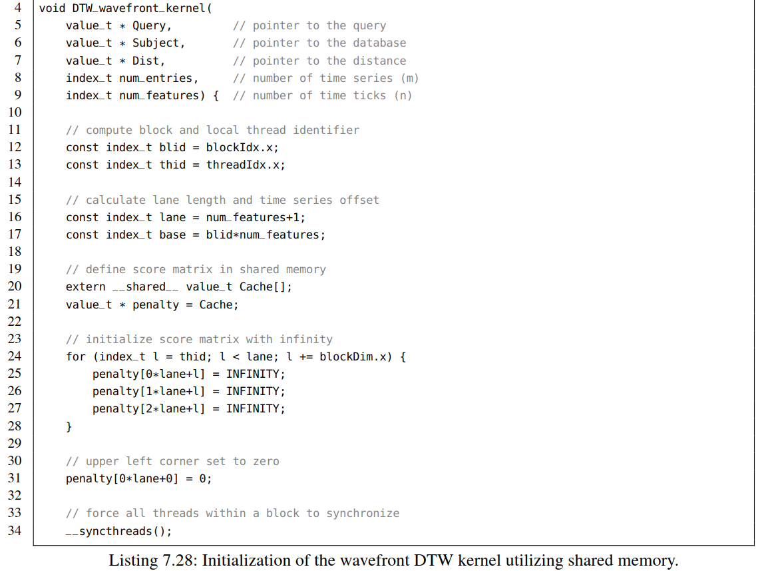

Listing 7.28: Initialization of the wavefront DTW kernel utilizing shared memory.

清单7.28:使用共享内存初始化波前DTW内核。

At this point, we can start relaxing the score matrix. The 2 · *(n* + 1*)* − 1 diagonal lanes are enumerated with the index *k*. Next, the cyclic lane indices have to be computed: the current lane *k*%3 is denoted as target_row, the row before *(k* − 1*)*%3 as source_row, and the row before that row *(k* − 2*)*%3 as before_row. The use of the ternary conditional statement ( )?( ):( ) is advisable since it reduces the number of modulo operations and can be easily optimized by the compiler. The number of expensive modulo operations could be reduced further by moving the initialization of target_row outside of the outer loop. The inner loop in Line 47 enumerates the cells with the index *l* using a block-cyclic distribution of length blockDim.x. The loop body consists of four steps. First, we compute the traditional indicesin Lines 50–51 in order to access the time series entries in a later stage. Second, we determine if the index combination *(k,l)* corresponds to a valid position *(j,j*′*)* in the score matrix (see Line 54). Third, the residual value for the index combination *(j,j*′*)* is determined if the cell is located inside the score matrix. In the opposite case it is set to inﬁnity. Fourth, cells within a diagonal are updated concurrently using the access pattern shown in Fig. 7.18. The block-wide barrier in Line 73 ensures that all cells within a lane have been updated before proceeding with the next diagonal. Finally, we write down the result stored in the lower right cell of the score matrix (see Line 77).

此时，我们可以开始松弛分数矩阵。用k来索引2·（n + 1）-1个对角线。接下来，必须计算循环通道索引：当前通道target_row通过k％3获得，前一行source_row通过（k-1）％3计算获得，之前第二行before_row 通过（k-2）％3计算获得。建议使用三目运算符( )?( ):( )，因为它减少了模运算的数量，并且可以很容易地通过编译器进行优化。通过将target_row的初始化移动到外部循环之外，可以进一步减少昂贵的模运算的数量。第47行中的内部循环使用长度为blockDim.x.的block循环分布用*l*来索引单元格。循环体包括四步。首先，我们计算第50-51行中的传统索引*(j,j*′*)*，以便在稍后阶段访问时间序列条目。其次，我们确定索引组合*(k,l)*是否对应于得分矩阵中的有效位置*(j,j*′*)* (参见第54行)。第三，如果单元位于得分矩阵内，索引组合*(j,j*′*)*的残差值就可以确定。在相反的情况下，它被设为无穷大。第四，使用图7.18所示的访问模式同时更新对角线内的单元格。第73行中的block级屏障确保在继续下一个对角线之前更新了lane中的所有单元格。最后，我们将结果存储在score矩阵的右下角单元格中(参见第77行)。

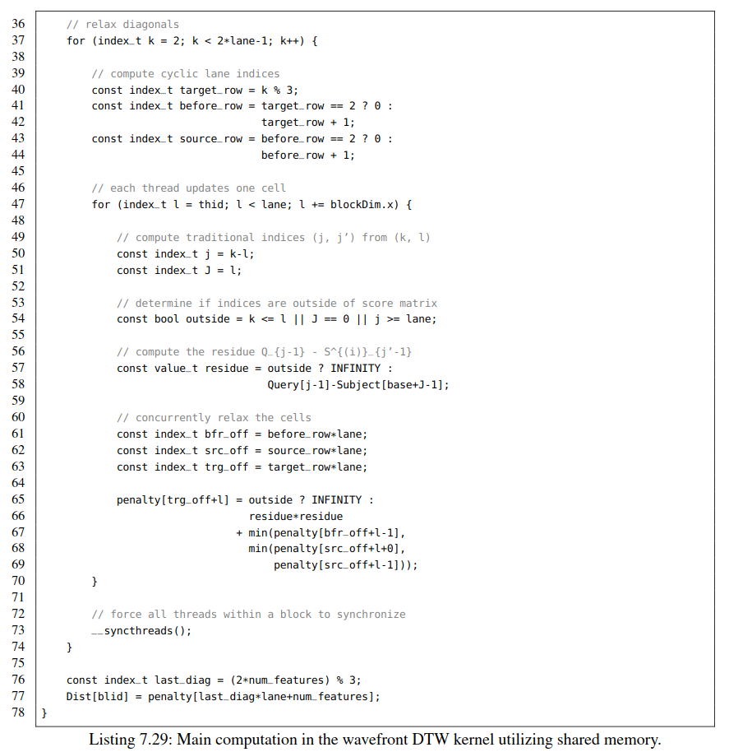

Listing 7.29: Main computation in the wavefront DTW kernel utilizing shared memory.

清单7.29：波前DTW内核利用共享内存完成主要计算。

The kernel call has to be modiﬁed to spawn one thread block for each database entry. Furthermore, we have to adjust the shared memory size.

必须修改内核调用以为便为每个数据库条目生成一个线程块。 此外，我们必须调整共享内存大小。

uint64_t threads = 32;

uint64_t sh_mem = 3*(num_features+1)*sizeof(float);

DTW_wavefront_kernel<<<num_entries, threads, sh_mem>>>

(Data, Data, Dist, num_entries, num_features);

The execution time of 940 ms is higher than the 630 ms for the naive kernel due to the increased number of relaxed cells. However, the kernel can now process time series up to a length of *n* = 4095 in comparison to the naive kernel which is limited to a maximum length of *n* = 191.

由于松弛单元数量的增加，现在的 940 ms的执行时间要高于初始版本的630 ms。但是，内核现在可以处理长度为n = 4095的时间序列，而初始内核处理的时间序列最大长度被限制在n = 191。

**CONCURRENT SCHEDULING AND BANK CONFLICTS （20190409）**

并发调度和bank冲突

Before we proceed with further optimization of the wavefront kernel let us brieﬂy analyze the measured execution times. The wavefront kernel is only 1.5 times slower than the naive kernel employing shared memory despite the fact it updates the double amount of cells. Usually, it is hard to pinpoint one explicit reason which causes deviations in estimated runtime since modern GPUs are complex dynamic systems which cannot be described by simple performance models. However, we can make educated guesses based on frequent observations.

在我们进一步优化波前kernel之前，让我们简要地分析一下测量到的执行时间。 尽管更新了双倍数量的单元，波前内核只比采用共享内存的naive内核慢1.5倍。 无法用简单的性能模型来描述。由于现代gpu是复杂的动态系统，无法用简单的性能模型来描述，因此通常很难找出导致运行时测量时间偏差的一个明确原因。但是，我们可以根据频繁的观察做出有根据的推测。

As an example, we know that the block scheduler may assign several thread blocks onto the same SM if it provides sufﬁcient resources for execution. The naive kernel needs roughly 33 KB of shared memory to store two lanes of length 129 for each of the 32 processed time series. Thus an SM with less than 66 KB of shared memory cannot simultaneously process two blocks. The Pascal generation features only 64 KB of shared memory per SM in contrast to some Maxwell GPUs (e.g. GM200) providing up to 96 KB. As a consequence, we may encounter a performance loss of roughly two if exceeding half the size of physically provided memory. This theoretical model can be validated as follows. Starting from a kernel that uses no shared memory at all we deﬁne an array of shared memory within the kernel via extern __shared__ dummy[]. Now we can measure the execution time of the kernel for different shared memory sizes. The performance of the kernel will monotonically decrease if we increase the amount of scratchpad memory. The wavefront kernel occupies less than 2 KB of shared memory allowing for the concurrent execution of up to 24 blocks on the same SM. Due to this increased level of parallelism we expect a decrease in runtime.

例如，如果block调度器为kernel执行提供了足够的资源，那么它可以将多个线程块分配到同一个SM上。初始内核需要大约33 KB的共享内存来为32个处理过的时间序列中的每一个存储两条长度为129的通道。因此，共享内存小于66 KB的SM不能同时处理两个块。Pascal系列仅为每个SM提供64 KB的共享内存，而一些Maxwell gpu(例如GM200)提供的共享内存高达96 KB。因此，如果使用的内存超过了提供的物理内存大小的一半，我们大约会有一半的性能损失。该理论模型可以验证如下。从一个完全不使用共享内存的内核开始，我们通过extern __shared__ dummy[]在内核中定义一个共享内存数组。现在我们可以测量不同共享内存大小下内核的执行时间。内核的性能将随着暂存器内存数量增长而单调下降。如果内核占用的共享内存不足2 KB，那么可以在同一个SM上可以并发执行最多24个块，由于并行度提高运行时间将会减少。

Proper memory access patterns are another aspect of shared memory performance. Since the release of the Fermi generation, scratchpad is organized in 32 memory banks which are assigned to its entries in a block-cyclic fashion, i.e., reads and writes to a four-byte word stored at position *k* are handled by the memory bank *k*%32. Thus memory accesses are serialized if two or more threads within a warp ac- cess the same bank resulting in performance degradation. An exception is the case where all threads in a warp address the same shared memory address, which is handled efﬁciently via a broadcast.

As an ex- ample, consider the case where we process eight-byte words stored in shared memory (such as int64_t or double) using a memory bank width of four. Thread 0 loads the lower four bytes from memory bank zero and the upper portion from memory bank one. Analogically, Thread 1 loads from memory bank two and three and so forth. In the same warp, Thread 16 also uses the memory banks zero and one re- sulting in a so-called bank conﬂict. Fortunately, starting from the Kepler generation we can reconﬁgure the width of the memory banks to be either four or eight via cudaDeviceSetSharedMemConfig() on the whole device or on a per-kernel basis via using the arguments

正确的内存访问模式影响共享内存性能的另一个因素。自从Fermi发布开始，scratchpad组织在32个内存bank中，这些bank以bank块循环的方式分配，比如存储在k位置的4个字节的读写访问的内存bank为k%32。如果warp中的两个或更多个线程访问同一个bank，则存储器的访问就是顺序的，这样性能就会下降。一个例外是warp中的所有线程都访问相同的共享内存地址,通过广播可以有效地处理这种情况。例如，考虑这样一种情况:我们想处理存储在共享内存中的8字节(例如int64_t或double)，这8个字节存储在bank宽度为4的共享内存中。线程0从bank0加载较低的4个字节，从bank1加载较高的部分. 类似地，线程1从存储体2和3加载，依此类推, 在同一个warp中，线程16也从Bank 0 和bank 1加载数据，这样就会导致所谓的bank冲突。幸运的是，从开普勒一代开始，我们可以在整个设备上通过cudaDeviceSetSharedMemConfig()或者在每个内核上通过带参数的cudaFuncSetSharedMemConfig()重新配置bank的宽度为4或8。

• cudaSharedMemBankSizeDefault(use the device default)

• cudaSharedMemBankSizeFourByte(4 B)

• cudaSharedMemBankSizeEightByte(8 B

in order to address this problem. Note that before Kepler it was impossible to write a bank conﬂict-free algorithm that processes eight-byte words. The naive DTW kernel employing shared memory stores the two lanes of the score matrix with an offset of *c* = 2·*(*128+1*)* = 258 entries. As a consequence, we access memory banks with a stride of two since Thread 0 uses memory bank *(*0·*c)*%32 = 0 for the entry *M*[0*,*0], Thread 1 uses memory bank *(*1 · *c)*%32 = 2 and so forth. By contrast, the **wavefront** kernel simultaneously accesses consecutive entries in shared memory avoiding any bank conﬂict. Concluding, the wavefront kernel has a smaller shared memory footprint which allows for the concurrent execution of several thread blocks on the same SM and further employs a better memory access pattern.

为了解决这个问题. 注意，在开普勒之前，不可能编写一个处理8字节类型的无bank冲突的算法。初始版本的DTW kernel采用共享内存存储偏移量为c = 2·(128+1) = 258条目的得分矩阵。因此，我们以步长为2访问存储器，因为线程0使用存储器bank (0·c)%32 = 0用于条目M [0,0]，线程1使用存储器bank(1 · c)%32 = 2等等。相比之下，wavefront内核同时访问共享内存中的连续条目，避免任何bank冲突。总之，wavefront内核占用较少的共享内存，这样就可以在同一个SM上并发执行多个线程块，并进一步采用较好的内存访问模式。

Another possibility to tweak shared memory shall not be unmentioned. CUDA allows for the reduction of manually maintained shared memory in favor of L1 cache which both share the same transistors on the chip. The scratchpad to L1 ratio can be conﬁgured globally using either cudaDeviceSetCacheConfig() or on a per-kernel level using cudaFuncSetCacheConfig(). Possible arguments for the preferred ratio (scratchpad / L1) are given as follows:

还有另外一种调整共享内存的方式。CUDA可以通过手动调整共享内存和L1缓存大小，这两部分在芯片上共享相同的晶体管。可以使用cudaDeviceSetCacheConfig()全局配置共享内存与L1 cache的比例，也可以使用cudaFuncSetCacheConfig()在每个内核级别共享内存与L1 cache的比例。共享内存与/ L1cache的比率参数如下：

• cudaFuncCachePreferNone(use the device default)

• cudaFuncCachePreferShared(48 KB / 16 KB)

• cudaFuncCachePreferL1(16 KB / 48 KB)

• cudaFuncCachePreferEqual(32 KB / 32 KB)

Note that CUDA ignores your conﬁguration if the amount of shared memory cannot be realized with the speciﬁed ratio. This level of optimization rarely affects overall performance and thus it is not advisable to employ it during early development stages of your program. A similar statement can be made about bank conﬂicts. In general, it is desirable to design bank conﬂict-free algorithms, however, it is not guaranteed to result in optimal code. As an example, if we transpose the shared memory layout of the naive kernel (similar to local memory) in order to avoid bank conﬂicts we end up with a slower implementation.

注意，如果不使用指定的共享内存的比率，CUDA将忽略此配置。该优化很少会影响整体性能，因此不建议在程序的早期开发阶段就使用它。bank冲突也可以做出类似的陈述。通常希望设无bank冲突的算法，但不能保证获得到最优的代码。比如，我们转换初始内核的共享内存布局（本地内存）以避免bank冲突，我们最终却得到一个非常慢的实现。

**TEXTURE MEMORY AND CONSTANT MEMORY**

纹理内存和常量内存

We now optimize the wavefront kernel to outperform the naive variant by exploiting advanced caching mechanisms of CUDA-enabled GPUs. Due to their original purpose GPUs are specialized to efﬁciently process graphics. One important aspect of scene rendering is linear, bilinear, and trilinear (re-)interpo- lation of textures. In terms of programming, textures can be described as multidimensional arrays which exhibit a spatial locality property. As an example, the texture elements (texels) of a 2D texture *T* should be accessed efﬁciently in both dimensions, i.e., reading the entries *T* [*i,j*], *T* [*i,j* + 1], and *T* [*i* + 1*,j*] should have approximately the same latency since they encode similar visual features in a neighborhood. However, we already know that *T* [*i,j*] and *T* [*i,j* +1] most probably reside in the same cache line in contrast to *T* [*i,j*] and *T* [*i* + 1*,j*], which are stored far apart. Addressing this, CUDA- enabled GPUs provide efﬁcient hardware-based texture interpolation mechanisms which makes use of intelligent caching strategies. Furthermore, textures can be evaluated at fractional texel positions using hardware-based multilinear interpolation or automatically map intensity values to the normalized interval [0*,*1]. Although not used in our example, both features can be exploited to save some Flop/s in interpolation tasks. A wavefront implementation of DTW can beneﬁt from texture memory since we access both the query and the subject in random order while traversing the diagonals.

现在，我们通过使用CUDA支持的高级缓存机制优化了wavefront内核，使其性能优于初始版本。GPU期初是专门用来高效处理图形的。场景渲染的一个重要部分是纹理的线性、双线性和三线性插值。就编程而言，纹理可以描述为具有空间局部性的多维数组。例如，2D纹理T的纹理元素(texels)应该在两个维度上都被有效地访问，比如，条目*T* [*i,j*], *T* [*i,j* + 1], and *T* [*i* + 1*,j*] 读取延迟应该差不多，因为它们在一个相邻区域对类似的视觉特性进行了编码。但是我们知道T [i,j]和T [i,j +1]很可能位于同一cache line上，而T [i,j]和T [i +1,j]存储的距离就会相差很远。为解决此问题，支持CUDA的GPU提供了基于硬件的高效纹理插值机制，该机制利用了智能缓存策略。此外，可以使用基于硬件的多线性插值在分散纹理元素位置预估纹理，或者自动将强度值映射到归一化区间[0,1]。虽然在我们的示例中没有使用，但是可以利用这两个特征来在插值任务中节省一些Flop/s。 DTW的wavefront实现可以从纹理存储器中受益，因为我们在遍历对角线时是以随机顺序访问查询和主题的。

Textures are deﬁned at compile time and can be bound to arrays at runtime. Note that CUDA makes a subtle distinction between arrays and linear memory – throughout this chapter we use the terms linear memory and array interchangeably. Further details can be found in the CUDA programming guide [4]. The maximum number of allowed texels bound to linear memory are 227 in the 1D case, in the 2D case and 40963 in the 3D case. In the following we will bind a 1D texture to the subject database stored in the array float * Data. First, we have to declare the texture itself as a static global variable:

纹理在编译时定义，并且可以在运行时绑定到数组。请注意，CUDA在数组和线性存储器之间进行了细微的区分，本章我们将交替使用线性存储器和数组这两个术语。更多细节可以参考CUDA编程指南[4]. 1D情况下，可以绑定到线性内存的纹理元素的最大个数为227，2D情况是65,0002，3D情况是40963。在下文中，我们将1D纹理与到存储在数组float * Data中的主题数据库进行绑定。 首先，我们必须将纹理本身声明为静态全局变量：

texture<float, 1, cudaReadModeElementType> tSubject;

In general, the template parameters of texture<DataType, Type, ReadMode>are speciﬁed as follows:

• DataType: a basic 32-bit type such as float or int

• Type: the dimension being either 1, 2, or 3 (optional: default=1)

• ReadMode: the mode being either cudaReadModeElementType which passes the data as is or

After declaration in the document body we can now bind the texture at runtime in the main function using

cudaBindTexture(0, tSubject, Data, sizeof(float)*num_entries*num_features);

通常，具体纹理<DataType，Type，ReadMode>的模板参数如下：

• 数据类型: 32-bit 类型，比如float 或 int

• 类型: 维度1, 2, or 3 (默认为1)

•读取模式: cudaReadModeElementType模式，它按原样传递数据； cudeReadModeNormalizedFloat模式，它将整数类型映射到区间[0,1]（默认是 cudaReadModeElementType）

声明之后，我们现在可以使用

cudaBindTexture(0, tSubject, Data, sizeof(float)*num_entries*num_features)

在main函数中绑定纹理。

The ﬁrst argument is a pointer of type size_t * storing an offset which we neglect. The remaining arguments specify the declared texture object, the address pointing to linear memory, and its corresponding size in bytes. Note that in our example we store *m* = 220 time series each of length *n* = 128 = 27 in the database resulting in exactly 227 texels. A texture can be unbound with a call to cudaUnbindTexture(). The signature of the wavefront kernel is slightly modiﬁed: we simply remove the pointer to Subject since texture objects are visible across the whole device.

第一个参数是size_t *类型的指针，存储偏移量。其余参数指定声明的纹理对象，指向线性内存的地址，以及以字节为单位的相应尺寸。请注意，本例中，我们将*m* = 220 个长度为*n* = 128 = 27时间序列存储在包含227 纹理元素的数据库中。纹理可以通过调用cudaUnbindTexture()解除绑定。wavefront内核的signature略有修改: 删除了指向Subject的指针，因为纹理对象在整个设备中都是可见的。

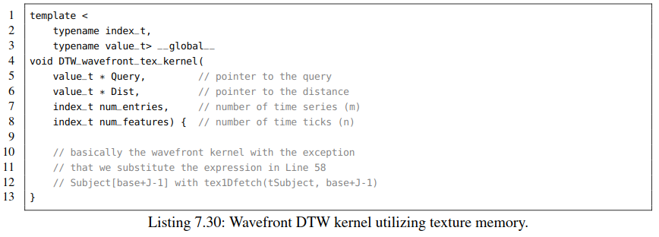

Listing 7.30: Wavefront DTW kernel utilizing texture memory.  
清单7.30:使用纹理内存的波前DTW内核

Finally, we have to alter the body of the wavefront kernel (Line 58) to access entries in the subject database via tex1Dfetch(tSubject, base+J-1)instead of using Subject[base+J-1]. The kernel call is identical to the non-optimized wavefront kernel except the missing argument Subject. A measurement of the runtime reveals that the use of texture memory reduces the runtime from 940 ms to 900 ms. This 4% improvement in runtime is rather marginal for *n* = 128. However, for higher values of *n* we gain reasonable improvements as shown in [11]. Moreover, this optimization is basically free since it depends only on minor modiﬁcations of the source code: technically one does not even need to remove the pointer to Subject since it is deﬁned anyway.

最后，我们必须修改wavefront内核(第58行)，以便通过tex1Dfetch(tSubject, base+J-1)而不是subject [base+J-1]来访问subject数据库中的条目。内核调用与未优化的wavefront内核相同，只是缺少参数Subject。对运行时的测量显示，纹理存储器的使用将运行时间从940毫秒减少到900毫秒。对于n = 128，4％的运行时间改善是相当小的。然而，对于更高的n值，我们获得了明显的性能提升，如[11]所示。此外，这种优化非常容易，只需对源代码进行微小修改：从技术上讲，甚至不需要删除指向Subject的指针，因为无论如何它都需要定义。

An even more powerful caching strategy can be pursued if we employ so-called constant memory. CUDA-enabled GPUs provide the possibility to store up to 48 KB of heavily cached read-only storage in global memory. Because of its small size we may only store a limited amount of information which can be accessed during the execution of a kernel across the whole device. Typical use cases include the distribution of runtime constants which specify the characteristics of an algorithm such as exponents of the *Lp*-norm or gap penalties in elastic matching algorithms. Actually, CUDA uses constant memory to broadcast the kernel arguments to all thread blocks. In our experiments, we will cache the query of length *n* = 128 since it is frequently accessed by each of the thread blocks.

如果我们常量内存，就可以利用更强大的缓存策略。支持CUDA的GPU可以从全局内存中预留高达48 KB的只读缓存。由于其体积小，我们只能存储有限的信息，这些信息可以在整个设备执行内核期间访问。典型的用例包括指定算法特征的运行时常量的分布，例如Lp-norm或弹性匹配算法中的间隙。实际上，CUDA使用常量内存将内核参数广播给所有线程块。本实验中，将缓存n = 128，它是query的长度，因为它经常被每个线程块访问。

Similarly to texture memory, constant memory has to be declared globally at compile time and can be altered at runtime. In our example, we declare the memory directly after the include section of our program:

与纹理内存类似，常量内存必须在编译时全局声明，并且可以在运行时更改。 在我们的示例中， include部分声明常量内存：

__constant__ float cQuery[12*1024];

Unfortunately, we have to know the size at compile and thus we decide to take the maximum value. If we are sure that we do not want to process longer queries, we could have hard-coded the size to *n* = 128. Subsequently we have to copy the query which here corresponds to the ﬁrst time series in the subject database from the device array float * Data to cQuery in the main function:

不幸的是，我们必须在编译时确定常量内存的大小，因此我们决定采用最大值。 如果我们确定处理的查询不是太长，我们可以将尺寸硬编码为n = 128。 随后我们必须将主题数据库中的第一个时间序列对应的查询从设备端数组float * Data复制到main函数中的cQuery：

cudaMemcpyToSymbol(cQuery, Data, sizeof(value_t)*num_features);

The ﬁnal modiﬁcation in the original wavefront kernel is straightforward: we simply substitute the access to Query[j-1]with cQuery[j-1]. Note that similarly to texture memory we do not have to pass cQuery as kernel argument since it is visible across the whole device

初始wavefront内核的最终修改是直接的：简单地用cQuery [j-1]替换对Query [j-1]的访问。注意，与纹理内存类似，我们不需要将cQuery作为内核参数传递，因为它在整个设备中都是可见的

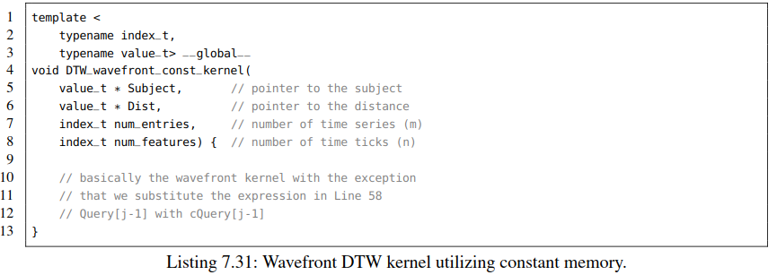

Listing 7.31: Wavefront DTW kernel utilizing constant memory.

代码清单7.31：使用常量内存的Wavefront DTW内核

The kernel call is identical to the non-optimized wavefront kernel except the missing argument Query. The corresponding runtime of the kernel is only 510 ms in contrast to the 940 ms of the non-optimized variant resulting in almost double the performance with only minor modiﬁcations of the source code. We can even outperform the naive shared memory approach which performs at 640 ms by almost 20%. Note that we could combine constant memory and texture memory within the same kernel; however, the reduction in runtime is barely noticeable. Concluding, the wavefront kernel using constant memory is signiﬁcantly faster than all aforementioned kernels based on the naive relaxation scheme and further supports the processing of reasonably longer queries.

除了缺少参数Query,内核调用与未优化的wavefront内核相同. 与非优化版本的940毫秒相比，内核的运行时间仅为510毫秒，只有很少的源代码修改就带来几乎两倍的性能提升。我们甚至可以超过初始的共享内存方法，比640毫秒时的性能提高了20%。注意，我们可以在同一个内核中组合常量内存和纹理内存; 但是性能提升不明显。综上所述，使用常量内存的wavefront内核比基于原始松弛方案的所有上述内核都要快得多，并且还支持处理较长时间的查询。

**---------------------------------------------------------------------------**

**7.5 OPTIMIZATION GUIDELINES**

优化准则

This section brieﬂy summarizes the optimization methods and execution times in order to derive general rules that might help you to optimize code. Moreover, we discuss further possible optimization techniques which are not covered by this example. The major take home-message is that *everything is about efﬁcient memory utilization*. GPUs provide excessive amounts of FLOP/s, however, we cannot beneﬁt from that if we ignore the characteristics of the attached memory. Hence, we have to ensure that the compute units have something to compute and do not waste their potential while waiting for data. This can be summarized as follows:

本节简要总结了优化方法和执行时间，以便得出可能有助于优化代码的一般规则。此外，我们还讨论了本例中没有涉及的其他可能的优化技术。最重要的是，一切都是关于内存的有效利用。gpu提供了过多的触发器/s，但是，如果忽略附加内存的特性，我们就无法从中受益。因此，我们必须确保计算单元具有可计算的内容，并且在等待数据时不会浪费它们的潜力。这可以概括如下:.

GPU提供了很高的FLOP/s，但是，如果我们不能好好利用附加内存的特性，就无法从中获益。 因此，我们必须确保计算单元有数据可算，并且在等待数据时不要浪费它们的计算潜力。 这可以总结如下：

“*Computation in vacuum is futile.*” 真空中计算是徒劳的

Starting from the sequential algorithm on the CPU which performs at approximately 90 seconds we have observed that a simple coarse grained task parallelization scheme over 32 CPU cores scales almost linearly. However, when porting the algorithm directly to the GPU, we have observed a massive decrease in performance of approximately one order-of-magnitude due to the non-coalesced memory access pattern. However, if we restructure the memory layout to allow coalesced memory accesses using either local memory or a transposed indexing scheme in global memory, we could achieve com- parable performance. Furthermore, we could signiﬁcantly speed up the kernel by using shared memory for the score matrix.

从CPU耗时约90秒的串行算法开始，我们发现一个简单的粗粒度任务并行化方案在CPU 32个核上的性能基本是线性扩展的。然而，当将算法直接移植到GPU时，由于采用非合并的内存访问模式，该模式导致大约一个数量级的性能下降。然而，如果重新调整内存布局，使用本地内存或全局内存中的转置索引方案来利用合并内存访问，就可以获得比较可观的性能。此外，对分数矩阵采用共享内存访问可以显著加快内核的速度。

“*Ensure your access pattern is coalesced. If not – make it so.*”

“确保采用合并的内存访问模式。如果没有，那就去做”

The use of shared memory imposes hard limitations due to its small size. This can be addressed by using ﬁne-grained parallelization strategies which assign a task to a whole thread block instead of using one thread per task. This approach may dramatically reduce the shared memory footprint of algorithms but has the disadvantage that we have to parallelize the task itself. Unfortunately, this requires the complete restructuring of the source code as shown in the wavefront kernel. Furthermore, a ﬁne-grained parallelization scheme might not be obvious or is completely unknown in the worst case. Consequently, one has to spend a reasonable amount of time to spot potential for ﬁne-grained parallelization of core algorithms.

由于共享存储器尺寸太小，所以使用上会有很多硬性限制。 这可以通过使用细粒度并行化策略来解决，这种策略将任务分配给整个线程块，而不是每个任务使用一个线程。该方法可以极大地减少算法的共享内存占用，但也有并行化任务本身的缺点。不幸的是，这需要彻底地代码重构，如wavefront内核所示。此外，细粒度并行化方案带来的性能提升不明显或完全未知。因此，必须花费大量的时间来发掘核心算法细粒度并行的潜力。

“*Fine-grained parallelization is better than coarse-grained parallelization.*”

“细粒度并行优于粗粒度并行”

We have employed advanced caching strategies to further boost the performance by using either texture or constant memory for frequently accessed data. We have observed that constant memory is worth it if we repeatedly read the same data across the whole device. Texture memory can be employed to beneﬁt from spatial locality of data accesses, however, reasonable improvements in runtime can only be expected if we exploit the hardware-based interpolation capabilities of higher-dimensional textures.

我们采用了先进的缓存策略，通过为频繁访问的数据使用纹理或常量内存来进一步提高性能。如果我们在整个设备上重复读取相同的数据，那么固定的内存是值得的。纹理存储器可用于从数据访问的空间局部性中获益，但是，只有利用基于硬件的高维纹理插值功能，才能期望在运行时得到合理的改进。

Note that this book covers only a fraction of available memory types. Further types such as surface memory, layered textures, or CUDA arrays are documented in the CUDA programming guide [4]. We strongly advise to read the provided documentation on a regular basis since each GPU generation introduces novel instructions which might dramatically speed up your algorithm.

本书仅涵盖可以使用的内存类型的一小部分。CUDA编程指南[4]中还记录了其他类型，如表面存储器，分层纹理或CUDA阵列。 我们强烈建议定期阅读提供的文档，因为每一代GPU都会引入新的指令，这些指令可能会大大加快算法的速度。

“*Do not rely on theoretical assumptions – experiment with novel techniques.*”

“不要依赖理论假设—用新技术做实验”

Finally, let us state that we could further optimize the wavefront kernel by using the enormous amount of registers per SM for the score matrix instead of shared memory. State-of-the-art implementations of elastic matching algorithms actually unroll the relaxation of several minor diagonals in registers resulting in even faster execution times [15]. Analogically, the next chapter shows you how to efﬁciently share information between threads in warp without the need for shared memory.

最后，我们可以通过使用每个SM的大量寄存器来进一步优化wavefront内核，而不是共享内存。 弹性匹配算法的最新实现实际上是利用寄存器对次对角线的松弛计算进行了展开，从而带来内核执行时间更快[15]。 类似地，下一章将向您展示如何在warp中的线程之间有效地共享信息，而无需共享内存。

**---------------------------------------------------------------------------**

**7.6 ADDITIONAL EXERCISES 练习题**

1. Write a CUDA program that computes the sum of two vectors *x,y* ∈ R*n* stored in the host arrays float * x and float * y. Compare the execution times of the corresponding kernel and memory transfers with a sequential program running on a single CPU core. Is your CUDA parallelization beneﬁcial?

编写一个CUDA程序，计算存储在主机数组float * x和float * y中的两个向量x，y∈Rn之和。 并对该内核执行和内存传输的执行时间和与在单个CPU核串行程序执行时间进行比较。看自己的CUDA并行化是否有益？

**2.** Let *x* = *(x*0*,x*1*,x*2*,x*3*)* ∈ R4 be an arbitrary vector in four-dimensional space and accordingly

*v* = *x(*0*),...,x(n*−1*)*

= *x*0*(*0*),x*1*(*0*),x*2*(*0*),x*3*(*0*),...,x*0*(n*−1*),x*1*(n*−1*),x*2*(n*−1*),x*3*(n*−1*)* ∈ R4·*n*

an array of *n* ∈ N vectors. Our goal is to normalize each vector *x(k)* individually:

设*x* = *(x*0*,x*1*,x*2*,x*3*)* ∈ R4是四维空间任意的向量，v是N个x类型的数组。我们的目标是将每个向量*x(k)*独立标准化:

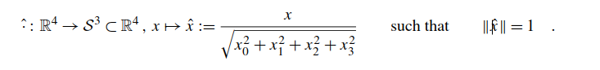

In practice, the array of vectors *v* is given by a floatarray of length 4 ·*n*. An important application for this task is the normalization of Hamiltonian quaternions to have unit modulus in order to represent rotations in three-dimensional Euclidean space. In the following, we will use *n* CUDA-threads to accomplish this task. Your implementation should use several blocks and work with an arbitrary number of vectors *n*.

**(i)** Write a naive CUDA-kernel that normalizes *n* vectors using *n* threads.

**(ii)** Do the same but treat the input array float * Vas an array of structs float4 * V. To achieve this, read four values at once using the float4 data type. Is the runtime affected?

**(iii)** Look up the mathematical functions rsqrt and rsqrtf in the CUDA documentation. Can you use them to speed up your implementation?

**(iv)** Propose another optimization, implement it and measure the runtime. Is it beneﬁcial to use a GPU for this dedicated task? Justify your claims.

实际上，向量v由长度为4·n的 float 数组给出。该任务的一个重要应用是将哈密顿四元数归一化，使其具有单位模量，以表示三维欧几里德空间中的旋转。在下面，我们将使用n个cuda线程来完成这项任务。你的实现应该使用几个block块来处理任意尺寸的数组。

(i) 编写一个简单的cuda内核，使用n个线程对n个向量进行标准化

(ii) 做同样的操作，但是要将输入数组float *修改为一个结构数组float4 * V。请使用float4数据类型一次读取四个值来完成。看运行时间是否有变化？

(iii) 在CUDA文档中查阅数学函数rsqrt和rsqrtf。使用它们能带来性能提升么？

(iv)提出另一个优化方法，实现并测试运行时间。使用GPU来完成这项任务是否有益?并作出证明。

**3.** Let *A,B* ∈ R*n*×*n* be two square matrices that can be mapped onto each other by transposition i.e.,*A* = *BT* , explicitly expressed in coordinates:

*Aij* = *BiTj* = *Bji* for all *i,j* ∈ {0*,...,n* − 1} *.*

Assume *A* and *B* ﬁt into global memory, then we can compute *B* from the knowledge of *A* or vice versa. Our goal is to store the transposed version of *A* in *B* using *O(n*2*)* many CUDA-threads. Your implementation should use several blocks and work with arbitrary matrix length *n*.

1. Write a naive CUDA kernel, that transposes *A* using *n*2 threads on a two-dimensional grid.

**(ii)** Let TILE∈ {1*,*2*,*4*,*8*,*16} be the length of a submatrix in *A* and *n* = TILE·*k* for some *k* ∈ N. Write a CUDA kernel that uses *n*2*/*TILE2 many threads such that one thread transposes a submatrix with TILE2 entries. Your implementation should work for all above-stated choices of TILE. Which variant performs best? Explain your observation.

**(iii)** Assume TILE= 4, i.e. one tile has 16 entries. Use four float4 structs to store the 16 entries in a CUDA thread. Afterwards transpose the 4 × 4 submatrix stored in four float4 structs using six swaps of floatvalues. Finally, write the transposed submatrix to the corresponding part of *B* using four writes of float4 structs. Visualize the indexing scheme with a sketch.

Measure the execution times of the three described implementations. Which one performs best? Explain your observation.

设A,B∈ Rn×n是两个方阵，通过转置可以互相映射，即A = B*T*，用坐标表示:

*Aij* = *BiTj* = *Bji* ， *i,j* ∈ {0*,...,n* − 1} *.*

假设A和B存在全局内存，然后我们可以根据A来计算B，反之亦然。目标是使用O(n2)个cuda线程在B中存储A的转置版本。你的实现应该使用一些block块来处理任意矩阵长度。

（i）写一个简单CUDA内核，使用n2线程组织的2维grid完成A的转置.

（ii）设分块切片 TILE∈ {1*,*2*,*4*,*8*,*16}为A的子矩阵长度，*n* = TILE·*k,* *k* ∈ N. 编写一个使用*n*2*/*TILE2个线程的CUDA内核，使每个线程完成包含TILE2 元素的子矩阵的转置。该kernel应该适用于上述所有TILE的选择。看哪一种分块表现最好?并给出解释。

（iii）假设TILE= 4, 每个分块还有16 元素. 每个CUDA线程采用float4 存储这16个元素。然后，使用6个浮点值交换完成存储在4个float4中的4×4子矩阵转置。最后，使用float4 类型的四次写操作将转置的子矩阵写到B的对应部分。用草图可视化索引方案。

测量上述三种实现的执行时间。看哪个性能最好，并作出解释。

**4.** Revisit the shared memory-based kernel for the efﬁcient computation of the covariance matrix in Listing 7.13.

回顾基于共享内存的内核，以便有效地计算清单7.13中的协方差矩阵。

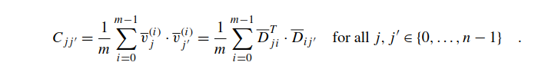

Adapt the code to be applicable to the multiplication of two arbitrarily shaped matrices *A* and *B* such that *C* = *A* · *B*. Discuss the memory layout of the involved matrices. Can you guarantee coalesced accesses to both *A* and *B*?

修改代码，使之适用于两个任意形状的矩阵A和B的相乘，即：C = A·B。讨论矩阵的内存布局，是否能保证A和B矩阵能够采用合并访存?

**5.** The Knapsack problem describes an optimization task, where a thief tries to pack up *n* objects *i* ∈ {0*,...,n*−1} of value *V* [*i*] and weight *W*[*i*] into a container of limited capacity *c*. For each object *i*, the thief may decide if he takes it or leaves it behind. The goal is to maximize the accumulated value of the chosen objects without violating the capacity constraint. Mathematically speaking, we are interested in the optimal subset *J*∗ ⊆ *I* amongst all subsets *J* ⊆ *I* := {0*,...,n* − 1} such that

背包问题描述了一个最优化任务，小偷试图尽可能多地从n个对象 i∈{0，...，n-1}打包到容量为C的容器中，其中每个元素的值为V [i]和权重为W [i]。 最终目标是在不违反容量约束的情况下最大化所选对象的累积值。从数学上讲，我们感兴趣的是所有子集*J* ⊆ *I* := {0,...,n − 1}中的最优子集*J*∗ ⊆ *I* 比如：

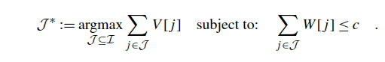

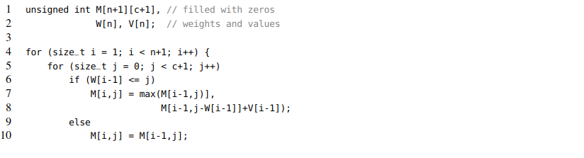

The optimal accumulated value is stored in M[n, c]. Our goal is to write an efﬁcient CUDA paral- lelization using multiple thread blocks.

**(i)** Discuss the dependencies between the individual entries of the matrix M. Which cells can be updated independently? Are there global barriers? If yes, how can we enforce global synchronization on CUDA-enabled GPUs?

**(ii)** Implement your proposed method. Is the use of shared, constant or texture memory beneﬁ- cial? Benchmark several implementations and create appropriate plots.

**(iii)** The asymptotic time complexity and the memory consumption of the aforementioned algorithm are in *O(N* ·*C)*. Using your considerations from (i), provide a linear memory algorithm that only uses *O(C)* cells to compute the result. Implement your approach.

最佳累计值存储在M [n，c]中。 我们的目标是使用多个线程块编写有效的CUDA并行化。

(i) 讨论矩阵M的各个条目之间的依赖关系。哪些单元可以独立更新？ 是否存在全局barriers？ 如果是，我们如何在支持CUDA的GPU上实施全局同步？

(ii) 实现提出的方法。使用共享内存、常量内存或纹理内存看是否有益吗? 测试几个实现并创建适当的图。

(iii) 上述算法的渐近时间复杂度和内存消耗均为O(N·C)。使用来自(i)的方法，提供一个线性内存算法，该算法只使用O(C)单元格来计算结果。实现该算法。

REFERENCES 参考文献

[1] Donald J. Berndt, James Clifford, Using dynamic time warping to ﬁnd patterns in time series, in: KDD Workshop, 1994, pp. 359–370.

[2] Thomas H. Cormen, et al., Introduction to Algorithms, 3rd edition, The MIT Press, 2009.

[3] NVIDIA Corporation, CUDA, parallel programming and computing platform, https://developer.nvidia.com/cuda-zone (vis-

ited on 10/12/2015).

[4] NVIDIA Corporation, CUDA programming guide version 8.0, https://docs.nvidia.com/cuda/cuda-c-programming-guide/,

2016 (visited on 09/25/2016).

[5] NVIDIA Corporation, GeForce 256, the world’s ﬁrst GPU, http://www.nvidia.com/page/geforce256.html (visited on

10/12/2015).

[6] NVIDIA Corporation, NVLink high-speed interconnect: application performance (whitepaper), http://www.nvidia.com/

object/nvlink.html, 2014 (visited on 09/25/2016).

[7] NVIDIA Corporation, Thrust parallel algorithms and data structures library, https://developer.nvidia.com/thrust (visited on

10/12/2015).

[8] Richard O. Duda, Peter E. Hart, David G. Stork, Pattern Classiﬁcation, 2nd edition, Wiley-Interscience, ISBN 0471056693,

2000.

[9] Khronos Group, OpenCL, the open standard for parallel programming of heterogeneous systems, https://www.khronos.org/

opencl/ (visited on 10/12/2015).

[10] Translational Imaging Group, NiftyReg: medical image registration using CUDA, http://cmictig.cs.ucl.ac.uk/wiki/

index.php/NiftyReg (visited on 10/12/2015).

[11] C. Hundt, B. Schmidt, E. Schömer, CUDA-accelerated alignment of subsequences in streamed time series data, in: 2014

43rd International Conference on Parallel Processing, 2014, pp. 10–19.

[12] Mohammed Waleed Kadous, Learning comprehensible descriptions of multivariate time series, in: Ivan Bratko, Saso Dze-

roski (Eds.), Proceedings of the 16th International Conference of Machine Learning (ICML-99), Morgan Kaufmann, 1999, pp. 454–463.

[13] David B. Kirk, Wen-mei W. Hwu, Programming Massively Parallel Processors: A Hands-on Approach, 2nd edition, Morgan Kaufmann Publishers Inc., San Francisco, CA, USA, 2013.

[14] Jeff Larkin, James Bayer, Comparing OpenACC 2.5 and OpenMP 4.5, in: NVIDIA GPU Technology Conference,

2016, http://on-demand.gputechconf.com/gtc/2016/presentation/s6410-jeff-larkin-beyer-comparing-open-acc-openmp.pdf (visited on 10/01/2016).

[15] Yongchao Liu, Bertil Schmidt, CUSHAW2-GPU: empowering faster gapped short-read alignment using GPU computing, IEEE Design & Test 31 (1) (2014) 31–39, http://dx.doi.org/10.1109/MDAT.2013.2284198.

[16] Ziwei Liu, et al., Deep learning face attributes in the wild, in: Proceedings of International Conference on Computer Vision (ICCV), 2015, http://mmlab.ie.cuhk.edu.hk/projects/CelebA.html (visited on 09/25/2016).

[17] OpenACC Organisation, OpenACC, directives for accelerators, http://www.openacc.org/ (visited on 10/12/2015).

[18] Oxford Learner’s Dictionaries: entry for the word ‘exact’, http://www.oxfordlearnersdictionaries.com/deﬁnition/english/ exact_1 (visited on 10/12/2015).

[19] H. Sakoe, S. Chiba, Dynamic programming algorithm optimization for spoken word recognition, Acoustics, Speech and Signal Processing, IEEE Transactions on 26 (1) (1978) 43–49, http://dx.doi.org/10.1109/TASSP.1978.1163055.

[20] Christian Szegedy, et al., Going deeper with convolutions, in: Proceedings of the IEEE Conference on Computer Vision and Pattern Recognition, 2015, pp. 1–9.

ADVANCED CUDA PROGRAMMING

第八章： 高级CUDA编程

Abstract

摘要：

In the recent past, CUDA has become the major framework for the programming of massively parallel accelerators. NVIDIA estimates the number of CUDA installations in the year 2016 to exceed one million. Moreover, with the rise of Deep Learning this number is expected to grow at an exponential rate in the foreseeing future. Hence, extensive CUDA knowledge is a fundamental pursuit for every programmer in the ﬁeld of High Performance Computing. The previous chapter focused on the basic programming model and the memory hierarchy of modern GPUs. We have seen that proper memory utilization is key to obtain efﬁcient code. While our examples from the previous chapter focused on thread-level implementations, we investigate now warp-level parallelization and the efﬁcient use of atomic functions. Both techniques in combination enable further code optimization. Moreover, we discuss overlapping of communication and computation in single-GPU and multi-GPU scenarios using streams. We conclude the chapter with a brief discussion of CUDA 9 and its novel features.

在最近的过去，CUDA已成为大规模并行加速器编程的主要框架。NVIDIA估计2016年CUDA安装数量将超过100万。此外，随着深度学习的兴起，在不远的将来，预计这个数字将会以指数速度增长。因此，深厚的CUDA知识是高性能计算领域中每个程序员的根本追求。前一章，重点介绍了基本编程模型和现代GPU的内存层次结构。我们已经发现合理利用内存是获得高效代码的关键。上一章的示例我们主要关注在线程级别的实现，现在我们会研究warp级并行和原子函数的有效使用。这两种技术组合能够进一步优化代码。此外，我们讨论使用流在单GPU和多GPU场景中的通信和计算的重叠。我们在本章结束时会简要讨论CUDA 9及其新颖的特性。

Keywords

CUDA, GPU, Warp intrinsics, Atomic operations, Z-normalization, Compare and swap loop, Parallel preﬁx scan, Multiple GPUs, CUDA streams, Asynchronous memory transfer, Dynamic parallelism, CUDA-aware MPI

关键字

CUDA, GPU, Warp intrinsics, Atomic operations, Z-normalization, Compare and swap loop, Parallel preﬁx scan, Multiple GPUs, CUDA streams, Asynchronous memory transfer, Dynamic parallelism, CUDA-aware MPI

**CONTENTS**

**8.1 Warp Intrinsics and Atomic Operations (Parallel Reduction) ..................................................** 288

Segmented Parallel Reduction.............................................................................. 288

Global Parallel Reduction ................................................................................... 292

Arbitrary Atomic Operations................................................................................. 294

Outlook ......................................................................................................... 295

**8.2 Utilizing Multiple GPUs and Streams (Newton Iteration) .......................................................** 296

Newton’s Iteration ............................................................................................ 296

Harnessing Multiple GPUs .................................................................................. 299

Interleaving Communication and Computation........................................................... 302

Streamed Computation on Multiple GPUs ................................................................ 305

**8.3 Outlook..................................................................................................................** 307

Uniﬁed Memory ............................................................................................... 307

Dynamic Parallelism.......................................................................................... 308

Cooperative Groups ........................................................................................... 308

Tensor Cores ................................................................................................... 309

Distributed Computation on GPU Clusters ................................................................ 309

**8.4 Additional Exercises..................................................................................................** 309

**References...................................................................................................................** 312

**目录**

**8.1 Warp Intrinsics及原子操作(并行规约) ..................................................** 288

分段并行规约........................................................................................... 288

全局并行规约 ................................. ........................................................ 292

任意原子操作........................................................................................... 294

展望 .................................................................................................. 295

**8.2 多GPU及流的利用(牛顿迭代法) ......................................................** 296

牛顿迭代.. ............................................................................................ 296

利用多GPU ...................................................... .................................... 299

通信与 计算交替.................................... .............................................. 302

多GPU的流式计算 .................................. ........ ................................... 305

**8.3 展望..................................................................................................................** 307

统一内存 .................................................................................................. 307

动态并行........................................................ .......................................... 308

Cooperative Groups间协作 ...................................................................... 308

Tensor Cores 张量核................................................................................. 309

GPU集群上的分布式计算 ..................................................................... 309

**8.4 课外习题................................................................................................** 309

**参考文献......................................................................................................** 312

**8.1 WARP INTRINSICS AND ATOMIC OPERATIONS (PARALLEL REDUCTION)**

**8.1 warp内嵌指令和原子操作（并行规约）**

Up to this point, we have used registers to exclusively store state variables such as indices or intermediate values. This section shows you how to use the enormous amount of registers per SM as data storage. Historically, registers have been designed as thread-local memory that can exclusively be manipulated in the scope of a single thread. Since 32 threads within a warp are concurrently executed in lock-step manner, one might want to share information between them. The traditional approach would employ shared memory for inter-thread communication. Starting from the Kepler generation, CUDA introduced so-called warp intrinsics to achieve the same. They offer two advantages: ﬁrstly they communicate more efﬁciently and secondly we can save valuable space in shared memory which can be now used to cache other quantities. Another important technique allowing for the concurrent access of memory without race-conditions is the use of atomic operations. Throughout the rest of this section we will demonstrate both techniques in detail.

到目前为止，我们已经使用寄存器来专门存储状态变量，例如索引或中间值。本节介绍如何将每个SM的大量寄存器用作数据存储。传统上，寄存器常被设计为线程本地存储器，可以在单个线程的范围内进行操作。由于warp中的32个线程以锁步方式同时执行，因此人们想在它们之间共享信息。传统方法是将使用共享内存实现进行线程间通信。从Kepler开始，CUDA引入了所谓的warp intrinsics来实现这样的目标。它们具有两个优点：首先线程间可以更有效地进行通信; 其次，我们可以在共享内存中节省出宝贵的空间，这些空间可以用来缓存其他数量。另一个重要技术是使用原子操作，它可以实现在没有竞争条件的情况下并发访问内存。 在本节的其余部分中，我们将详细介绍这两种技术。

**SEGMENTED PARALLEL REDUCTION**

分段并行规约

In the following, we develop a simple algorithm for parallel reduction based on warp intrinsics. Assume you want to process a data matrix *Dij* = *Sj(i)* storing *m* one-dimensional time series of ﬁxed length *n*. The index *i* enumerates the time series and *j* denotes the time ticks. A popular preprocessing technique in the ﬁeld of time series data mining is *z-normalization* which adjusts the mean and variance of each sequence

在下文中，我们基于warp内在函数开发了一种简单的并行规约算法。假设您要处理数据矩阵 存储m个一维固定长度为n的时间序列。索引i枚举时间序列，j表示时间滴答。z-归一化是时间序列数据挖掘领域一种流行的预处理技术，z-归一化用来调整每个序列的均值和方差。

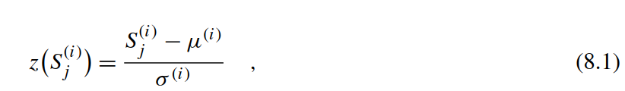

where *μ(i)* and *σ(i)* are the individual means and standard deviations of each of the *m* time series. Note that a similar technique is applied during batch normalization of deep neural networks [12]. Afterwards, each time series has vanishing mean and unit variance. Z-normalization is usually applied to remove offsets and variability in amplitudes in order to allow robust classiﬁcation in a subsequent phase. A traditional ﬁne-grained parallelization approach would process one time series per thread block. The corresponding sums could be evaluated in shared memory using parallel reduction

*μ(i)* 和 *σ(i)*为每一个时间序列的均值和标准差。注意，在对深度神经网络[12]进行批处理归一化时也采用了类似的技术。之后每个时间序列消失均值和单位方差。z归一化通常用于消除振幅中的偏移量和变异性，以便在后续阶段进行鲁棒分类。传统的细粒度并行方法是每个线程块处理一个时间序列。通过并行规约，利用共享内存来计算相应的总和。

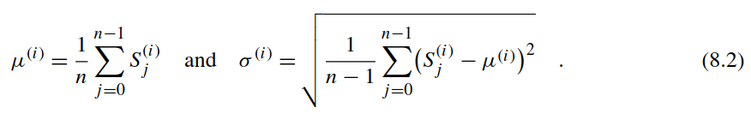

Note that a coarse-grained parallelization scheme where each thread processes one time series is also conceivable. However, you would have to transpose the data matrix to guarantee coalesced memory accesses. Here, we can achieve the same without transposition. For the sake of simplicity, assume that *n* = 32 such that we can process all time ticks within a single warp. Our to be implemented algorithm can be split into four phases:

注意，每个线程处理一个时间序列的粗粒度并行化方案也是可行的。然而，必须转置数据矩阵以确保可以合并内存访问。在这里，我们可以不用转置来同样实现粗粒度并行方案。为了简单起见，假设n = 32，这样我们就可以在一个warp内处理所有时间滴答。待实现算法可以分为四个阶段:

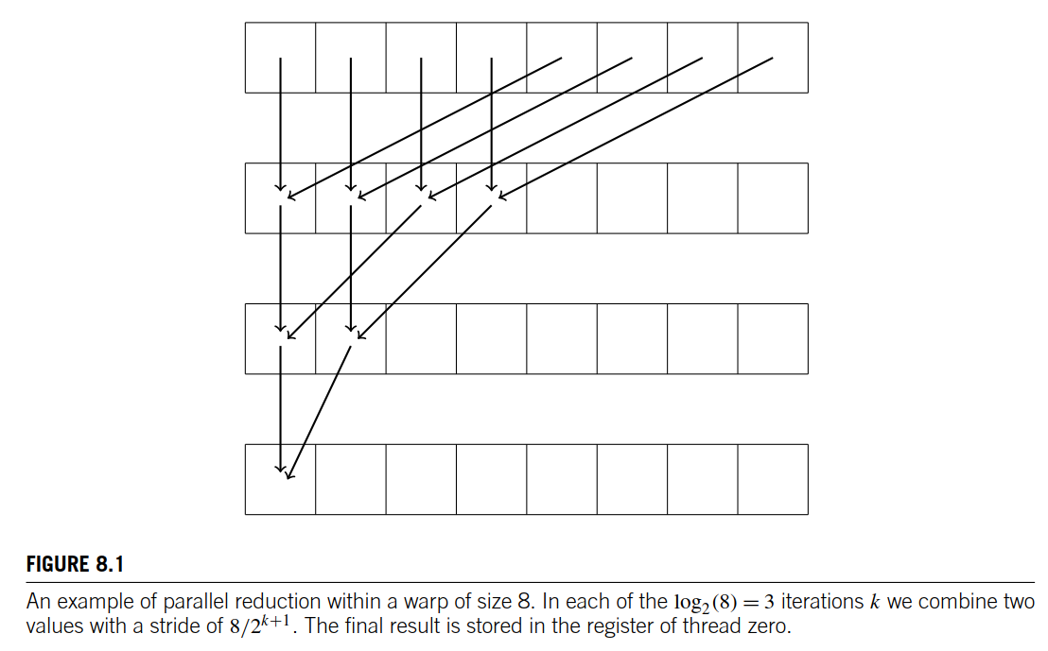

图8.1

An example of parallel reduction within a warp of size 8. In each of the log2*(*8*)* = 3 iterations *k* we combine two values with a stride of 8*/*2*k*+1. The ﬁnal result is stored in the register of thread zero.

Warp 大小为8的并行规约的例子。在每一次迭代过程中log2(8) = 3,将步长为8/2k+1 Th的两个值进行合并，将最终结果写会线程0的寄存器。

**1.** Each thread *j* within a warp loads its corresponding value *Sj(i)* into a register.

**2.** We perform an all-reduce on the registers to compute the average *μ(i)*.

**3.** Another all-reduce is performed in registers in order to calculate *σ(i)*.

**4.** Finally, we normalize each entry in registers and write them back to global memory.

1. 一个warp内的每个线程j 读取相对应的数据Sj(i)到寄存器
2. 在寄存器上执行全局规约来计算均值*μ(i)*.
3. 另一个寄存器全局规约计算*σ(i)*.
4. 最后对寄存器中每个条目执行均一化并把结果写会全局内存。

Steps 2 and 3 are accomplished using so-called **warp intrinsics** which allow for the efﬁcient sharing of registers within a warp. Initially, we will implement the all-reduce primitive with a traditional scheme for parallel reduction and subsequently broadcast the result to all threads within a warp as shown in Fig. 8.1. Later we will use another approach which directly accumulates the result in all threads.

第2步和第3步使用所谓的warp intrinsics来完成，它允许在warp内有效地共享寄存器。首先，我们将使用传统的并行规约方案实现all-reduce原语，然后将结果广播到warp内的所有线程，如图8.1所示。稍后，我们将使用另一种方法直接在所有线程中累积结果。

UP to CUDA 8 the strided access can be realized with a shufﬂe-down instruction __shfl_down() which was introduced by the Kepler generation. This CUDA 8 intrinsic operation takes three argu- ments: the ﬁrst one corresponds to the used register, the second one denotes the stride, and the third one speciﬁes the warp size up to a length of 32 (optional).

从CUDA 8开始，可以使用从开普勒一代引入的__shfl_down()指令来实现跨步访问。 这个CUDA 8内在操作需要三个参数：第一个对应于使用的寄存器，第二个参数表示步长，第三个指定warp大小，最大值为32（可选）。

// CUDA 8 shuffle down

T __shfl_down_(T var, unsigned int delta, int width=32)

Note that starting from CUDA 9 the intrinsic command __shfl_down() is deprecated and replaced by __shfl_down_sync()since threads in a warp are not implicitly synchronized anymore.

注意，从CUDA 9开始，内部命令__shfl_down() 被弃用，并被__shfl_down_sync()替换，因为warp中的线程不再隐式同步。

// CUDA 9 shuffle down

T __shfl_down_sync(unsigned int mask, // <- the mask is new

T var, unsigned int delta, int width=32)

The new parameter unsigned int mask encodes the participating threads within a warp in binary representation (0xFFFFFFFFfor all threads). This allows for the utilization of arbitrary subsets of a warp in contrast to CUDA 8 which is limited to widthconsecutive threads where width∈ {1*,*2*,*4*,*8*,*16*,*32}. The following wrapper is compatible to both CUDA 8 and CUDA 9:

新的参数unsigned int mask以二进制形式(0xfffffffffffffor all threads)对warp中的参与线程进行编码。与CUDA 8相比，这允许使用warp的任意子集，而CUDA 8则仅限于width∈{1,2,4,8,16,32}的连续线程。以下包兼容CUDA 8和CUDA 9:

template <typename T>

T my_warp_shfl_down(T var, unsigned int delta) {

#if defined(CUDART_VERSION) && CUDART_VERSION >= 9000 return __shfl_down_sync(0xFFFFFFFF, var, delta, 32); #else

return __shfl_down(var, delta, 32);

#endif

}

Another shufﬂe intrinsic can be used to read the value of a certain thread srcLane:

另一个shuffle intrinsic可以用来读取某个线程srcLane的值:

template <typename T>

T my_warp_shfl(T var, int srcLane) {

#if defined(CUDART_VERSION) && CUDART_VERSION >= 9000 return __shfl_sync(0xFFFFFFFF, var, srcLane, 32); #else

return __shfl(var, srcLane, 32);

#endif

}

Assume we have already provided a device-sided pointer to the data matrix Data which is ﬁlled with instances of the CBF data set of length *n* = 32 using generate_cbf() as shown in the main function of Listing 7.22. Then we can compute the sum for the mean *μ(i)* as follows:

假设我们已经提供了一个指向数据矩阵Data的设备端指针，该数据矩阵使用generate_cbf()填充长度为n = 32的CBF数据集的实例，如清单7.22的main函数所示。 然后我们可以计算均值μ(i)的总和，如下：

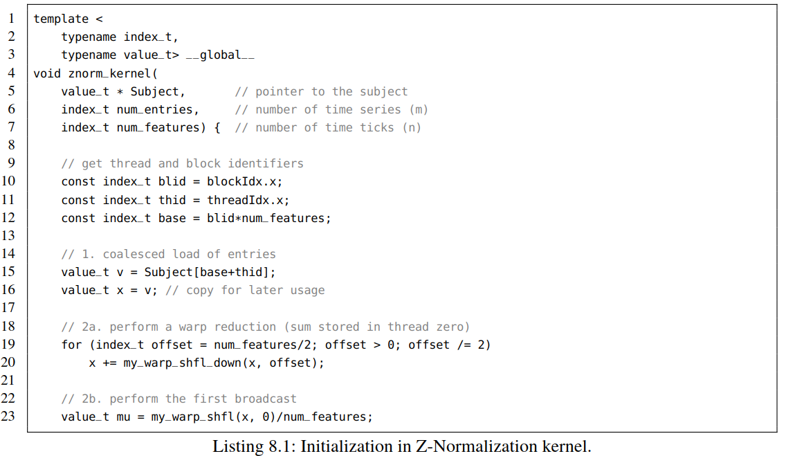

Listing 8.1: Initialization in Z-Normalization kernel.

清单8.1：清单8.1: Z-Normalization内核初始化

The for-loop performs the parallel reduction by fetching the entries from above using my_warp_shfl_down(). In a second phase we broadcast the ﬁnal sum back to the upper entries via my_warp_shfl() which reads the register of Thread 0. Now we can proceed with the computation of the variance. Here, we employ the same approach with the exception that we compute the sum of squared residues. Finally, we perform the normalization and write the result back to global memory.

for循环通过使用my_warp_shfl_down()对从上面指令获取的数据条目执行并行规约。在第二阶段中，我们通过my_warp_shfl()将最终的和广播回上面的条目，其中，my_warp_shfl()用来读取线程0的寄存器。然后可以继续计算方差。除了计算残差平方和，我们都使用相同的方法。最后，我们执行标准化并将结果写回全局内存。

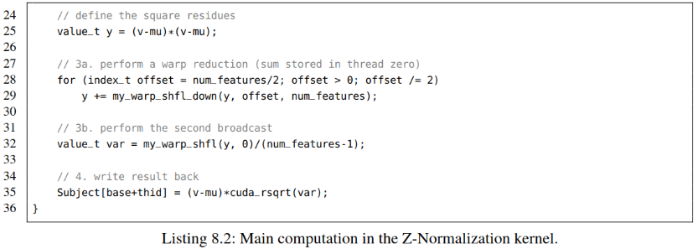

Listing 8.2: Main computation in the Z-Normalization kernel.

清单8.2：Z-Normalization内核的主要计算

The call to cuda_rsqrt is mapped to either the single-precision or double-precision variant of rsqrt – an efﬁcient instruction for the reverse square root. In general, you can deﬁne overloaded functions to allow for the mixing of C++ templates with C-signatures of some CUDA calls.

对cuda_rsqrt的调用被映射到rsqrt的单精度或双精度变变体： 一个反向平方根的有效指令。 通常可以通过定义重载函数，来将C ++模板与某些CUDA调用的C函数进行混合。

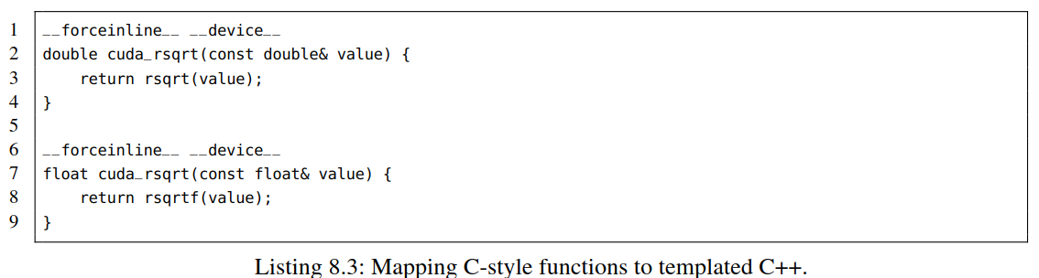

Listing 8.3: Mapping C-style functions to templated C++.

清单8.3: 将c风格的函数映射到模板化的c ++

Note that we can completely get rid of the broadcast phases 2b and 3b by using the CUDA 8/9 instruction __shfl_xor()/__shfl_xor_sync() instead of calling the aforementioned __shfl_down()/__shfl_down_sync() instructions as shown in [9]. Further optimization techniques can be applied when processing longer time series. An obvious approach is the stacking of several reduction per warp operating on distinct registers. Basically, we have pursued a similar technique by computing both the mean and variance in one warp. However, both reductions depend on each other in our experiment – the general case would interleave several independent reductions in order to beneﬁt from instruction parallelism. Moreover, we could use several warps per block to increase the thread occupancy of the SMs. Unfortunately, we have to use shared memory in this case in order to communicate the partial results between distinct warps.

注意，我们可以使用CUDA 8/9中的指令_shfl_xor()/ _shfl_xor_sync()去除广播阶段2b和3b，而不用调用前面提到的_shfl_down()/ _shfl_down_sync()指令，如[9]所示。当处理较长的时间序列时，可以应用进一步的优化技术。一种显而易见的方法是用不同的寄存器对每个warp进行多次还原叠加。基本上，我们采用了一种类似的技术在一个warp内同时计算平均值和方差。然而，在我们的实验中，这两种规约相互依赖，一般情况下，为了从指令并行性中获益，会将几个独立的规约相互交错。此外，我们可以在每个块中使用多个warp，以增加SMs的占用率。但在这种情况下，我们必须使用共享内存实现在不同warp之间传递部分结果。

**GLOBAL PARALLEL REDUCTION**

**全局并行规约**

Sometimes one has to accumulate a huge array instead of independently reducing many short arrays. In this case, we can pursue a similar approach by initially computing the partial reductions in all thread blocks and afterwards merge the results. To achieve that, we have basically two options. On the one hand, one could store the partial results in an auxiliary array value_t * Auxresiding in global memory and subsequently call the same kernel recursively on the auxiliary memory until we have accumulated all contributions in a single memory position. As an example, when reducing 32 blocks consisting of 32 threads, we would store the 32 partial results of the blocks in Aux and afterwards perform another parallel reduction using one thread block. On the other hand, one could concurrently write the partial contributions to a single memory location. Unfortunately, this introduces a race condition on the memory position storing the ﬁnal result.

有时必须积累一个巨大的数组，而不是对许多较短的独立数组进行规约。在这种情况下，我们可以采用类似的方法先用线程块完成部分规约，然后再合并结果。为此，我们基本上有两种选择。一方面，我们可以将部分结果存储在全局内存中的辅助数组alue_t * Aux中，然后在辅助内存上递归调用相同的内核，直到我们在一个内存位置得到累计的最后结果。例如，32个线程块，每个线程块包含32个线程，32个线程块获得的部分结果会存储在Aux中，然后再由一个线程块来执行并行规约。另一方面，可以并发地将部分结果写入某个内存位置，但是，这将在存储最终结果的内存位置上引入竞态条件。

This issue can be resolved if we use atomic operations in order to guarantee correct results. The CUDA programming language provides an extensive set of atomic instructions such as AtomicAdd(), AtomicSub(), AtomicMin(), and AtomicMax()[4]. All aforementioned commands accept as ﬁrst argument a pointer to global or shared memory and as second argument the corresponding value.

原子操作可以保证结果的正确性来解决上面的问题。CUDA编程语言提供了一组广泛的原子指令，如AtomicAdd（），AtomicSub（），AtomicMin（）和AtomicMax（）[4]。 所有上述命令的第一个参数都是指向全局或共享内存的指针，第二个参数为相对应的待操作值。

In the following, we will compute the sum of all entries in an array value_t * Input of size length and subsequently store the ﬁnal result in value_t * Output using atomics. The workﬂow of the algorithm consists of three phases:

**1.** We load all entries of Input into registers.

**2.** Each block consisting of a single warp performs a warp reduction.

**3.** Finally, each warp atomically adds its partial result to Output.

The corresponding implementation is straightforward (see Listing 8.4).

下面，我们将计算长度为length的数组value_t * Input中所有条目的总和，并采用原子操作将最终结果存储在value_t * Output中。 算法的工作流程包括三个阶段：

1.加载Input条目到寄存器。

2.每个block包含一个warp执行warp 规约。

3.最后，每个warp对他的部分结果执行原子加到Output。

相应的实现很简单(见 Listing 8.4).

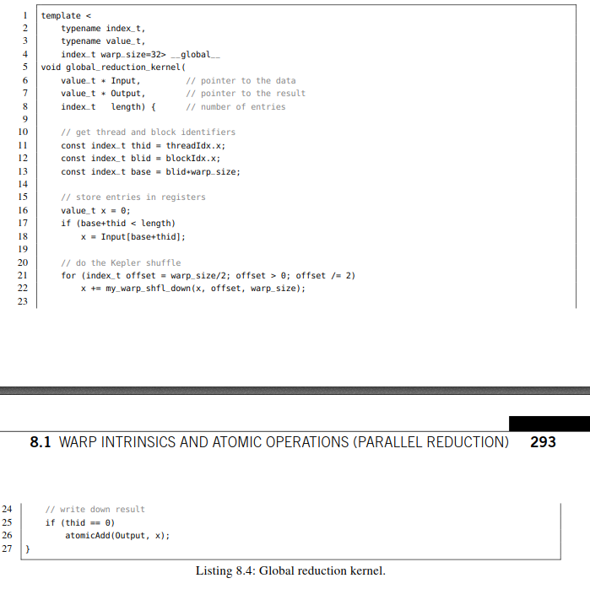

Listing 8.4: Global reduction kernel.

清单8.4： 全局规约内核

This kernel has the disadvantage that we only utilize 32 threads per block and further have to spawn quite a high number of SDIV(length, 32) many blocks. A solution that works with an arbitrary number of blocks and warps per block could be implemented as follows:

**1.** We spawn a ﬁxed number of blocks with a ﬁxed number of warps.

**2.** All warps read their values from Inputinto registers. If we run out of warps, we simply read several

values in a round robin fashion and add them up until we exhaust length.

**3.** Each warp performs a parallel reduction and subsequently accumulates the ﬁnal result atomically

in Output.

The corresponding source code is shown in Listing 8.5.

这个内核的缺点是每个块只使用32个线程，并且还需要产生相当多的SDIV（长度为32）个块。任意数量的线程块和每个块多个warp的方案实现如下：

1. 固定数量的线程块和每个块固定数量的warp

2. 所有warps从input读取对应数据到寄存器，如果warps用完，只需要以循环的方式读取数据并累加直到读完Length个长度。

3. Each warp performs a parallel reduction and subsequently accumulates the ﬁnal result atomically

in Output. 每个warp执行并行规约，并对最终结果执行原子累积操作。

相关源代码 (见 清单 8.5)

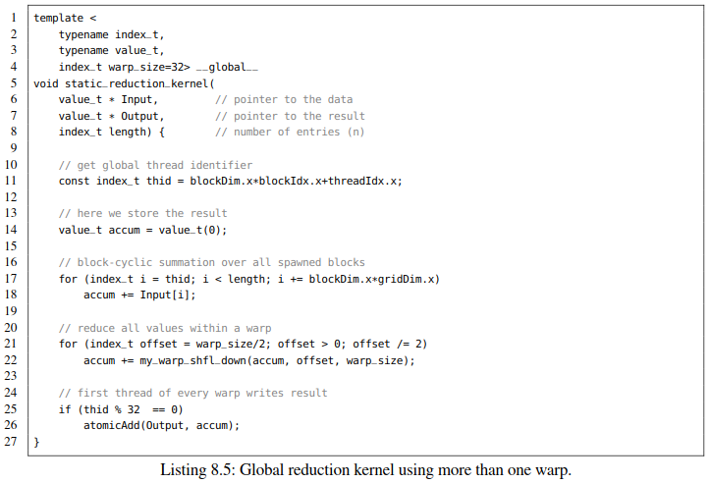

清单 8.5: 使用多个warp的全局规约kernel

Note that the presented implementations have to be taken with a grain of salt. If we choose the template parameter value_t to be an integral data type such as int32_t or uint32_t, then the result stored in Output will always be the same independently of the execution order of warps. However, when using ﬂoating-point data types such as floator double, we cannot rely on the associativity of addition since *(a* + *b)* + *c* = *a* + *(b* + *c)* for all *a,b* and *c* in general. Hence, the numerically stable summation of ﬂoating-point values requires a little more effort [14].

对所提供的实现持保留态度，如果我们模板参数value_t实例化为整数数据类型，例如int32_t或uint32_t，那么存储在Output中的结果始终是相同的，且与warp的执行顺序无关。然而，当使用浮点数据类型(如float 或者double)时，我们不能依赖对所有的a、b和c都适用加法的结合律即 (a + b) + c = a + (b + c)。因此，浮点值的数值稳定求和需要花费更多的精力[14]。

**ARBITRARY ATOMIC OPERATIONS**

Although CUDA provides a comprehensive set of atomic instructions [4], you might encounter a situ- ation where you have to atomically update a value with an unsupported operation. Assume we deﬁne the following associative1 binary operation

**任意原子操作**

尽管CUDA提供了一套全面的原子指令[4]，但也可能会遇到CUDA不支持的原子操作。假设我们定义了以下关联的二元操作。



then you will desperately search for an atomic o= assignment in the CUDA documentation. The bad news is that you will not ﬁnd it. The good news is that you can implement virtually every atomic operation on your own as long as the data type ﬁts into 64 bits of memory. This can be achieved with a compare-and-swap (CAS) instruction which atomically performs the following three actions without interruption.

**1.** Compare a given value expectation with a value source stored in memory.

**2.** If both values expectation and source coincide then set sourceto a given value target, otherwise do nothing.

**3.** Return target if the swap in 2. was successful, otherwise return source.

在CUDA文档中拼命搜索原子o=赋值。坏消息是你不会找到它。好消息是，只要数据类型适合64位内存，就可以自己实现几乎所有原子操作。这可以通过使用比较和交换(CAS)指令来实现，该指令原子性地执行以下三个操作而不会中断。

1. 将给定的值expectation与存储在内存中的值source进行比较。

2. 如果两个值expectation和source满足要求，就将source设置为给定值target，否则不执行任何操作。

3. 如果步骤2中的交换成功则返回target，否则返回source。

The return value in 3. can be rewritten as ternary conditional statement: (expected == source) ? target : source. Conceptually, CAS tries to swap two values under the constraint that our assumptions about the source location are fulﬁlled. But how can you use that to atomically update a value? We have to take into consideration that our expectation could be wrong, i.e., another thread has already altered the source position and thus the swap will (and should consequently) fail. We might have to update our expectation and reapply the CAS operation. Hence, **CAS has always to be performed within a loop** until we ﬁnally succeed or alternatively we can cancel the attempt due to a certain constraint violation. In order to demonstrate the latter, let us artiﬁcially extend the binary operation in Eq. (8.3) to be only applied if 0 ≤ *x* ◦ *y <* 10. Concluding, we aim to implement a custom function atomicUpdateResultBoundedByTen().

步骤3中的返回值可以重写为三元条件语句: (expected == source) ? target : source. e.

从概念上讲，CAS试图在约束条件下交换两个值，即我们对源位置的假设得到满足。 但是，如何使用它以原子方式更新值？ 我们必须考虑到我们的期望可能是错误的，即另一个线程已经改变了源位置，因此交换将（并且因此应该）失败。 我们可能需要更新我们的期望并重新应用CAS操作。 因此，CAS总是在循环内执行，直到最终成功，或者我们可以取消由于某种约束违规导致的尝试。 为了演示后者，让我们人为地扩展方程式（8.3）中的二元运算。仅在0≤x◦y<10时应用。最后，我们的目标是实现一个自定义函数

The CUDA programming language provides CAS primitives for three basic integral data types value_t∈ {int*,*unsigned int*,*unsigned long long int}:

CUDA编程语言为三种基本的整型数据类型value_t∈{int,unsigned int,unsigned long long int}提供了CAS原语:

value_t atomicCAS(value_t* source_address, value_t expected, value_t target)

Unfortunately, we have to recast any other data type that ﬁts into either 32 or 64 bits at pointer level into one of those three types (even the modern int32_t, uint32_t, and uint64_t equivalents). As an example, you can reinterpret a float y on byte-level as int x via int x = (int*)(&y) and vice versa. At this point, we can implement our atomicUpdateResultBoundedByTen() function. For the sake of simplicity, we assume value_t to be a basic integer.(page296)

不幸的是，我们必须将指针级别上适合32位或64位的任何其他数据类型重新转换为这三种类型之一（甚至是现代的int32_t、uint32_t和uint64_t等效类型）。 例如，您可以在字节级重新解释float y作为int x via int x =（int *）（＆y），反之亦然。 此时，我们可以实现我们的atomicUpdateResultBoundedByTen（）函数。 为简单起见，我们假设value_t是一个基本整型。

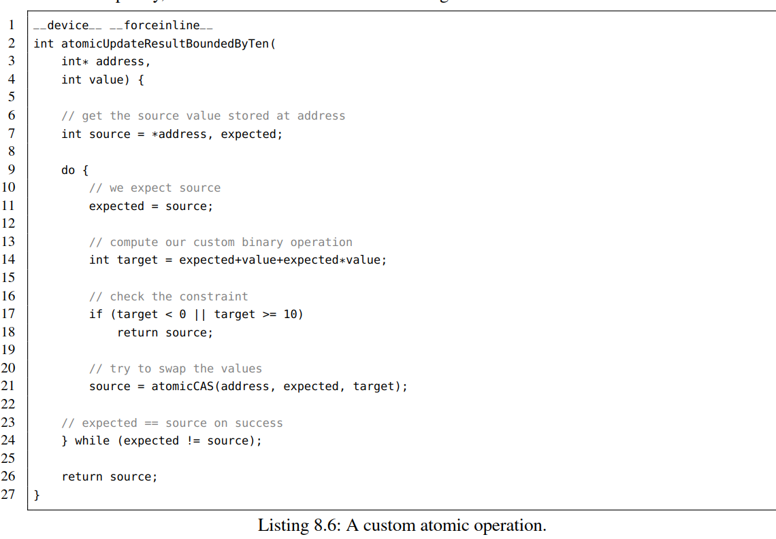

清单8.6 自定义原子操作

The loop incrementally updates expected with source (Line 11) and source itself with the value stored at address (Line 21) until we meet our assumption and thus have swapped the values (Line 24) or alternatively violated the constraint (Line 17). Concluding, every atomic function can be expressed in terms of CAS loops.

循环逐步用source(第11行)更新expected，用存储在attress(第21行)的值更新source本身，直到满足我们的假设，并因此而交换了值(第24行)或违反约束(第17行)。最后，每个原子函数都可以用CAS循环来表示。

OUTLOOK

展望

We have seen that warp intrinsics and atomic operations are powerful tools which enable us to write short yet efﬁcient code. In general, they can be used to accelerate many traditional algorithms on the GPU (far too many to be discussed within the scope of this book). Nevertheless, we want to mention some noteworthy examples: The discussed wavefront relaxation scheme of DTW (see Section 7.4) which stores three diagonals could be implemented in registers for time series up to a length of 32. Moreover, we could design sorting networks such as Bitonic Sort or selection networks using intra-warp shufﬂes. Other examples include short length Fast Fourier Transforms (FFT), segmented and global preﬁx scans [15], or warp aggregation [1]. Furthermore, atomics could be used to dynamically assign block identiﬁers to enumerate the blocks according to their spawn order [11]. This can be used to model dependencies between thread blocks. A similar approach was used during the computation of preﬁx scans for inter-block synchronization without the need to terminate the kernel [15].

warp内在函数和原子操作是非常强大的工具，使我们能够编写简短而有效的代码。一般来说，它们可以用于加速GPU上的许多传统算法（太多了，在本书的讨论范围内无法讨论）。然而，还是想提一些值得注意的例子:第7.4节讨论的存储三条对角线的DTW波前弛豫方案可以在寄存器中实现，时间序列最长可达32。此外，我们可以设计排序网络，如位元排序或warp内部变换的选择网络。其他例子包括短长度的快速傅里叶变换(FFT)、分段和全局前缀扫描[15]或warp聚合[1]。此外，可以使用atomics动态分配块标识符，根据块的派生顺序[11]枚举块。这可以用来构建线程块之间的依赖关系模型。在计算块间同步的前缀扫描时使用了类似的方法，而不需要终止内核[15]

Finally, let us state a list of useful libraries that make excessive use of the discussed techniques. Thrust [10] is a high-level library bundled with CUDA which provides efﬁcient parallel primitives such as preﬁx scans, reductions, histograms, and sorting algorithms for the GPU. It mimics the interface of STL vectors and thus provides a low barrier to entry especially for inexperienced users. CUDA Unbound (CUB) [2] is a yet more efﬁcient low-level library which features highly conﬁgurable device-wide, block-wide and warp-wide parallel primitives individually optimized for several GPU generations. Moreover, CUB is a header-only library which can be easily integrated into existing projects. Fast Fourier Transforms of arbitrary length can be computed in single- and double-precision using the cuFFT library [6] which is also bundled with the CUDA toolkit. Other note worthy examples include cuBLAS [3], cuRAND [7], cuDNN [5], and cuSOLVER [8]. Concluding, it is highly advisable to search for a potentially existing library before you try reinventing the wheel. These libraries are usually well documented, optimized for current GPU generations, and extensively tested which favors their use in production code.

最后，让我们列出一些有用的库，这些库都使用了我们所讨论的技术。Thrust [10]是一个与CUDA捆绑的高级库，它为GPU提供了高效的并行原语，如前缀扫描、约简、直方图和排序算法。它模仿了STL向量的接口，因此为没有经验的用户提供了一个较低的进入门槛。CUDA Unbound (CUB)[2]是一个更高效的底层库，它具有高度可配置的device级、block级和warp级并行原语，分别针对多代GPU进行优化。此外，CUB是一个头文件库，可以很容易地集成到现有项目中。使用cuFFT库[6]可以计算单精度和双精度且任意长度的快速傅里叶变换的。其他值得注意的例子包括cuBLAS[3]、cuRAND[7]、cuDNN[5]和cuSOLVER[8]。所以，在尝试重新发明轮子之前，最好先搜索可能存在的库。这些库通常都有很好的文档，且都针对当前几代的GPU进行了优化和大量的测试，有利于它们在生产代码中使用。

8.2 UTILIZING MULTIPLE GPUS AND STREAMS (NEWTON ITERATION)

利用多gpu和流(牛顿迭代)

Up to this point, we have utilized a single GPU for the execution of kernels. In this section, you will learn how to concurrently harness multiple accelerator cards attached to the same compute node. Furthermore, we will discuss how you can hide the communication over the slow PCIe bus behind computation by interleaving memory transfers and kernel execution. Finally, we will combine both techniques to fully exploit the vast computational resources of single node workstations with multiple GPUs.

到目前为止，我们已经使用单个GPU来执行内核。 在本节中，将学习如何同时利用单个计算节点的多个加速卡。 此外，我们将讨论如何通过交叉存储器传输和内核执行来隐藏通过速度较慢的PCIe总线进行的通信。 最后，我们将结合这两种技术，充分利用具有多个GPU的单节点工作站的大量计算资源。

NEWTON’S ITERATION (牛顿迭代)

In order to demonstrate the beneﬁts of streamed computation on multiple GPUs, we need a compute- heavy kernel which rarely accesses global memory. A good representative for this class of kernels is the iterative ﬁx point computation of zero crossings of arbitrary differentiable functions. For the sake of simplicity, we choose to compute the square root of a certain value using Newton’s iteration method. Let *f* : R→ R*, x* → *f (x)* be a differentiable function where *f* ′*(x)* = 0 for all *x* and *x*0 be an initial (not necessarily good) guess for *f (x)* = 0 then the recursive application of

为了展示利用多个gpu进行流计算的好处，我们需要一个访问全局内存很少的计算密集型内核。这类内核的一个很好的代表是任意可微函数零点交叉的迭代不动点计算。为了简单起见，我们选择用牛顿迭代法计算某个值的平方根。设f: R→R, x→f (x)为可微函数，其中对于所有x, f ' (x) = 0, x0是f（x）= 0的初始（不一定是好的）猜测，然后是递归应用

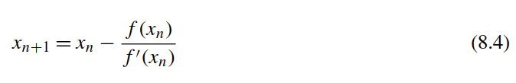

yields a better approximation for a zero crossing. Note that there could be multiple solutions of *f (x)* = 0, e.g., when investigating polynomials of higher degree – this approach merely computes one possible solution. The derivation of Eq. (8.4), its geometric interpretation, and further analysis of convergence speed and numerical stability can be found in any basic text book about Univariate Analysis. In our case, we want to determine the positive square root of some given value *α*. Thus, we aim to solve the equation

产生一个零交叉的更好的近似。注意，可能存在f（x）= 0的多个解，例如，当研究更高程度的多项式时 - 该方法仅计算一种可能的解。公式(8.4)的推导、几何解释以及收敛速度和数值稳定性的进一步分析可以在任何一元分析的基础教材中找到。本例子中,我们想要确定一个给定值α的平方根。因此，目标是解这个方程



on the domain R+ = *(*0*,*∞*)*. The ﬁrst derivative *f (x)*′ = 2 ·*x* is greater than zero on the whole domain and thus the quotient in Eq. (8.4) is always well-deﬁned. If we plug in the function into the iterative scheme, we obtain a simple recursive formula

在定义域R+ = *(*0*,*∞*),* 一阶导数*f (x) ' = 2·x*在整个定义域上大于零，因此公式(8.4)中的商总是有明确的定义。如果我们把这个函数代入迭代格式，我们得到一个简单的递归公式

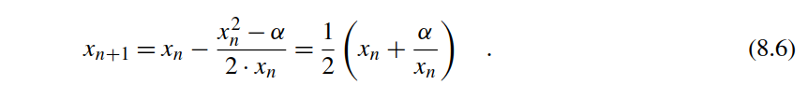

Note that for positive values of *x*0 and *α* all consecutive values *xn* are positive and thus we compute a unique solution on R+. Hence, we can set *x*0 = *α* in the initialization step. The iteration is usually performed until two consecutive results *xn* and *xn*+1 agree within a certain error threshold or coincide in terms of ﬂoating point values. In our case, we pursue an orthogonal approach and perform the update procedure for a ﬁxed number of iterations. Listing 8.7 shows an exemplary kernel which determines the square roots of all entries stored in a device array value_t * Data.

注意，对于x0和α的正值，所有连续值xn都是正的，因此我们计算R+上的唯一解。因此，在初始化步骤中设置x0 =α.迭代直到两个连续结果xn和xn + 1在某个误差阈值范围内或者两者的浮点数值基本一致时结束。本例中，我们采用正交方法并对固定数量的迭代执行更新过程。清单8.7展示了一个示例内核，它确定了存储在设备数组value_t * Data中的所有条目的平方根。

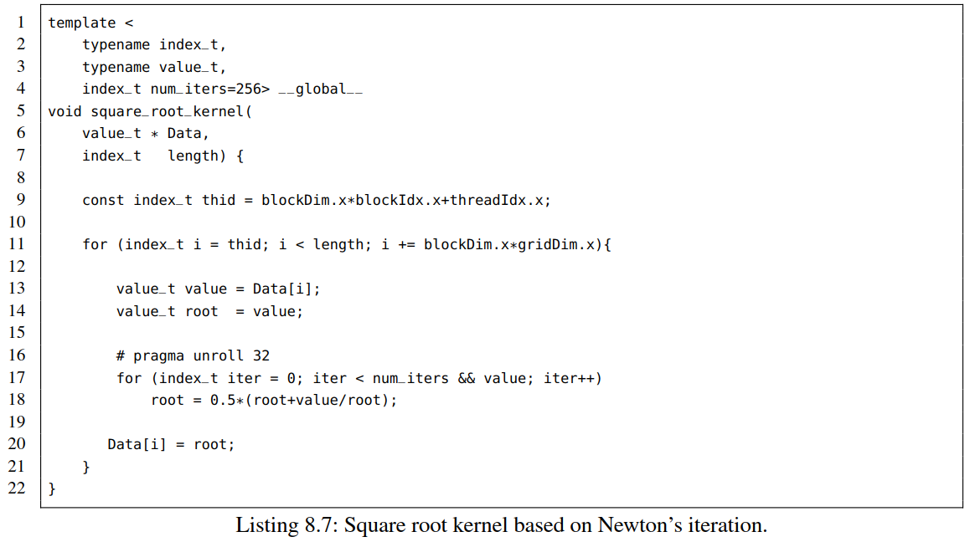

Listing 8.7: Square root kernel based on Newton’s iteration. 清单8.7:基于牛顿迭代的平方根内核

Note that this approach is inefﬁcient due to the existence of the fast sqrt() call and the rather high number of iterations. However, we can easily alter the num_iters parameter to adjust the execution time in our experiments. Furthermore, there could be non-trivial tasks like solving equations like *f (x)* = *x* · exp*(*·*x)* − *α* = 0 that cannot be explicitly expressed in terms of *x*. In this case, CUDA does not provide a specialized instruction to efﬁciently compute the Lambert W function *x* = *W(α)*.

注意，由于存在快速的sqrt()调用和相当高的迭代次数，这种方法效率很低。但是，我们可以很容易地修改参数num_iters来调整实验中的执行时间。此外，此外，可能存在困难的任务，例如求解*f (x)* = *x* · exp*(*·*x)* − *α* = 0等无法用x来明确表达的方程式。在这种情况下,CUDA没有提供专门的指令可以有效地计算出Lambert W 函数x = W(α)。

The kernel can be called from within the main function. We further add timers to allow for the omparison of the execution time of the kernel with the time taken for memory transfers.

可以从main函数中调用内核。 我们还添加定时器，以便比较内核的执行时间和内存传输所花费的时间。

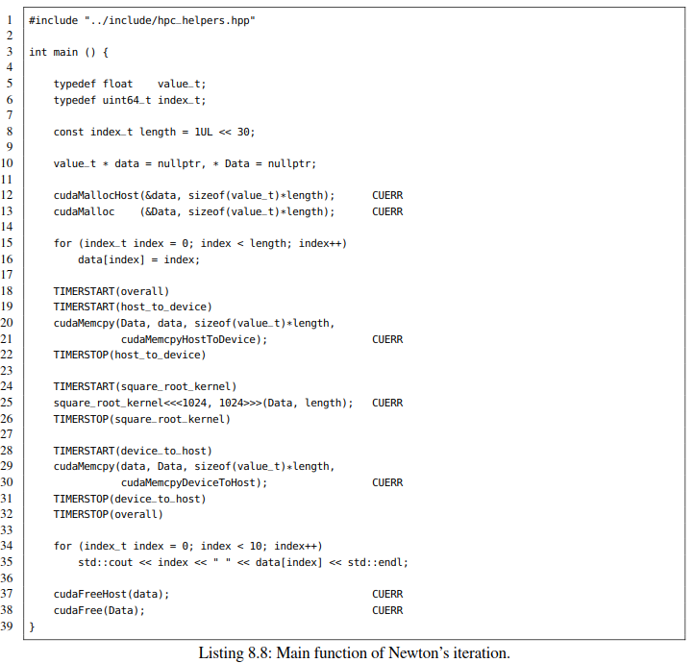

Listing 8.8: Main function of Newton’s iteration清单8.8:牛顿迭代main函数

When executed on a single Pascal-based Titan X, we obtain the following output:

当在一个基于pascal的Titan X上执行时，得到如下输出:

TIMING: 357.873 ms (host_to_device)

TIMING: 1346.27 ms (square_root_kernel)

TIMING: 325.595 ms (device_to_host)

TIMING: 2029.82 ms (overall)

It takes roughly 350 ms to copy the 4 GB of single-precision ﬂoating point values stored in data over the PCIe bus from the host to the device (≈ 11*.*4 GB/s) and vice versa. The kernel itself runs ap- proximately 1300 ms resulting in an overall time of two seconds for both the memory transfers and computation. Concluding, we spend roughly double the time taken for memory transfers on computation.

将存储在data中，类型为单精度浮点的4GB数据通过PCIe 总线从主机拷贝到设备上大约需要350 ms，反之亦然。内核本身运行大约1300毫秒，因为内存传输和计算的总时间为2秒。最后，我们在计算上花费的时间大约是内存传输时间的两倍。

HARNESSING MULTIPLE GPUS

利用多个gpu

This subsection demonstrates the distribution of the aforementioned task among several GPUs attached to the same workstation. Note that throughout the rest of this section we will exclusively modify the main function and keep the kernel as is. We can reuse the same kernel by simply splitting the device array Data into chunks of size length/num_gpus. The amount of available CUDA-capable GPUs can be determined with the following two host-sided commands

本小节演示了上述任务在连接到同一工作站上的多个gpu中的分布情况。注意，在本节的其余部分中，我们将只修改主函数且保持内核不变。只需将设备数组data分割成大小为length/num_gpu的块来重用相同的内核可以使用。可以使用以下两个主机端命令来确定可用的支持cuda的gpu数量

int num_gpus;

cudaGetDeviceCount(&num_gpus);

You can set the environment variable CUDA_VISIBLE_DEVICES in a terminal if you want to explicitly mask certain GPUs. As an example, CUDA_VISIBLE_DEVICES=0,2 would mask the devices 1 and 3 in a workstation with four GPUs. This might become handy if you use third party libraries such as Tensorﬂow and want to exclude the GPU which renders the Desktop in order to avoid occasional freezes of your GUI. Within a CUDA application we can choose the currently used device using cudaSetDevice() which accepts integral arguments ranging from 0 to num_gpus-1. Notably, this command is not a hardware switch which globally selects the used GPU like in a state machine: cudaSetDevice() acts within the currently deﬁned scope and further is thread-safe. Consequently, allocation of memory and launching of kernels is bound to the selected device within the lifetime of that scope. At this point, we could optionally gather information about the attached devices such as provided VRAM, number of SMs, or clock rate in order to design proper distribution patterns of our data. This can be achieved as follows

如果希望显式屏蔽某些gpu，可以在终端中设置环境变量CUDA_VISIBLE_DEVICES。例如，CUDA_VISIBLE_DEVICES=0,2将屏蔽工作站中带有四个gpu的设备1和3。如果使用第三方库（如Tensor fl ow）并希望排除渲染桌面的GPU以避免偶尔冻结GUI，设置环境变量可能会变得很方便。我们可以使用cudaSetDevice（）选择当前使用的设备，该设备接受从0到num_gpus-1的整数作为参数。值得注意的是，该命令不是一个硬件开关，就像在状态机中一样，它全局地选择可供使用的GPU: cudaSetDevice()在当前定义的范围内工作，而且是线程安全的。相应地，内存的分配和内核的启动都绑定到该范围内所选的设备。此时，我们可以选择收集有关所连接设备的信息，例如提供的VRAM，SM数量或时钟速率，以便设计数据的正确分布模式。可以通过如下完成

cudaDeviceProp property;

cudaGetDeviceProperties(&property, gpu);

where gpu is an integer enumerating the devices. The cudaDeviceProp struct stores useful member variables such as the amount of VRAM (size_t totalGlobalMem), the number of SMs (int multiProcessorCount), or the frequency of the GPU (int clockRate) [4]. In our experiments, we will use two Pascal-based Titan X GPUs with 12 GB of VRAM.

Hence, we can safely assume that both devices can store the data array of size 4 GB and further exhibit the same peak performance.

Moreover, we assume that the length of Data is a multiple of the number of attached GPUs. In the following, we will split the host array data into chunks of size length/num_gpus and allocate num_gpus many device arrays of the same length on distinct GPUs, copy the partial arrays to the corresponding devices, launch the kernel operating on each partial device array, and ﬁnally copy the results back to the host.

其中gpu是整数，用来枚举设备的数量。结构体cudaDeviceProp存储有用的成员变量，例如VRAM的数量（size_t totalGlobalMem），SM的数量（int multiProcessorCount），或GPU的频率（int clockRate）[4]。本实验将使用两个基于pascal的Titan X GPU和12 GB的VRAM。因此，我们可以安全地假设两个设备都可以存储大小为4 GB的数据阵列，和相同的峰值性能。此外，我们假设Data的长度是节点所配GPU数量的倍数。接下来，我们将主机阵列data拆分成多个大小为length / num_gpus的块，在在不同的gpu上分配许多相同长度的设备数组，拷贝部分数组到相应的设备上，启动内核对在每个设备上的数组进行操作，最后将最后结果拷贝会主机端。

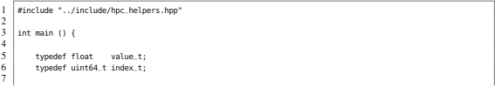

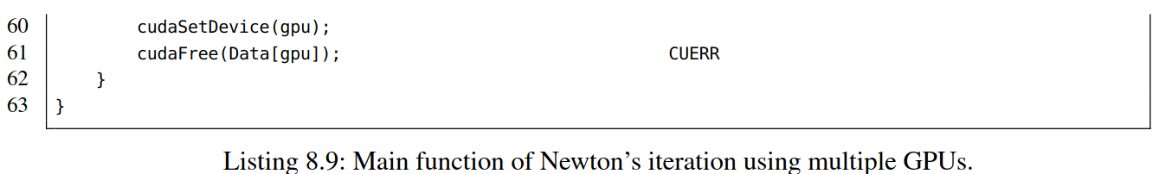

清单8.9：Main function of Newton’s iteration using multiple GPUs.

采用多个GPU的牛顿迭代主函数

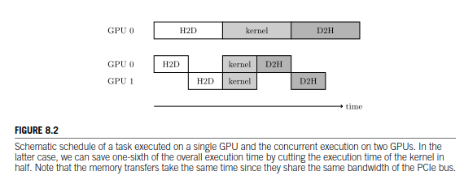

Schematic schedule of a task executed on a single GPU and the concurrent execution on two GPUs. In the latter case, we can save one-sixth of the overall execution time by cutting the execution time of the kernel in half. Note that the memory transfers take the same time since they share the same bandwidth of the PCIe bus.

在一个GPU上执行任务和在两个GPU上并发执行任务的示意图。在后一种情况下，通过将内核的执行时间减半来节省总执行时间的六分之一。注意，由于共享PCIe总线的带宽相同，内存传输花费相同的时间.

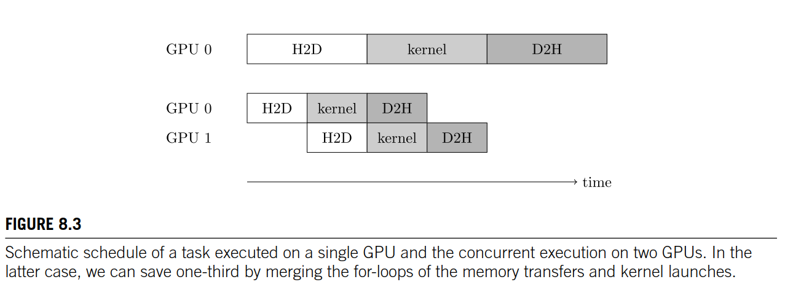

图8.3 Schematic schedule of a task executed on a single GPU and the concurrent execution on two GPUs. In the latter case, we can save one-third by merging the for-loops of the memory transfers and kernel launches.

在一个GPU上执行任务和在两个GPU上并发执行任务的示意图。在后一种情况下，通过合并内存传输和内核启动的for循环，我们可以节省三分之一。

When using two Pascal-based Titan X devices the GPU-related part of the program (Line 28 to Line 53) including memory transfers and kernel launches terminates after 1400 ms. This is slightly more than half of the 2000 ms overall execution time of the single GPU variant. Nevertheless, we can explain the 400 ms difference as follows: both GPUs block the sequential instruction ﬂow until their respective memory transfer is accomplished and thus we can only cut the single GPU kernel execution time of 1300 ms in half, resulting in approximately 650 ms spent on computation and 750 ms on memory transfers (see Fig. 8.2). Consequently, we expect this approach to scale even worse when utilizing three or more devices. Note that we can slightly reduce the overall execution time of the multi-GPU approach to 1200 ms by merging the for-loops of the memory transfer to the device (Line 30) and the kernel launches (Line 39). Fig. 8.3 depicts the corresponding schedule.

当使用两个基于pascal的Titan X设备时，程序中与gpu相关的部分(第28行到第53行)包括内存传输和内核启动花费大概1400 ms。这只是单GPU版本2000毫秒总执行时间的一半多一点。我们可以将400ms的差异解释为:两个GPU都阻塞顺序指令流，直到各自的内存传输完成，因此我们只能将单个GPU内核1300 ms的执行时间减半，,导致大约650毫秒用于计算和存储传输量耗时750毫秒(见图8.2)。因此，当使用三个或更多的设备时，我们预计这种方法的伸缩性会更差。注意，通过合并到设备的内存传输(第30行)和内核启动的for循环(第39行)，我们可以将多gpu方法的总执行时间降低到1200 ms。图8.3给出了相应的进度表。

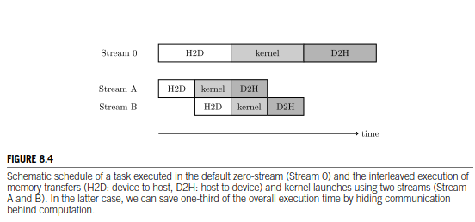

Schematic schedule of a task executed in the default zero-stream (Stream 0) and the interleaved execution of memory transfers (H2D: device to host, D2H: host to device) and kernel launches using two streams (Stream A and B). In the latter case, we can save one-third of the overall execution time by hiding communication behind computation.

图8.4：任务在默认零流（流0）中执行的示意图和并实现内存传输（H2D：设备到主机，D2H：主机到设备）和内核启动在两个流（流A和流B）交错执行的示意图。 在后一种情况下，我们可以通过隐藏计算后的通信来节省总执行时间的三分之一

**INTERLEAVING COMMUNICATION AND COMPUTATION**

* **通信和计算交叉**

This subsection discusses an alternative approach to signiﬁcantly reduce the execution time of the square_root_kernel on a single GPU using CUDA streams. The main idea behind streaming relies on the fact that we can interleave the slow PCIe transfers and fast kernel executions. Hence, after having transferred a portion of our data to the device, we can start the computation while another portion of the data is still being copied. In the ideal case, we can reduce the perceivable memory transfers to the initial copy of the ﬁrst chunk to the device and the last chunk to the host. The remaining memory transfers are executed during computation and thus do not contribute to the overall execution time. Unfortunately, this approach is only beneﬁcial if the kernel execution time is in the same order-of-magnitude as the memory transfers. Note that for educational purposes we have chosen a compute-heavy kernel from the very beginning. Fig. 8.4 depicts an example using two CUDA streams.

本小节讨论了使用CUDA流在单个GPU上显著减少square_root_kernel执行时间的替代方法。流计算背后的主要思想依赖于这样一个事实，即我们可以实现缓慢的PCIe传输和快速的内核执行之间的重叠。因此，在将一部分数据传输到设备之后就可以开始计算，而另一部分数据仍在被复制。在理想情况下，我们可以将可感知的内存传输减少到第一个到设备的初始拷贝以及到最后一个从设备到主机的块传输，剩余的内存传输是在计算期间执行，所以不会影响总体执行时间。不幸的是，只有当内核执行时间与内存传输时间的数量级相同时，这种方法才有用。注意，出于教学目，开始就选择了一个计算量很大的内核。图8.4描绘了使用两个CUDA流的示例。

Before we discuss the usage of user-deﬁned streams let us brieﬂy revisit CUDA’s default behavior. Memory transfers and kernel launches are executed in the default *zero-stream* if we do not explicitly specify a user-deﬁned stream. The zero-stream acts like expected: Several stacked kernels are executed in order without overlapping and synchronize with explicit global barriers (cudaDeviceSynchronize()) or implicitly deﬁned ones (e.g. cudaMalloc[Host](), cudaMemset(), and cudaMemcpy()). The only exception to this sequential behavior is the execution of host code which is not blocked by the asynchronous kernel invocations. Concluding, the zero-stream organizes the workﬂow of our program in a strict serial manner. Thus, a traditional kernel call is equivalent to a kernel invocation in the zero-stream (speciﬁed by the fourth argument in triple angle brackets):

在讨论用户定义流的使用之前，让我们简要回顾一下CUDA的默认行为。如果我们没有显式地指定用户定义的流，那么内存传输和内核启动将在默认*zero-stream*中执行。zero-stream会按照预期执行：按顺序执行多个堆叠的内核，而不与显式全局屏障(cudaDeviceSynchronize())或隐式定义的屏障(例如cudaMalloc[Host]()、cudaMemset()和cudaMemcpy())重叠和同步。这种顺序行为的唯一例外是主机代码的执行，它不会被异步内核调用阻塞。最后，*zero-stream*以严格的串行方式组织了程序的工作流程。因此，传统的内核调用相当于*zero-stream*中的内核调用(由三尖括号中的第四个参数指定):

kernel <<<num_blocks, num_threads, sh_mem>>> (args);

kernel <<<num_blocks, num_threads, sh_mem, 0>>> (args);

In contrast, kernels launched in distinct user-deﬁned streams act independently and thus do not syn- chronize with each other or kernels in the zero-stream. As a result, we can asynchronously spawn several kernels each using their own stream which are executed in parallel on the GPU. User-deﬁned streams can be declared as follows: assume we want to create num_streams many streams then we can simply deﬁne an array of type cudaStream_t * and subsequently initialize it via:

相反，在用户定义的不同流中启动的内核是独立工作的，不会彼此同步，也不会在zero-stream中同步。因此，我们可以异步地生成几个内核，每个内核都使用自己的流，这些流在GPU上并行执行。用户定义的流可以声明如下:假设我们想创建num_streams个流，那么我们可以简单地定义一个类型为cudaStream_t *的数组，然后通过:

cudaStream_t streams[num_streams];

for (int streamID = 0; streamID < num_streams; streamID++)

cudaStreamCreate(&streams[streamID]);

Streams should be destroyed at the end of our program using cudaStreamDestroy:

程序结束时使用cudaStreamDestroy销毁streams

for (int streamID = 0; streamID < num_streams; streamID++)

cudaStreamDestroy(streams[streamID]);

The asynchronous invocation of several kernels in distinct stream is straightforward:

在不同的流中异步调用多个内kernel非常简单：

for (int streamID = 0; streamID < num_streams; streamID++)

kernel <<<num_blocks, num_threads,

sh_mem, streams[streamID]>>> (args);

Several kernel launches stacked within the same stream behave as usual: they are executed se- quentially without overlap. Moreover, we can synchronize a certain stream with host code using cudaStreamSynchronize(streams[streamID]) or alternatively enforce a global barrier affecting all user-deﬁned streams and the zero-stream with a call to cudaDeviceSynchronize(). Furthermore, CUDA features a sophisticated event system which could be used to model complex dependencies between streams [4]. Finally, we have to discuss memory transfers which are now executed while other kernels perform computation. Unfortunately, we cannot use a traditional call to cudaMemcpy() since it imposes a global barrier across the whole device. Hence, we have to use cudaMemcpyAsync(), which accepts exactly the same arguments as cudaMemcpy() with the exception of an additional argument specifying the used stream:

几个堆在同一流中的内核启动的行为与往常一样:它们是按顺序执行的，没有重叠。此外，我们可以使用cudaStreamSynchronize(streams[streamID])将特定流与主机代码同步，或者通过调用cudaDeviceSynchronize()强制设置一个全局屏障，该屏障将影响所有用户定义的流和zero-stream。此外，CUDA还提供了一个复杂的事件系统，可以用来构建流[4]之间的复杂依赖关系的模型。最后，我们必须讨论在某些内核执行计算时，某些内核正在执行内存传输。不幸的是，我们不能使用传统的cudaMemcpy()调用，因为它会在整个设备上设置了一个全局屏障。因此，我们必须使用cudaMemcpyAsync()，除了一个额外的参数指定使用的流指望,它接受与cudaMemcpy()完全相同的参数：

cudaMemcpyAsync(target_ptr, source_ptr, size_in_bytes, transfer_mode, streams[streamID]);

As expected, asynchronous copies within the same stream stack in order and synchronize with kernel calls. There is only one important limitation: host memory should be allocated as *pinned memory* with cudaMallocHost in order to avoid swapping to disk. At the time of writing, it is not advisable to use host memory allocated with new or malloc in combination with streams. Note that CUDA further provides the asynchronous MemsetAsync() command. Unfortunately, there exists no asynchronous routine for memory allocation on the device that is callable from the host. Hence, we have to allocate device memory at the very beginning of our program.

与预期的一样，异步拷贝在同一个流中顺序入栈，并与内核调用同步。有个非常重要的限制:

应使用cudaMallocHost将主机内存分配为pinned内存，以避免被交换到磁盘。本文不建议将使用new或malloc分配的主机内存与流结合使用。注意，CUDA进一步提供了异步MemsetAsync()命令。遗憾的是，在可从主机调用的设备上不存在用于存储器分配的异步例程。 因此，我们必须在程序的最开始分配设备内存。

Let us start coding. The workﬂow of our program in Listing 8.10 is straightforward. We partition the host array value_t * data into chunks of size length/num_streams and subsequently transfer each batch asynchronously to the device (Line 34). Afterwards, we launch num_streams kernels operating on their corresponding chunk (Line 40). Finally, we copy the result back chunk by chunk using streams again (Line 44). Looking for simplicity, the code assumes that the length of the array Data is a multiple of the number of streams.

让我们开始编码。清单8.10所示的工作流程非常简单。我们将主机数组value_t * data划分为大小为length/num_streams的块，然后将每个块异步传输到设备(第34行)。然后，我们启动num_streams个内核，来处理相对应的块(第40行)。最后，我们再次使用流将结果块一块一块地拷贝回主机端(第44行)。为了简单起见，假设数组Data的长度是流数量的倍数。

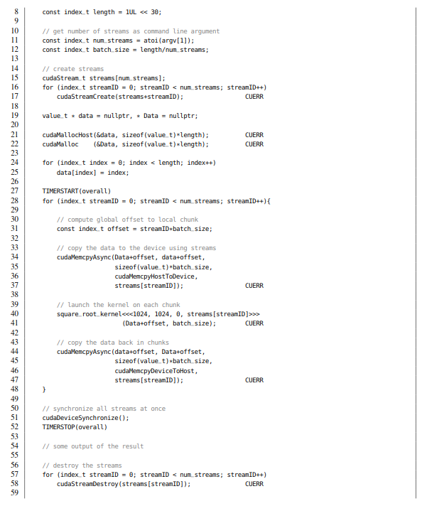

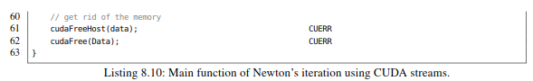

Listing 8.10: Main function of Newton’s iteration using CUDA streams

清单8.10使用CUDA流来完成牛顿迭代的主函数

When executed on a Pascal-based Titan X, we measure the following runtimes depending on the number of used streams:

在基于Pascal的Titan X上，根据使用的流的数量来测量以下运行时间：



Obviously, we can almost completely reduce the overall execution to the plain execution time of the kernel (1300 ms) by hiding the slow PCIe transfers behind computation. Notably, the streamed single GPU version is even faster than the naive non-streamed multi-GPU variant from the previous subsection (1400 ms).

显然，通过在计算过程中隐藏慢速的PCIe传输，几乎可以将整体执行时间减少到内核的执行时间（1300 ms）。 值得注意的是，单GPU版多个流版本甚至比前一小节（1400 ms）中的初始多GPU非流版本更快。

STREAMED COMPUTATION ON MULTIPLE GPUS

多GPU上执行流计算

Let us revisit what we have seen:

**1.** We can reduce the execution time of a kernel by utilizing several GPUs.

**2.** Memory transfers can be efﬁciently hidden by using streams.

It is obvious that we should combine both techniques in order to efﬁciently exploit the compute capa- bilities of all attached GPUs. We adapt the code shown in Listing 8.10 to use num_streams streams per GPU which each operate on a chunk of size length/(num_streams*num_gpus). We again assume for simplicity that the length is a multiple of the chunk size.

让让我们回顾一下：

1.我们可以通过使用几个GPU来减少内核的执行时间。

2.使用流可以有效地隐藏内存传输。

很明显，我们应该结合这两种技术，以便有效地利用所有连接的GPU的计算能力。我们对清单8.10中所示的代码进行调整，以便在每个GPU上使用num_streams个流，每个流要处理大小为length/(num_streams*num_gpus) 的数据块。为了简单起见，我们再次假设data长度是块大小的倍数。

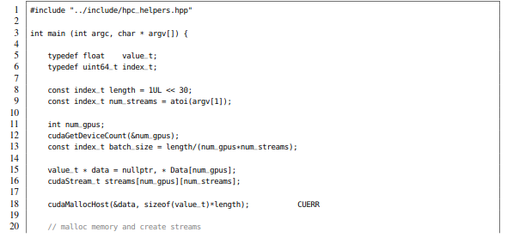

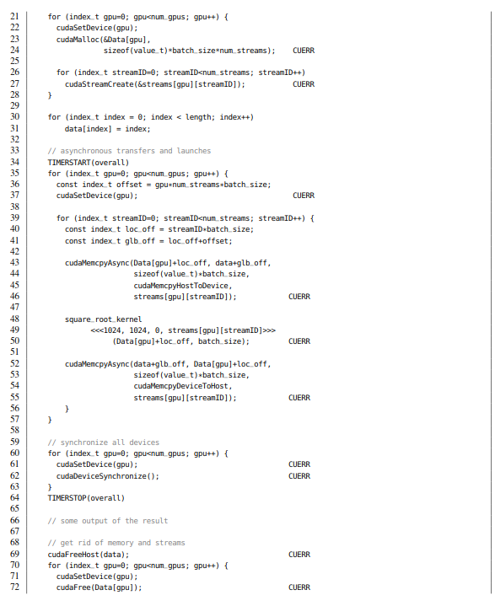

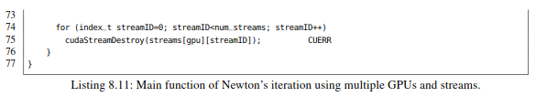

Listing 8.11: Main function of Newton’s iteration using multiple GPUs and streams.

清单8.11:使用多个GPU和多个流来完成Newton迭代的主要函数。

When executed on two Pascal-based Titan X GPUs, we measure the following runtimes depending on the number of used streams per GPU:

在两个scal的Titan X GPU上执行，根据每个GPU使用的流的数量测量运行时间：



We can reduce the overall runtime of the non-streamed single GPU version of 2000 ms to merely 670 ms which corresponds to approximately half of the plain execution time of the single GPU kernel (1300 ms). Note that even the single stream variant (1020 ms) performs better than the naive non-streamed multi-GPU version (1400 ms). As a result, the use of streams is highly advisable when utilizing several GPUs.

我们可以将单GPU非流版本的整体运行时间2000 ms减少到670 ms，大约相当于单GPU ker- nel纯执行时间(1300 ms)的一半。注意，即使是单流版本(1020 ms)也比多gpu非流的版本(1400 ms)表现得更好。因此，在使用多个GPU时，强烈建议使用流。

Finally, let us mention a useful tool for monitoring and debugging of CUDA applications. The NVIDIA visual proﬁler (nvvp) is a comprehensive application that allows for the investigation of stream scheduling on multiple GPUs and other important performance metrics in a user-friendly GUI. It can be used to analyze and improve the workﬂow of your application.

最后，让我们介绍一个用于监视和调试CUDA应用程序的有用工具NVIDIA visual profiler (nvvp). nvvp是一个全面的应用程序，使用nvvp提供的友好GUI界面可以查看多个GPU的流调度和其他重要的性能指标，以此来分析和改进应用程序的工作流。

8.3 OUTLOOK

At this point, we have ﬁnished our journey. As you might have observed, CUDA is a mighty framework that allows for the massively parallel computation of huge data sets in short time. Notably, we can often outperform state-of-the-art multi-core CPUs as seen in Section 7.4 where we gain an additional speedup of roughly six over a dual socket Xeon CPU harnessing up to 32 hardware threads. However, speed comes with complexity: we have to properly access the attached memory, exploit local caches and employ sophisticated techniques such as warp intrinsics, atomics, and streams in order to yield reasonable performance. Although we have covered a signiﬁcant fraction of CUDA’s features, there are still some useful techniques left which cannot be discussed in detail within the scope of this book.

至此，我们已经完成了本章的学习旅程。正如你所观察到的，CUDA是一个很强大的框架，它可以在短时间内完成对大量数据集进行大规模的并行计算。令人兴奋的是它还可以超越最先进的多核CPU，如第7.4节所示，与使用最多32个硬件线程的双路Xeon CPU平台相比，我们可以获得大约6倍的加速比。然而，加速比也伴随着复杂性:为了为了获得合理的性能，必须正确地访问附加的内存，利用本地缓存并使用复杂的技术，如warp intrinsics、atomics和streams. 虽然我们已经介绍了CUDA特性的一部分，但是仍然有一些有用的技术没有在本书的范围内详细讨论。

UNIFIED MEMORY

统一寻址

With the release of CUDA 8, NVIDIA introduced a *Uniﬁed Virtual Memory (UVM)* layer which treats the address spaces of host memory and device memory as one. UVM allows to design completely new distribution patterns especially when dealing with multiple GPUs. In the foreseeable future, we will see novel approaches such as lock-free hash maps distributed over multiple GPUs using system-wide atomics. However, this reduced complexity of source code might result in programs that are hard to analyze since the programmer has to pinpoint memory bottlenecks which are completely hidden behind syntactic sugar. As an example, the following code is a valid CUDA 8 program executed on the GPU despite the lack of explicit memory transfers:

随着CUDA 8的发布，NVIDIA引入了一个统一的虚拟内存(UVM)层，该层将主机内存空间和设备内存地址空间视为一体。UVM允许设计全新的分发模式，尤其是在处理多个GPU时。在可预见的将来，我们将看到一些新的方法，比如利用系统级的原子操作完成无锁哈希映射到多GPU的分布。这样会降低源代码的复杂性，但可能会导致程序难以分析，因为程序员必须查明完全隐藏在语法的内存瓶颈。例如，下面的代码是一个在GPU上没有显式内存传输但非常有效的CUDA 8程序，尽管缺乏显式内存传输:

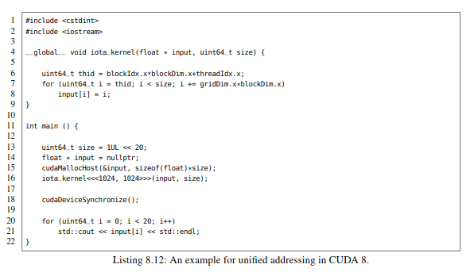

Listing 8.12: An example for uniﬁed addressing in CUDA 8.

清单8.12：CUDA 8中统一寻址的一个例子

**DYNAMIC PARALLELISM**

动态并行性

All discussed examples in this book were executed on a static grid of thread blocks that had to be deﬁned during kernel launch. However, an application might operate on an adaptive grid which is reﬁned on demand. Examples are the integration of unsteady ﬂows in the ﬁeld of ﬂuid dynamics, basic recursive applications such as Quicksort, Strassen’s algorithms for fast matrix matrix multiplication, computation of fractals, or branch-and-bound algorithms. This adaptive reﬁnement of the grid can be realized by calling kernels recursively from within a kernel. However, this comes with a reasonable overhead which renders *Dynamic Parallelism (DP)* impracticable in many cases. Nevertheless, DP should be considered especially when dealing with recursive reﬁnements of spatial domains.

本书中讨论的所有示例都执行在线程块的静态网格上，同时这些线程块都是在内核启动期间定义的。但是，应用程序可能会在需要时重新定义的自适应网格上运行。例如流体动力学中非定常流场的积分，基本的递归应用程序，如快速排序，Strassen的快速矩阵乘算法，分形计算，或分枝定界算法。网格的这种自适应优化可以通过从内核中递归调用内核来实现。然而，这带来了合理的开销，这使得动态并行（DP）在许多情况下变得不切实际。不过在处理空间域的递归改进时，应特别考虑DP。

**COOPERATIVE GROUPS**

协作组

Up to CUDA version 8, warp intrinsics accomplishing intra-warp shufﬂes of register entries are limited to 32 consecutive threads. Moreover, we have learned that a warp is the defacto compute unit in the CUDA programming model that either applies 32 instructions in lock-step or serializes instruction divergences using masks. However, CUDA version 9 (release candidate of August 2017) introduces a new paradigm for the organization of threads: so-called cooperative groups.

Loosely speaking, cooperative groups are user-deﬁned teams of threads of ﬂexible size providing convenient synchronization, communication and partition instructions. This paradigm shift in the organization of threads might have signiﬁcant impact on the design of massively parallel algorithms in the future. As an example, the __syncthreads() call guarantees both a thread fence and a memory fence.

Starting with CUDA 9, threads within a warp are not guaranteed to act in lock-step anymore (so-called independent thread scheduling) and thus we have to rethink intra-block communication using either shared memory or warp intrinsics. As a consequence, traditional software that exploits implicit warp synchronization, so-called warp-synchronous code, has to be rewritten or augmented with __syncwarp() statements.

Among the new CUDA 9 features are persistent grids and multi-grids than can be synchronized across thread blocks and distinct GPUs. This allows for new computation schemes for iterative algorithms that rely on global barriers such as parallel reductions, parallel preﬁx sums, or sequence alignment algorithms.

由于warp内变换所需要寄存器条目，直到CUDA8，一个warp被限制在32个连续的线程。此外，我们还了解到warp是CUDA编程模型中实际的计算单元， warp要么在在锁步中应用32条指令，要么使用掩码序列化指令分支。但是，CUDA版本9（2017年8月发布）引入了线程组织的新范例，即所谓的合作组织。简而言之，合作组是用户定义的线程大小灵活的线程组，提供方便的同步，通信和分区指令。这种线程组织的范式转换可能会对未来大规模并行算法的设计产生重大影响。例如， _syncthreads()调用可以同时保证线程屏障和内存屏障。从CUDA 9开始，warp中的线程不再保证在锁步中运行(所谓的独立线程调度)，因此我们必须重新考虑使用共享内存或warp intrinsics进行块内通信。因此，利用隐式warp同步的传统软件，即所谓的warp同步代码，必须重写或用__syncwarp()语句来增强。新的CUDA 9功能包括持久网格和多网格，可以实现跨线程块和不同GPU之间的同步。这为依赖全局屏障的迭代算法提供了新的计算方案，比如并行约简、并行前缀和或序列对齐算法。

**TENSOR CORES**

**张量核**

The Volta generation introduces novel compute units allowing for the ultra-efﬁcient multiplication of small matrices: so-called tensor cores. Each of the 80 SMs consist of eight tensor core units for the computation of the afﬁne mapping *D* = *A* · *B* + *C* where *A* and *B* are 4 × 4 FP16 matrices and *C* is an FP16 or FP32 matrix of the same shape. This certain operation is a fundamental building block in deep learning algorithms. The 640 tensor cores of a Tesla V100 card provide up to 120 tensor TFlop/s. Hence, a workstation equipped with eight V100 cards such as the DGX Volta box performs at 960 tensor TFlop/s for this speciﬁc task. Concluding, if you have to accelerate an application involving linear algebra and half-precision is sufﬁcient (stochastic optimization, probabilistic machines, ensembles of weak linear classiﬁers), you should deﬁnitely have a look at tensor cores.

Volta一代引入了新的计算单元，可以实现超高效的小矩阵乘法，即张量核。80个SM中的每一个都包含8个张量核心，用于计算仿射变换D = A·B + C，其中A和B是4×4 FP16矩阵，C是一个形状相同的FP16或FP32矩阵。

这种特定的操作是深度学习算法的基本组成部分。特斯拉V100的640张量核心可以提供高达120TFlop/s性能。因此，一个配备了8张V100卡的工作站，例如DGX Volta盒子，在某个特定任务下可以提供高达960TFlop/s性能。总之，如果需要加速的应用涉及到线性代数和半精度（随机优化，概率机器，弱线性组合分类器），就应该好好考虑使用张量核心。

**DISTRIBUTED COMPUTATION ON GPU CLUSTERS**

GPU集群上的分布式计算

In the CUDA chapters we have mainly discussed single GPU applications with the exception of the last section. Although it is straightforward to distribute a kernel over multiple GPUs attached to the same workstation, the communication between several compute nodes in a distributed memory architecture is far more complex. This can be achieved by interleaving CUDA with Message Passing Interface languages such as MPI (see Chapter 9) or PGAS-based languages such as UPC++ (see Chapter 10). In this context, a noteworthy technique is CUDA-aware MPI [13] which provides high-level wrappers for point-to-point primitives and global collectives which allow for the direct communication between compute nodes without stating explicit memory transfers over the PCIe bus.

CUDA一章主要讨论了单个GPU应用程序。尽管将内核分发到连接到同一工作站上的多个GPU上相对简单，但是分布式内存体系结构中几个计算节点之间的通信要复杂得多。这可以通过将CUDA与消息传递接口语言（如MPI（参见第9章））或基于PGAS的语言（如UPC ++）混合来实现（参见第10章）。在这种情况下，一个值得关注的技术是CUDA感知的MPI [13]，它为点对点原语和全局collective提供了上层封装，实现计算节点之间的直接通信，而无需通过PCIe总线显式内存传输。

**8.4 ADDITIONAL EXERCISES**

**8.4 课外习题**

**1.** Cross-correlation, a minor modiﬁcation of convolution, computes a weighted average of a signal *f* in a local neighborhood using the weight coefﬁcients *g*. Assuming that *f* and *g* are sampled on a discrete grid and thus can be represented as arrays, we can compute the cross-correlation *h* of *f* and *g* as follows:

互相关是卷积的一个小修改，使用权重系数g计算局部邻域内信号f的加权平均值。 假设f和g在离散网格上采样，因此可以用数组来表示，我们可以计算f和g的互相关h，如下所示：

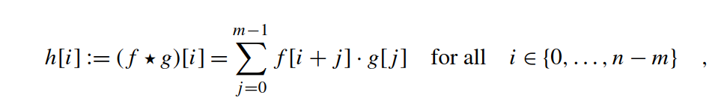

where *n* is the length of the signal *f* and *m* is the number of weights stored in *g*. The ﬁnal result *h* has *n* − *m* + 1 entries if *m* ≤ *n*. In the following, assume *n* = 230 and *m* = 25.

其中n为信号f的长度，m为存储在g中权值的个数。当m≤n时，最终结果h有n - m + 1个元素，下面，假设n = 230 and m = 25.

**(i)** What is the time and memory complexity of the described computation pattern.

所描述的计算模式的时间和内存复杂度是多少？

**(ii)** Implement an efﬁcient kernel that stores *g* in constant memory and further evaluates the sum in shared memory in order to avoid redundant memory accesses to global memory. Do not forget to reserve storage for the halo values that are caused by the overlap of *g* with *f* :

实现一个有效的内核，它将g存储在常量内存中，在共享内存中进一步计算和，以避免对全局内存的冗余访问。不要忘记为g和f重叠造成的halo值预留空间:

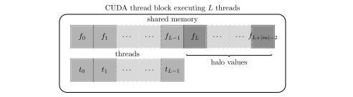

**(iii)** Cross-correlation can also be computed by the pointwise multiplication of the corresponding Discrete Fourier Transforms (DFTs):

互相关也可以通过对应的离散傅里叶变换(dft)的点乘计算得到:

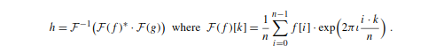

Here, ∗ corresponds to complex conjugation (time reversal in index space), *ι* =√−1 denotes the imaginary solution of the equation *ι*2 = −1 and · is the index-wise complex multiplication of two numbers. DFTs and their inverses can be computed efﬁciently in *O(n*log2 *n)* time using so-called Fast Fourier Transforms (FFTs). How fast can you compute *h* using FFTs? Compare your result with the theoretical complexities in (i).

这里*对应复数共轭（索引空间时间反转），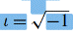 表示为方程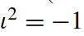的虚解，·是两个数的**指数**复乘法。可以使用所谓的快速傅立叶变换（FFT）在O*(n*log2 *n)*时间内有效地计算DFT及其逆。使用FFT计算h的速度有多快？ 将您的结果与（i）中的理论复杂度进行比较。

**(iv)** Implement the idea discussed in (iii) using NVIDIA’s fast cuFFT library. First, embed *g* in a zero vector of length *n*. Second, compute the FFTs of both *f* and *g*. Third, evaluate the pointwise product using a custom kernel. Finally, compute the inverse transformation of your result.

通过调用NVIDIA的快速cuFFT库来实现（iii）中讨论的想法。 首先，将g嵌入长度为n的零向量中。 其次，计算f和g的FFT。 第三，使用自定义内核评估点乘。 最后，计算结果的逆变换。

**(v)** This task is for the mathematical reader: Prove the correlation theorem in (iii). First, show that a constant translation in index space results in a constant multiplicative phase in Fourier space. Second, apply a linear index substitution to the phase factors in the product *F(f )*∗ · *F(g)*. Finally, spot the inverse transformation by starring at the equation.

这个作业主要针对数学专业读者：证明(iii)中的相关定理。首先，索引空间中的常数平移等同于Fourier空间中一个常量和相exp*(ιφ*0*)*的乘积。其次，用线性指数替换乘积*F(f )*∗ · *F(g)*中的相位因子。最后通过方程找出逆变换

**2.** Revisit the wavefront kernel for the computation of the Dynamic Time Warping similarity measure in Listing 7.28. In the following we want to investigate further parallelization potential.

回顾清单7.28中所示动态时间warp相似性度量的计算wavefront 内核。接下来，我们将进一步研究并行化的潜力。

**(i)** Instead of using texture memory for the subject database, we could manually cache the sub- ject sequences in shared memory in order to speed-up the random accesses during relaxation. Implement this approach.

可以手动将主题序列缓存在共享内存中，而不是使用纹理内存作为主题数据库，以便在放松期间加速随机访问。 请完成这种方法。

**(ii)** During an update of a cell each thread *tl* has to read two entries already processed by the previous thread *tl*−1 (left and diagonal) and one entry already processed by the same thread (above) as shown in Fig. 7.18. Implement a wavefront kernel for DTW that performs the intra warp communication using warp intrinsics instead of shared memory. For simplicity assume

that the length of the time series is exactly *n* = 31.

在每个单元格的更新过程中，每个线程t1必须读取已经由前一个线程tl-1（左和对角线）处理的两个条目以及已经由相同线程（上面）处理的一个条目，如图7.18所示。 为DTW实现wavefront内核，使用warp内在函数而不是共享内存来执行内部warp通信。 为简单起见，假设时间序列的长度恰好是n = 31。

**3.** The Hillis–Steele scan is a parallel computation scheme for the efﬁcient calculation of preﬁx sums. It concurrently computes the inclusive preﬁx scan of a vector *x* ∈ R*n* in log2 *n* time using *n* compute units. The corresponding OpenMP code looks as follows:

Hillis-Steele scan是一种高效计算前缀和的并行计算方案。使用n个计算单元，在log2 *n*时间内并行计算向量*x* ∈ R*n*的包含前缀扫描。对应的OpenMP代码如下

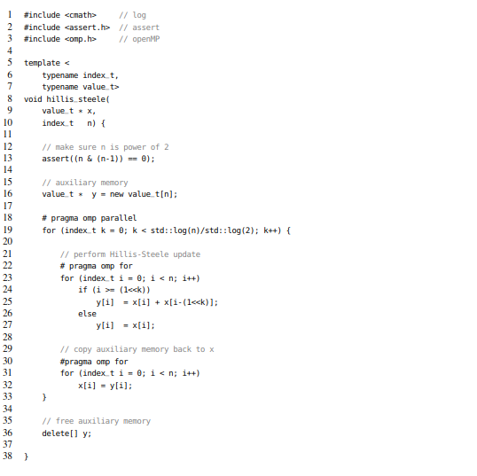

**(i)** Draw a sketch that visualizes the computation pattern over the log2 *n* iterations of the outer loop.

**(ii)** Implement a warp scan using warp shufﬂes.

**(iii)** Extend your implementation to work on segments with more than 32 threads within a block as follows. Compute the scans independently in each warp. Store the last entry of each preﬁx sum in shared memory and subsequently determine the preﬁx sum over these entries in registers. Adjust the overall preﬁx sum using the result from the previous step.

(i) 绘制一个草图，描述外循环log2 n次迭代的计算模式。

(ii) 用warp内shuffle指令完成warp内scan

(iii) 如下所示，将您的实现扩展到一个块中包含32个以上线程的段上。每个warp独立完成scan计算，将每个前缀和的最后一个条目存储在共享内存中，接着在寄存器中确定这些条目的前缀和。使用上一步的结果调整整个前缀和。

**4.** Let uint32_t * Data be an array of length *n* = 230 storing numbers from the set *S* = {0*,...,*9} and uint32_t * Counts be an array of length *m* = 10 storing the number of occurrences for each element in *S*.

设uint32_t * Data是一个长度为*n* = 230的数组，存储集合S ={0，…，9}的数字，设 uint32_t * count是一个长度为m = 10的数组，存储S中每个元素在n中出现的次数。

**(i)** Implement a histogram kernel where each thread reads an entry from Data and atomically increments the corresponding slot in Counts.

实现一个直方图内核，其中每个线程从Data中读取一个条目，然后在counts中的对应槽进行原子累积操作。

**(ii)** Improve that kernel by computing local histograms per CUDA thread block in shared mem- ory and subsequently merge the partial histograms using atomic operations.

通过在共享内存中计算每个CUDA线程块的局部直方图来改进内核，然后使用原子操作合并部分直方图

**(iii)** Provide a register-only variant where each thread independently increments *m* = 10 regis- ters. Subsequently the counts stored in registers have to be accumulated using warp intrinsics. Finally, the block-local histograms are written atomically to Counts.

提供一个寄存器变量，每个线程独立地对m=10个寄存器进行累加。随后，必须使用warp内在函数对存储在寄存器中的数量进行累加。 最后以原子方式将块本地直方图写入counts

Measure the execution times. Which approach performs best?

度量执行时间看哪种方法执行得最好?

**5.** Revisit the shared memory-based kernel for the efﬁcient computation of the covariance matrix in Listing 7.13

重新回顾清单7.13所示的基于共享内存的内核，有效地计算其中的协方差矩阵。

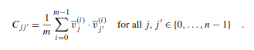

Obviously, the sum can be calculated incrementally over the index *i* since addition is associative. Thus, one could determine *C* on half of the indices and later add the contributions of the other half.

显然，由于加法结合律，求和可以在索引i上递增计算，因此，可以利用一半的索引确定C，然后直接加上另一半。

**(i)** Implement a multi-GPU variant that computes partial covariance matrices on distinct devices and subsequently merges the partial results.

实现一个多GPU版本，在不同的设备上计算部分协方差矩阵，然后合并部分结果。

**(ii)** The same approach is applicable to CUDA streams. Make it so.

同样的方法也适用于CUDA流。

**(iii)** Provide a streamed multi-GPU variant in order to max out the compute capability of your

GPUs.

完成多GPU和多个流的版本，以最大限度地发挥GPU的计算能力。

**(iv)** Write a heterogeneous implementation that additionally harnesses the cores of your CPU to

further improve performance.

另外利用CPU的核心，编写一个异构实现来进一步提高性能。

**REFERENCES 参考文献**

[1] NVIDIA Coporation, Optimized ﬁltering with warp-aggregated atomics, https://devblogs.nvidia.com/parallelforall/cuda- pro-tip-optimized-ﬁltering-warp-aggregated-atomics/, 2014 (visited on 01/20/2017).

[2] Duane Merril, NVIDIA Corporation, CUDA unbound, https://github.com/NVlabs/cub, 2017 (visited on 01/20/2017).

[3] NVIDIA Corporation, cuBLAS library, https://developer.nvidia.com/cublas, 2017 (visited on 01/20/2017).

[4] NVIDIA Corporation, CUDA programming guide version 8.0, https://docs.nvidia.com/cuda/cuda-c-programming-guide/,2016 (visited on 09/25/2016).

[5] NVIDIA Corporation, cuDNN library, https://developer.nvidia.com/cudnn, 2017 (visited on 01/20/2017).

[6] NVIDIA Corporation, cuFFT library, https://developer.nvidia.com/cufft, 2017 (visited on 01/20/2017).

[7] NVIDIA Corporation, cuRAND library, https://developer.nvidia.com/curand, 2017 (visited on 01/20/2017).

[8] NVIDIA Corporation, cuSOLVER library, https://developer.nvidia.com/cusolver, 2017 (visited on 01/20/2017).

[9] NVIDIA Corporation, Faster parallel reductions on Kepler (blog), https://devblogs.nvidia.com/parallelforall/faster-parallel-reductions-kepler/, 2016 (visited on 09/25/2016).

[10] NVIDIA Corporation, Thrust parallel algorithms and data structures library, https://developer.nvidia.com/thrust (visited on 10/12/2015).

[11] Juan Gomez-Luna, et al., In-place data sliding algorithms for many-core architectures, in: Parallel Processing (ICPP), 2015 44th International Conference on, 2015, pp. 210–219.

[12] Sergey Ioffe, Christian Szegedy, Batch normalization: accelerating deep network training by reducing internal covariate shift, in: Proceedings of the 32nd International Conference on Machine Learning, ICML 2015, Lille, France, 6–11 July 2015, 2015, pp. 448–456, http://jmlr.org/proceedings/papers/v37/ioffe15.html.

[13] Jülich Supercomputing Centre (JSC), CUDA-aware MPI, https://www.fz-juelich.de/SharedDocs/Downloads/IAS/JSC/EN/ slides/cuda/07-cuda-aware-MPI.pdf, 2016 (visited on 01/20/2017).

[14] W. Kahan, Pracniques: further remarks on reducing truncation errors, Communications of the ACM (ISSN 0001-0782) 8 (1) (Jan. 1965) 40–48, <http://dx.doi.org/10.1145/363707.363723>, http://doi.acm.org/10.1145/363707.363723.

[15] Yongchao Liu, Srinivas Aluru, LightScan: faster scan primitive on CUDA compatible manycore processors, in: CoRR, 2016, http://arxiv.org/abs/1604.04815.